What You Need for This Project
Legal Warning: Don’t steal other people’s passwords! If you do, you will risk prosecution and jail time. The purpose of this project is to demonstrate the vulnerability of mixed-mode authentication—not to break into other people’s accounts.
- A computer running Linux to be the Attacker (I wrote the instructions on a Ubuntu 8.04 virtual machine).
- A second computer running any OS to be the Target. I used my Windows 7 host machine as the target.

Goal
The Attacker will serve as a proxy, converting secure HTTPS sessions to insecure HTTP ones. This will not be obvious to the user.

Starting the Target Machine
- Start your Target machine.
- Open a browser on your Target machine and make sure you can connect to the Internet.

Opening Facebook on the Target Machine
- On your Target machine, in Firefox, go to facebook.com. Notice that this page is not secure—the URL starts with http instead of https, as shown below on this page.
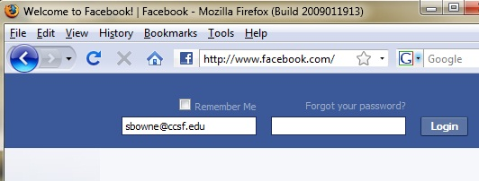

- On your Target machine, in Firefox, click View, "Page Source". In the "Source of http://www.facebook.com" window, click Edit, Find. In the Find: box at the bottom of the window, type login and click the Next button.
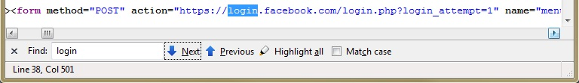
- You can see the form statement for the login form. This shows that although the page is not secure, the actual login method uses a URL starting with https. Many Websites use this system: a single page has both secure and insecure items. That is the vulnerability we will exploit.

Starting the Attacker Machine
- Start an Ubuntu 8.04 virtual machine. That will be your Attacker machine.
- Open a browser on your Attacker machine and make sure you can connect to the Internet.

Downloading SSLstrip
- On the Attacker Linux machine, open Firefox and go to this URL:
thoughtcrime.org
- Click Software. On the next page, click sslstrip. In the Download section, Click sslstrip. At the time I wrote this (July 27, 2009), it was at version 0.4.
- Save the file on your desktop.
- On your desktop, right-click the sslstrip-0.4.tar.gz file and click "Extract Here".
- On your desktop, double-click the sslstrip-0.4 folder to open it.
- Right-click README and click Open. A box pops up asking "Do you want to run "README", or display its contents?". Click the Display button. Read through the instructions—that's a quick summary of what we are doing here.
- Close the README window.

Starting IP Forwarding on the Attacker Machine
- On the Attacker Linux machine, click Applications, Accessories, Terminal. In the Terminal window, type this command. Then press the Enter key.
sudo cp /etc/sysctl.conf /etc/sysctl.conf.bak
Enter your password when you are prompted to. This makes a backup copy of the sysctl.conf file in case you make a mistake later.
- On the Attacker Linux machine, click Applications, Accessories, Terminal. In the Terminal window, type this command. Then press the Enter key.
sudo pico /etc/sysctl.conf
This opens the sysctl.conf file in the pico editor.
- Scroll down and find the line that says "#Uncomment the next line to enable packet forwarding for IPv4". Remove the # at the start of the next line, as shown below on this page.

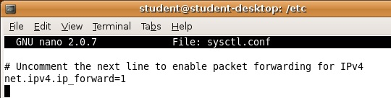

- Press Ctrl+X, Y, Enter to save the file.

Setting iptables to redirect HTTP requests
- On the Attacker Linux machine, in a Terminal window, type this command. Then press the Enter key.
sudo iptables –t nat –A PREROUTING –p tcp
--destination-port 80 –j REDIRECT --to-port 8080
- In the Terminal window, type this command, and then press the Enter key:
sudo iptables –t nat -L
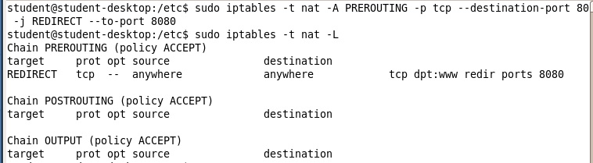
- You should see one rule in the PREROUTING chain, as shown below on this page. Check it carefully. If you find any mistake, use this command to delete the rule: sudo iptables –t nat –D PREROUTING 1 and then repeat the commands above to re-create it without the error.

Starting sslstrip
- On the Attacker Linux machine, in a Terminal window, type this command. Then press the Enter key.
cd ~/Desktop/sslstrip-0.4
- On the Attacker Linux machine, in a Terminal window, type this command. Then press the Enter key.
sudo python sslstrip.py -h
A help message appears, showing the options. There aren't many of them.
- On the Attacker Linux machine, in a Terminal window, type this command. Then press the Enter key.
sudo python sslstrip.py –p –l 8080
This starts sslstrip collecting data. It writes the data into a file named sslstrip.log. Leave this Terminal window open.

Starting the Logfile Scanner
- On your Attacker machine, click Applications, Accessories, Terminal to open a new Terminal window. Type this command. Then press the Enter key.
cd ~/Desktop/sslstrip-0.4
- In the Terminal window, type this command. Then press the Enter key.
tail –f sslstrip.log | grep POST
This command searches the captured data for the string pass= and prints out the lines it finds. Leave this Terminal window open.

Finding the Attacker Machine's IP Address
- On your Attacker machine, click Applications, Accessories, Terminal. Type in ifconfig and press the Enter key.

Attacker IP: _________________
- Find your IP address and write it in the box to the right on this page.

Setting Firefox to Use a Proxy Server on the Target Machine
- In a real attack, we would redirect traffic by ARP poisoning. But for this project, we'll just set the proxy within Firefox. That makes the project easier to do, because it won't affect other machines in the lab.
- On the Target machine (the Windows XP host), open Firefox. From the Firefox menu bar, click Tools, Options.
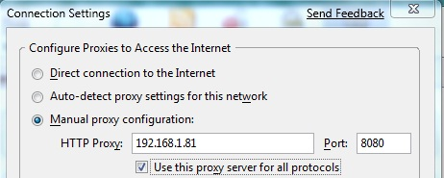
- In the Options box, click the Advanced button. Click the Network tab. Click the Settings… button. Click the "Manual proxy configuration" button. Set the HTTP Proxy to the Attacker IP address you wrote in the box above on this page. Set the Port to 8080. Check the "Use this proxy server for all protocols" box.
- In the "Connection Settings" box, click OK. In the Options box, click OK.

Opening Facebook on the Target Machine
- On your Target machine, in Firefox, go to facebook.com. Click View, "Page Source". In the "Source of http://www.facebook.com" window, click Edit, Find. In the Find: box at the bottom of the window, type login and click the Next button.
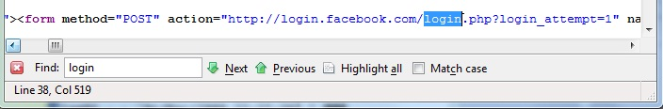
- Now the form statement uses http, not https! This is the magic of SSLstrip—it acts as a proxy, replacing all secure connections with insecure ones. There is nothing the user can see to detect this in the normal Web page view.

- Close the "Source of http://www.facebook.com" window. In the Facebook page, log in with this account:
User name: cnit.target@gmail.com Password: P@ssw0rd
Click the Login button.

Viewing the Captured Traffic
- On the Attacker Linux machine, look at the window running the tail command. You should see the captured password(s) as shown below on this page.

Other Sites to Try
- Wordpress.com
- Twitter.com
- deviantART.com
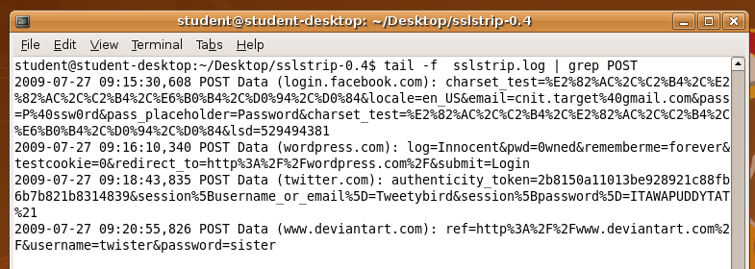

Wall of Stripped Sheep
For a prettier display, do the steps below. But be warned—this script will only show passwords from these four sites:
  - Facebook.com
  - Wordpress.com
  - Twitter.com
  - deviantART.com
- If you have sslstrip running, stop it with Ctrl+C.
- In your Linux attacker machine, open Firefox and go to samsclass.info/defcon.html
- Right-click the "Wall of Stripped Sheep" link. Download the sheep.tar.gz archive and save it on your desktop.
- Extract all the files from the sheep.tar.gz. archive and put them in the sslstrip-0.4 folder.
- On your Attacker machine, in a Terminal window, in the sslstrip-0.4 directory, type this command. Then press the Enter key.
sudo bash defcon
- On your Windows target machine, log in to the four sites listed above. You should see the captured passwords as shown below.
- When you are done, click in the Terminal window and press Q. Don't just stop it with Ctrl+C or you will leave some processes running, which you will have to terminate with sudo kill:

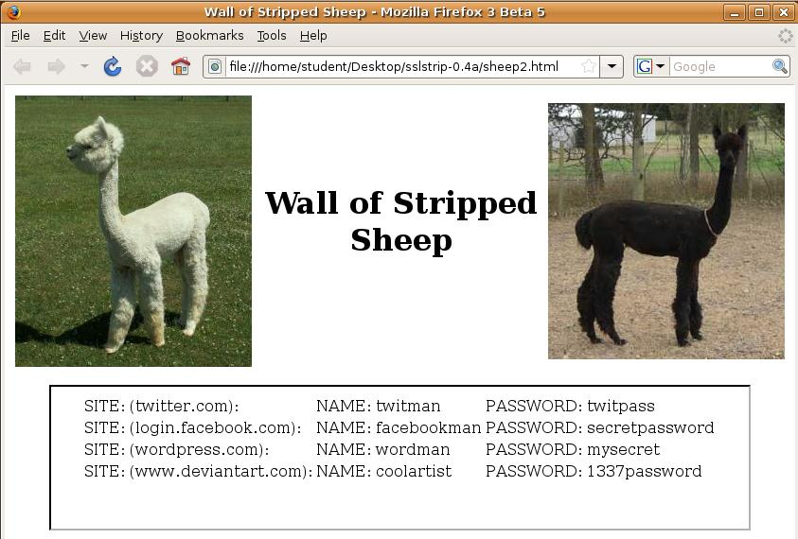

Saving a Screen Image
- Make sure the "Wall of Stripped Sheep" window is visible, showing at least one captured password.
- Click on the host machine's desktop, outside the virtual machine to make the host machine’s desktop active.
- Press the PrintScrn key to copy the whole desktop to the clipboard.
- In the host machine, click Start, "All Programs", Accessories, Paint. In the untitled - Paint window, select Edit, Paste from the menu bar. The desktop appears in the Paint window, with only a corner of it visible.
- In the untitled - Paint window, click File, Save. Save the document in the My Pictures folder (or any other place you wish, such as a floppy disk) with the filename Your Name SSLStrip. Select a Save as type of JPEG.

Turning in Your Project
- Email the JPEG image to me as an attachment to an e-mail message. Send it to: cnit.10@gmail.com with a subject line of Proj SSLStrip From Your Name, replacing Your Name with your own first and last name. Send a Cc to yourself.

Troubleshooting
Sometimes the Firefox window just shows a 1x1 GIF image. To cure that, disable and re-enable the network card on the Windows machine.

Returning Firefox to Normal Function
- On the Target machine, from the Firefox window's menu bar, click Tools, Options. In the Options box, click the Advanced button. Click the Network tab. In the Connection section, click the Settings button. In the "Connection Settings" box, click the "Direct connection to the Internet" radio button. In the "Connection Settings" box, click OK. In the Options box, click OK.

Credits
I am grateful to Moxie Marlinspike for writing sslstrip and presenting it at Black Hat.
Last Modified: 8-26-09 4 pm

