What You Need for This Project
Legal Warning! This is a really powerful attack, and could stop many real Web servers on the Internet. The project includes instructions for setting up your own server to attack. Don’t try it on anyone else’s server, or you risk prosecution and jail time!
- A computer running Linux to be the Attacker (I wrote the instructions using a Ubuntu 8.04 virtual machine).
- A second computer running Apache to be the Target. I used my Windows 7 host machine as the target.

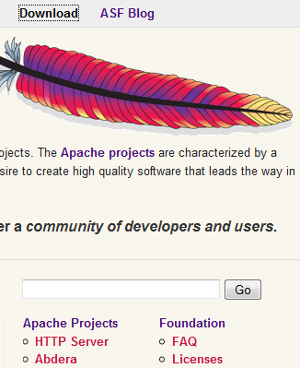
Goal
The Attacker will send incomplete HTTP requests to the Target. This will fill a queue, so that it cannot serve any Web pages. As soon as the attack stops, the normal function of the Web server resumes.

Starting the Target Machine and Installing the Apache Web Server
- Start your Target machine.
- Open a Web browser and go to apache.org
- In the upper right of the page, click Download.
- On the next page, on the right side, click the "HTTP Server" link, as shown to the right on this page.
- On the next page, in the "Apache 2.2.11 Released" section, click the Download link.
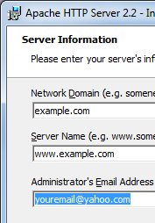
- On the next page, in the "Apache HTTP Server 2.2.11 is the best available version" section, on the "Win32 Binary without crypto" line, click the apache_2.2.11-win32-x86-no_ssl.msi link. Save the file on your desktop.
- Double-click the installer and install the software with the default options. When it asks you for a domain name, use example.com, as shown to the right on this page. Put in your real email address.
- During the installation, it will ask you which port to use. The default port is 80—if you use something else, make a note of it.

- Click Start, "All Programs", Accessories, "Command Prompt". In the Command Prompt window, type IPCONFIG and press the Enter key. Find the IP address of your machine and write it in the box to the right on this page. Also write down the port number you are using—it is usually 80.

Target IP: _____________________________

Port: _____________________________
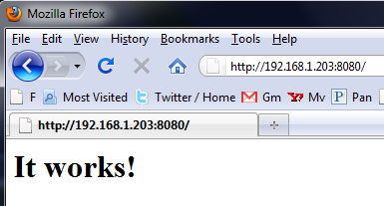
- Open a browser on your Target machine. In the Address bar, type in the "Target IP" address you wrote on the previous page, followed by a colon, then the Port number. Press the Enter key. You should see the message "It works!" as shown to the right on this page.
- To make the project more fun, you may want to make a more interesting Web page to see. To do that, just put an HTML page in this directory:
C:\Program Files\Apache Software Foundation\Apache2.2\htdocs

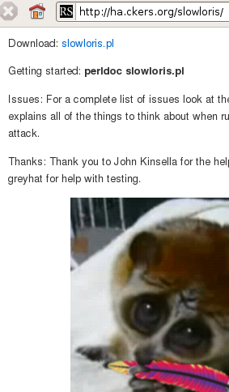
Starting the Attacker Machine
- Start an Ubuntu 8.04 virtual machine. That will be your Attacker machine.
- Open a browser on your Attacker machine and make sure you can connect to the Internet.

Downloading Slowloris
- On the Attacker Linux machine, open Firefox and go to this URL:
ha.ckers.org/slowloris
- Scroll to the bottom of this page. After the word "Download:", right-click the slowloris.pl link, as shown to the right on this page. Click "Save Link As…" and save the file on your desktop.

Viewing the Target Web Page from the Attacker Machine
- Open Firefox on your Attacker linux machine. In the Address bar, type in the "Target IP" address you wrote on a previous page, followed by a colon, then the Port number. Press the Enter key. You should see the message "It works!" as shown to the right on this page, or the other custom page you put on your Web server.
- Click the Reload button a couple of times and notice how quickly the page reloads. It should reload instantly now, because the Web server is not being attacked.
- Leave this Firefox window open—you will need it again later.

Preparing Slowloris
- On the Attacker Linux machine, click Applications, Accessories, Terminal. In the Terminal window, type this command. Then press the Enter key.
cd Desktop
This moves the working directory to your desktop.
- In the Terminal window, type this command. Then press the Enter key.
sudo apt-get install perl-doc
Enter your password when you are prompted to. This installs the Perl documentation module we need to see the Slowloris help page. Wait while packages download and install.
- In the Terminal window, type this command (all on one line). Then press the Enter key.
sudo apt-get install libhtml-parser-perl libio-socket-ssl-perl
When a question asks whether to proceed, type Y and press the Enter key. This installs some libraries Slowloris requires. Wait while packages download and install.
- In the Terminal window, type this command. Then press the Enter key.
perldoc slowloris.pl
This shows the documentation for Slowloris. Scan through it, and when you are done, type Ctrl+Z to end it.

Editing the hosts File
- The only way I know to use Slowloris is with a DNS name. Our test server doesn't have a public DNS name, so we need to add it to the hosts file. In the Terminal window, type this command. Then press the Enter key.
cd /etc
This moves the working directory to /etc
- In the Terminal window, type this command. Then press the Enter key.
sudo cp hosts hosts.bak
Enter your password if you are prompted to. This makes a backup copy of the hosts file in case you make an error later.
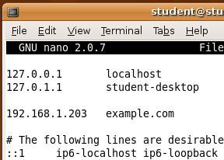
- In the Terminal window, type this command. Then press the Enter key.
sudo nano hosts
- The hosts file opens in the nano text editor, as shown to the right on this page. Add a line containing the IP address you wrote in a box on the previous page, and the DNS name example.com
- To save your changes, type Ctrl+X, then Y, then Enter.

Finding the Sever's Time-out
- On the Attacker Linux machine, in the Terminal window, type this command. Then press the Enter key.
cd
This moves the working directory to your home directory.
- In the Terminal window, type this command. Then press the Enter key.
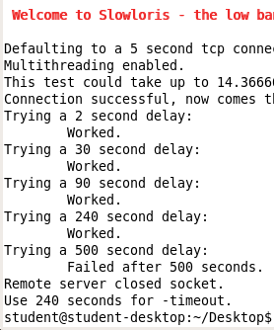
cd Desktop
This moves the working directory to your desktop.
- In the Terminal window, type this command (all on one line). Then press the Enter key.
sudo perl slowloris.pl –dns example.com –port 80 -test
Enter your password if you are prompted to. This tests the server to see what its timeout window is.
- Wait until the test finishes—it will take several minutes. When it's done, you will see output like that shown to the right on this page. It will tell you what timeout value to use—when I did it, it said "Use 240 seconds for -timeout"

Saving a Screen Image
- Make sure the "Welcome to Slowloris" window is visible,.
- Click on the host machine's desktop, outside the virtual machine to make the host machine’s desktop active.
- Press the PrintScrn key to copy the whole desktop to the clipboard.
- In the host machine, click Start, "All Programs", Accessories, Paint. In the untitled - Paint window, select Edit, Paste from the menu bar. The desktop appears in the Paint window, with only a corner of it visible.
- In the untitled - Paint window, click File, Save. Save the document in the My Pictures folder (or any other place you wish, such as a floppy disk) with the filename Your Name Proj Slowloris. Select a Save as type of JPEG.

Starting the Slowloris Attack
- In the Terminal window, type this command (all on one line). Then press the Enter key.
sudo perl slowloris.pl –dns example.com –port 80
–timeout 240 –num 500 –tcpto 5
This performs the actual attack. If the previous step told you to use a different timeout value, use that.

Reloading the Web page
- In the Firefox window, click the Reload button. You should see the error message shown below on this page—the server has been rendered unavailable! The attack has completely denied service to users!
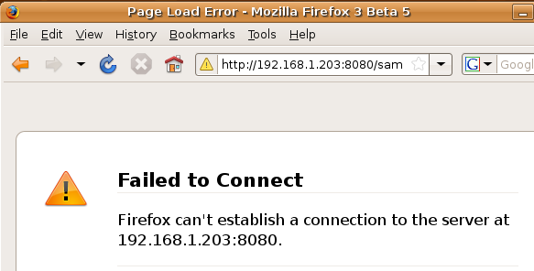

Stopping the Slowloris Attack
- In the Terminal window, type Ctrl+C. That will stop Slowloris.

Reloading the Web page
- In the Firefox window, click the Reload button. The page should reload immediately. Slowloris does not damage the server. It just lets you turn it on and off like a light switch.

Turning in Your Project
- Email the JPEG image to me as an attachment to an e-mail message. Send it to: cnit.10@gmail.com with a subject line of Proj SlowLoris From Your Name, replacing Your Name with your own first and last name. Send a Cc to yourself.

Acknowledgments
I am very grateful to Rsnake for writing Slowloris and agreeing to join me at my Defcon presentation to explain it, and to Fabian Rodriguez for introducing me to Slowloris.
Last Modified: 8-26-09

