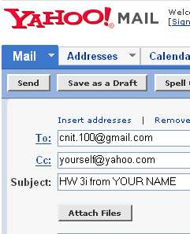
You can use any e-mail service you like, but the instructions below are written specifically for Yahoo mail. With other services like AOL, Hotmail, Gmail, etc. the steps are slightly different.

- Finish your homework and save it on a floppy diskette. If you are in a public lab, be sure to save it on a floppy diskette, because the lab computers generally lose all files saved by students when they are shut down. If you are using your own computer at home, you may save your homework file in the My Documents folder or any other folder that you can find.
- Start Internet Explorer (or any other browser), go to yahoo.com, click Email, and log in with your Yahoo name and password.
- In the Yahoo! Mail screen, click the gray Compose button.
- Enter cnit.100@gmail.com in the To: line
- Click the blue Add CC link, and enter your own email address in the Cc: line
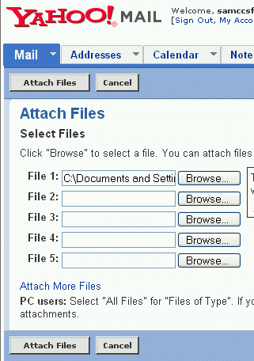
- Enter HW 3i from YOUR NAME in the Subject: line, replacing the homework number with the correct one, and replacing YOUR NAME with your own first and last name.
- Click the gray Attach Files button.
- In the Attach Files window, click one of the gray Browse buttons.
- In the Choose File window, open the floppy disk (or the other folder you saved your homework file in) and find your file. Double-click on the file.
- In the Attach Files window, click the gray Attach Files button.
- In the Attachments screen, click the gray Done button.
- In the Yahoo! Mail screen, click the gray Send button.
- If you see a “Are you sure you want to send an empty message?” message, click Send again.
- Check your Inbox and verify that you received your copy.
- You will receive your grade either by email or in a note in your envelope.

Last modified 9-11-05

