How to Set Up a Yahoo E-mail Account

Start Internet Explorer and type in yahoo.com in the Address box. Press the Enter key to open the Yahoo! main page. Then do these steps.
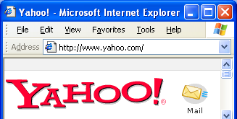
2: Click
Sign Up
1: Click Mail
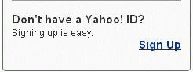

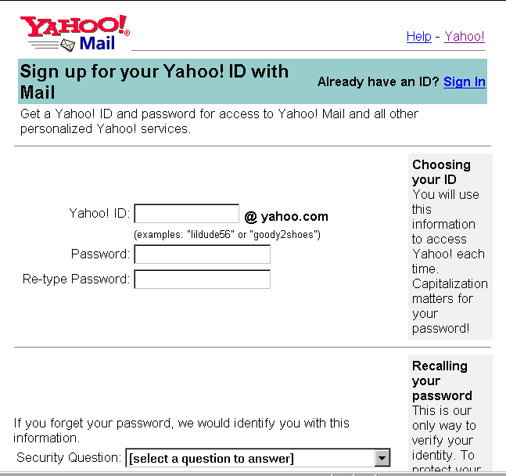
3: Answer all the questions in the form shown to the right. You will have to make up your own Yahoo ID and password. Scroll down and complete the entire form.

If you make any errors, such as choosing a Yahoo ID that someone else is already using, you will get an error screen with red error messages on it. Follow the instructions on the screen to correct the entries.

4. Write your Yahoo! ID and Password below:

Yahoo! ID: _________________________

Password: _________________________


5: When you succeed in filling out the form correctly, you will get a Registration: Please Activate Your Account! message as shown to the right on this page.

Click the
Continue to Yahoo! Mail button.

How to Set Up a GeoCities Web Page
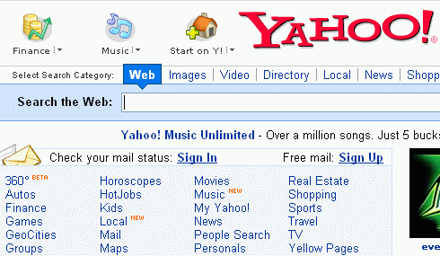
You must already have a Yahoo! ID and password. If you do not, follow the steps in the How to Set Up a Yahoo Email Account handout before you build your webpage.
1: Click GeoCities

Start Internet Explorer and type in www.yahoo.com in the Address box. Then do the following steps.

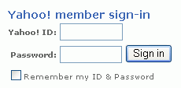
2: Fill in your Yahoo! ID and Password
and then click the
Sign in
button

3: At the GeoCities FREE page, answer the questions and scroll to the bottom of the page. Click the Submit button.

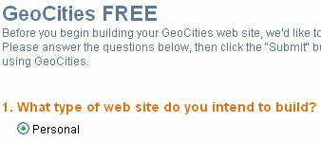

4. You should see a screen titled Welcome to Yahoo! GeoCities, with a box showing your home page URL, as shown to the right on this page. Write that URL in the box below:
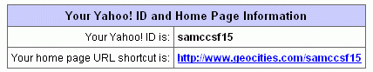

Your URL: ___________________________________________________________________________

In the Welcome to Yahoo! GeoCities screen, click Build your Web site now!

You are now at the GeoCities home page. In the future you will get to this screen each time you sign in to GeoCities without having to repeat steps 3 or 4.

Geocities Home Page

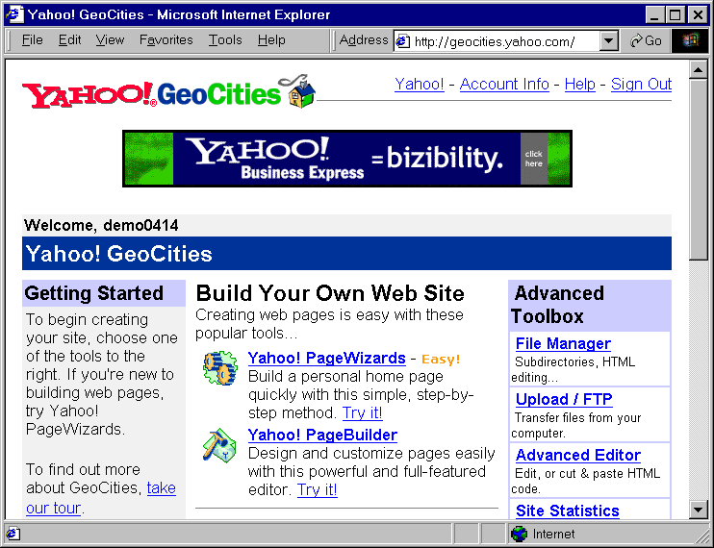
5: Click
Yahoo! PageWizards

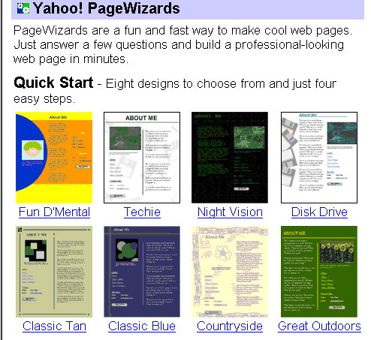
6: Click any one of the eight
Quick Start
designs

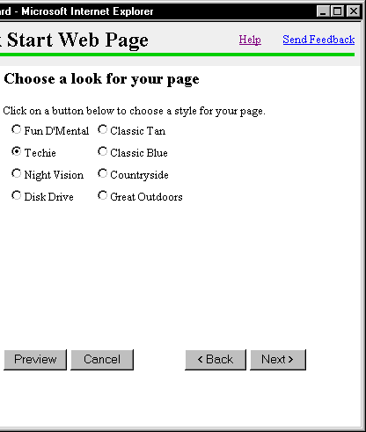
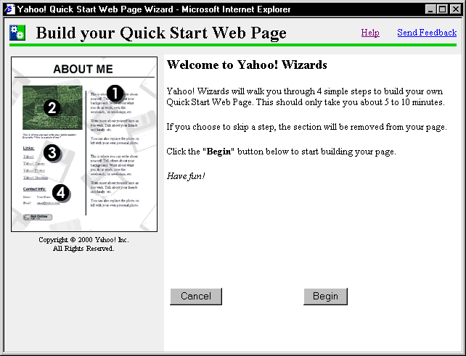
7: Click Begin
8: Click Next
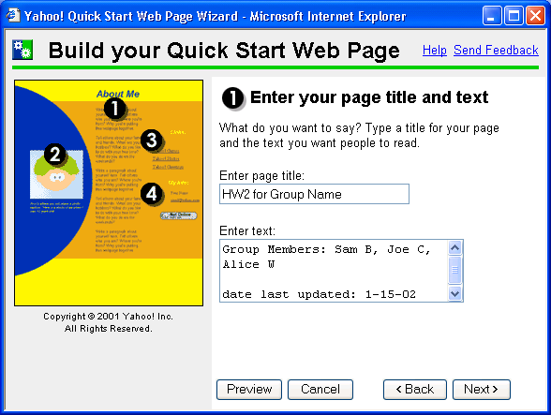
9: The first wizard box is titled 1 Enter your page title and text. In the Enter Page Title box, type:

HW2g for group name

Do not type the words “group name”, but replace them with your group’s name.

In the Enter Text: box, type the names of your group members, and the date your page was last updated (today’s date), as shown in the example to the right. Then click the Next button.

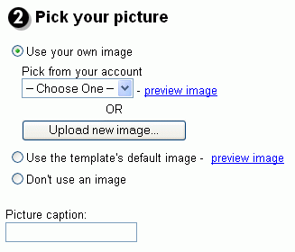
10: Pick Your Picture
Insert your HW1g floppy disk into the drive.
Click the Use your own image radio button and then click the Upload new image button.
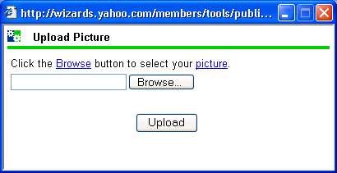
11: Click the Browse button.

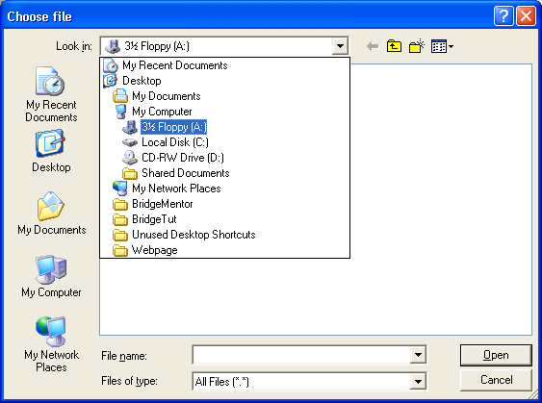
12: A Choose File dialog box opens. Click the arrow at the right of the Look in: drop-down box, and click on 3 ½ Floppy (A:).

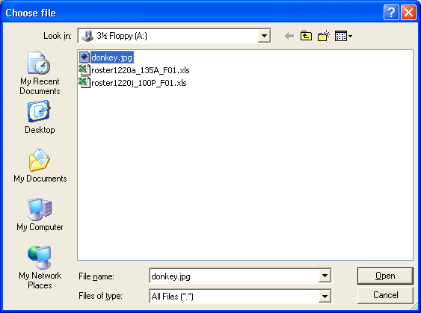
13: A list of files on the floppy disk appears. Click on your picture and then click the Open button.

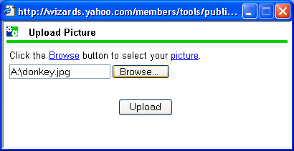
14: In the next box, click the Upload button. A cartoon of turning gears plays for few seconds

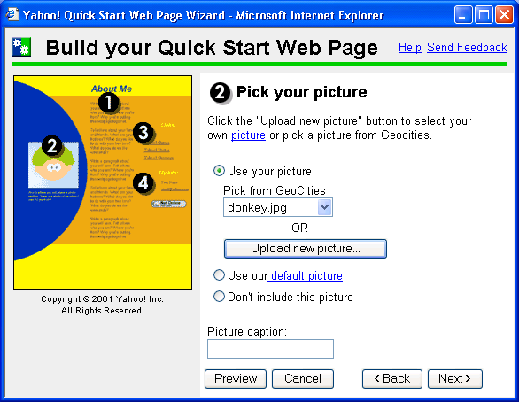

15: When the Pick your picture box returns, click the Next button.

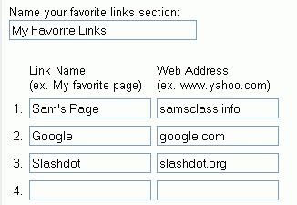
16: Enter your favorite links
This screen starts out with links to four Yahoo sites. Erase the Yahoo Link Names and Web Addresses, and type in these three entries as shown:

Link Name Web Address
Sam’s Page samsclass.info
Google Search google.com
Slashdot slashdot.org

Then click the Next button.

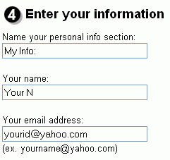
17: Enter your first name and last initial in the Your name: box, and your email address in the Your email address box. Do not enter the literal strings "Your N" or "yourid@yahoo.com" – use your own name and e-mail address.

Click Next

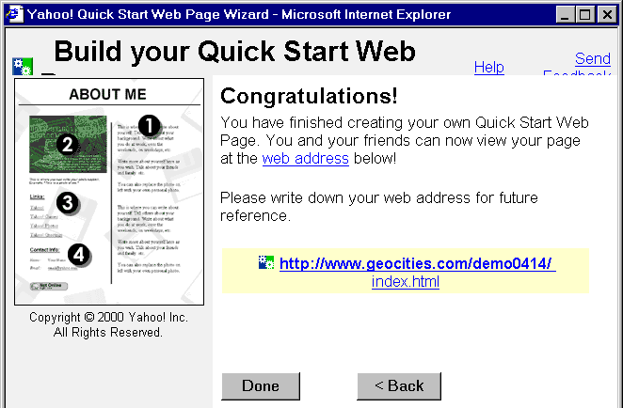
23: A Congratulations! screen appears as shown below. Your page’s web address appears in blue text in the middle of the screen. Write your web address here and also on your HW2g page.

Web Address: ___________________________________________________________

Click the blue web address to see your page.
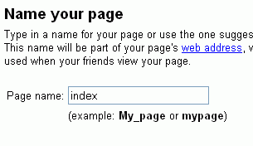
18: Type the name
index
in the Page name box and click Next

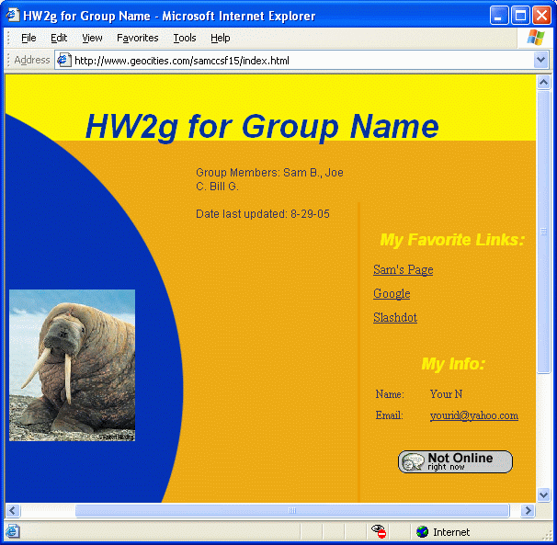
19: Your page should look like the example to the right on this page.

Check your page to make sure all the required elements for HW2g are there, and click on the 3 Links to make sure they work. If anything is wrong, change your page this way:

Changing your page

To change your page, repeat steps 1 and 2 to log in to GeoCities. The GeoCities Home Page opens. Do steps 5 (Click Yahoo! Page Wizards ) and 6 (select the same design you chose before). A Create or change your page? window opens as shown below. Click the arrow under the Edit existing page message, and select index from the drop-down list. Then click Next, and proceed with the steps starting at step 7 as before.
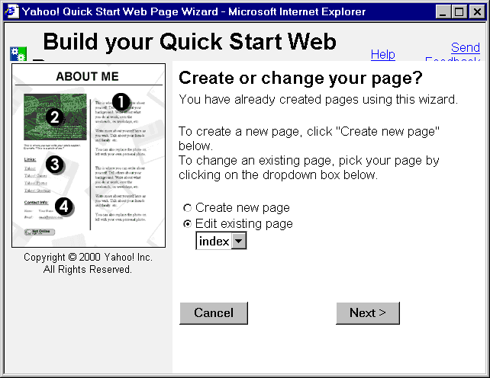
For more complete control over your webpage design, edit your page with the Yahoo! PageBuilder. Start PageBuilder by clicking its name in step 5.

