
Getting a Yahoo E-mail Account

- Start Internet Explorer, Firefox, or any other browser. Type yahoo.com into the Address box. Press the Enter key to open the Yahoo! main page. Then click the My Mail button.

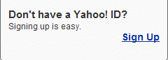
- Click the Sign up link.

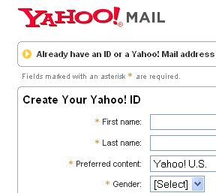
- A form appears, as shown to the right. Answer all the questions, but don’t use your real name—make up a fake one. You will have to make up your own Yahoo ID and password. Scroll down and complete the entire form. Then click the I Agree button at the bottom.

If you make any errors, such as choosing a Yahoo ID that someone else is already using, you will get an error message. Follow the instructions on the screen to correct the entries.

- Write your Yahoo! ID and Password below, just to make sure you remember it. Your Yahoo email address is your Yahoo! ID with @yahoo.com after it.

Yahoo! ID: _________________________________________________

Password: _________________________________________________


- When you succeed in filling out the form correctly, you will get a Registration Completed message as shown to the right on this page.

Clear the Yes, get Yahoo! Toolbar and search theweb from anywhere box and click the Continue without installing Yahoo! Toolbar button.
Sending an Email Message

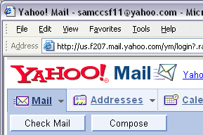
- When the Yahoo! Mail window opens, click the Compose button.

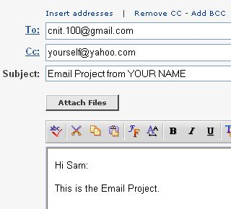
- The Yahoo Message Composition window opens. Fill in the To:, Cc:, and Subject: boxes as shown to the right on this page. To fill in the CC, click the blue Add CC link.:

Do not enter the literal e-mail address "yourself@yahoo.com" – use your own email address. Do not put the literal words "YOUR NAME" in the subject – use your own name.
- Click the gray Send button in the Yahoo Compose screen to send the message.
- Wait a few minutes, and then click the Check Mail button to see if you have received your copy.

Saving a Picture

- You will need a picture for your Web page. You can either take a picture of yourself with a webcam in the classroom and save it on a diskette, or go to Google.com and search for an image to use. To save an image from Google, right-click on it and select Save Picture As…. Then save it on a diskette. If you have trouble saving a picture, ask your instructor for help.

Making a GeoCities Web Page
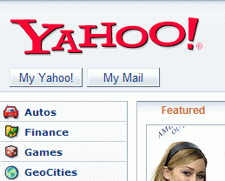
- Start Internet Explorer (if necessary), type yahoo.com in the Address box, and press the Enter key.

- Click GeoCities.

- If you are not already signed in to Yahoo, click the Sign in to Geocities link Then enter your Yahoo! ID and password.



- In the GeoCities FREE section, click the Sign Up button.

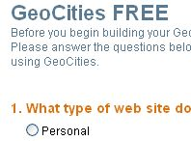

- A form appears, as shown to the right on this page. Answer the questions and click the Submit button at the bottom.

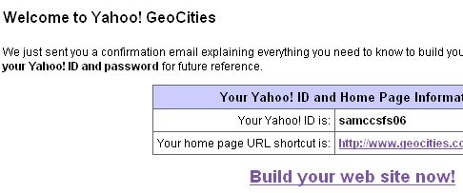

- A Welcome to Yahoo! GeoCities screen appears, as shown to the right on this page. Click the Build your Web site now! link.

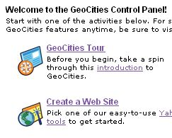
- The GeoCities Control Panel opens, as shown to the right on this page. Click Create a Web Site.

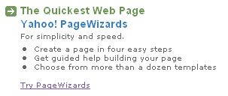

- In the next screen, click the Try PageWizards link.

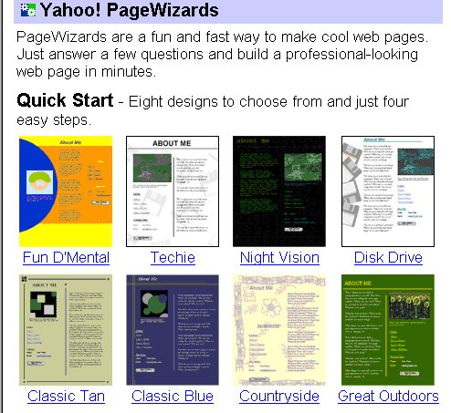
- Click one of the eight Quick Start designs. Don’t use the special ones below, such as Baby Announcement, because they don’t all let you add the other things you will need, such as a picture.

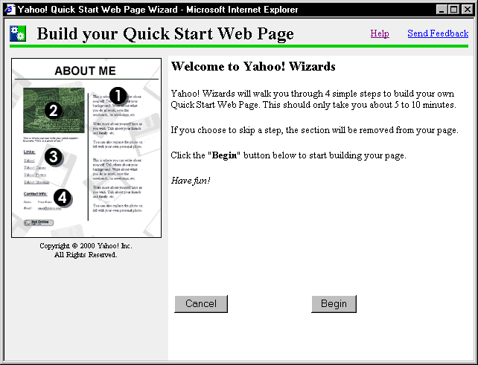

- A box opens with Build your Quick Start Page at the top, and Welcome to Yahoo! Wizards in the right pane, as shown to the right on this page. Click the Begin button.

- In the Choose a look for your page screen, click the Next button.

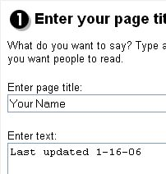
- The 1 Enter your page title and text screen appears. In the Enter Page Title box, type in your name. I recommend that you use a fake last name, but please use your real first name to help me grade the homework. In the Enter text box, type in the date. Then click the Next button.

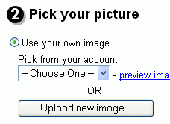
- In the 2 Pick Your Picture screen, click the Upload new image button.

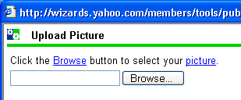
- In the Upload Picture box, click the Browse button.

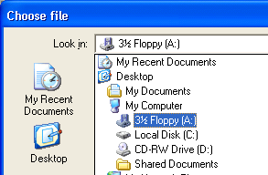
- A Choose File dialog box opens. Click the arrow at the right of the Look in: drop-down box, and click on 3 ½ Floppy (A:). If your picture is saved somewhere else, such as in the My Pictures folder, open that folder instead. When you see your picture, double-click on it. When the Upload Image box reappears, click the Upload button.

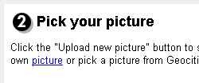
- When the Pick your picture box reappears, click the Next button.

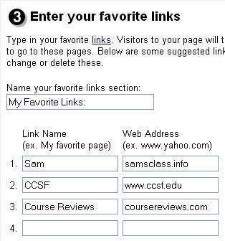
- In the3 Enter your favorite links box, type in the three links shown to the right on this page. Then click the Next button.

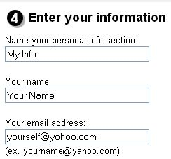
- In the4 Enter your information box, enter your name in the Your name: box. I recommend that you use a fake last name, but please use your real first name to help me grade the homework. Enter your email address in the Your email address: box. Do not enter the literal strings "Your Name" or "yourself@yahoo.com" – use your own name and e-mail address. Then click Next.

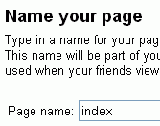

- In the Name your page box, enter index in the Page name: box. Then click Next.

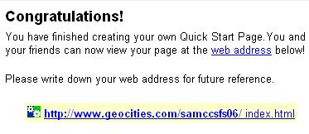
- A Congratulations! screen appears as shown to the right. Your page’s web address appears in blue text in the middle of the screen. Your web address starts with http://www.geocities.com. Click your web address to open your page.
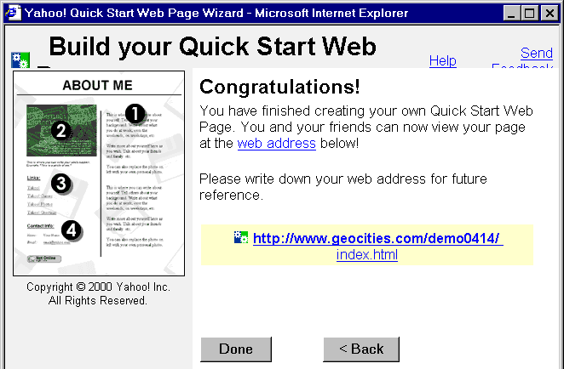

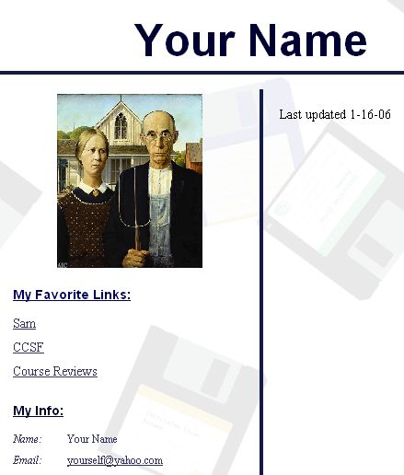
- Make sure your web page has the required elements listed below, as shown to the right on this page. Click the links to make sure they work:
  - Your Name at the top
  - A Last Updated date
  - A picture you put on the page.
  - A link to Sam’s Page (samsclass.info)
  - A link to CCSF (www.ccsf.edu)
  - A link to Course Reviews (coursereviews.com)
  - Your name and e-mail address in the My Info section

Changing your page
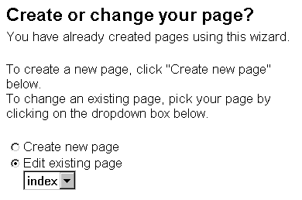
- If anything is wrong on your page, such as a link that does not work, use the Back button in the PageWizards box to return to the appropriate item and fix it. If you have closed the PageBuilder page, start at Yahoo again and click Geocities. Start Page Wizards as you did before. A Create or change your page? window opens as shown to the right. Click the arrow under the Edit existing page message, and select index from the drop-down list. Then click Next, and proceed through the wizard pages to fix your error.

Sending Your Web Page URL by Email

- You should have your Web page open in a browser window. Resize the window so it fits in the right half of the screen.
- Open a second browser window and go to the yahoo.com page. Click the Email icon and sign in to your Email account. Resize the window so it fits in the left half of the screen. Click the Compose button and the Add CC link, and address the message as shown in the figure below.
- Drag the URL Handle (the little blue e) from the window displaying your Web page and drop it into your Email message, as shown below. The Web Address will appear in your email message in blue letters, as shown below. Then click the Send button at the bottom of the Email message.
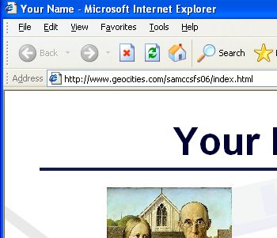
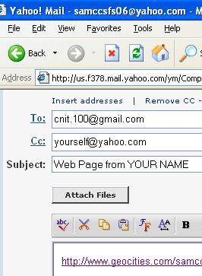

- In the Yahoo! Mail window, click the Check Mail button. Make sure the copy you sent yourself arrived, and that you can click the link in the message to open your Geocities page.

Last modified 8-16-06

