You do not need to print anything or hand in any paper for any of these projects. Turn them all in as email attachments. You can use any e-mail service you like, but the instructions below are written specifically for Yahoo mail. With other services like AOL, Hotmail, Gmail, etc. the steps are slightly different.

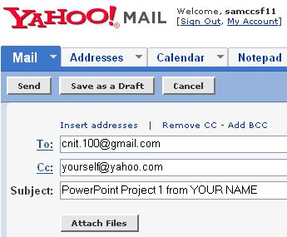
- Finish your project and save it. If you are in a public lab, be sure to save it on a diskette, because the lab computers lose all files saved by students when they are shut down. If you are using your own computer at home, you may save your project file in the My Documents folder or any other folder that you can find.
- Start Internet Explorer (or any other browser), go to yahoo.com, click Email, and log in with your Yahoo name and password.
- In the Yahoo! Mail screen, click the gray Compose button.
- Enter cnit.100@gmail.com in the To: line
- Click the blue Add CC link, and enter your own email address in the Cc: line
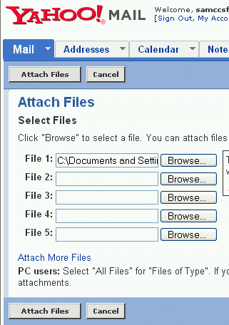
- Enter PowerPoint Project 1 from YOUR NAME in the Subject: line, replacing the project name and number with the correct one, and replacing YOUR NAME with your own first and last name.
- Click the gray Attach Files button.
- In the Attach Files window, click one of the gray Browse buttons.
- In the Choose File window, open the floppy disk (or the other folder you saved your project file in) and find your file. Double-click on the file.
- In the Attach Files window, click the gray Attach Files button.
- In the Attachments screen, click the gray Done button.
- In the Yahoo! Mail screen, click the gray Send button.
- If you see a “Are you sure you want to send an empty message?” message, click Send again.
- Check your Inbox and verify that you received your copy.
- You will receive your grade either by email or in a note in your envelope.

Specific Files to Send for Each Project

PowerPoint Project 1: Send the Make Friends presentation.
PowerPoint Project 2: Send the Enjoy Spring Break presentation.
Word Project 1: Send the Hidden Lake Announcement.doc document.
Word Project 2: Send the E-Retailing Paper document
Word Project 3: Send three documents: Carter Resume, Carter Letterhead, and Carter Cover Letter. You do not need to make the envelope.
Excel Project 1: Send the Dynamite Music 4th Quarter Sales workbook.
Excel Project 2: Send the Greenback Stock Club workbook. Insert the Web Query, but don’t try to email the workbook from within Excel.
Excel Project 3: Send the Awesome Intranets workbook.
Access Project 1: Send the Alisa Vending Services database. However, before you can email an Access database, you must copy it and rename it, as explained below.
- Close Access entirely before emailing in the project. When you close Access, the database will be saved on your hard drive or floppy with the name Alisa Vending Services.mdb – you can't send that file by Email, however. You must make a copy of the file and change the extension to .mdbx before emailing it, so the full file name of the file you send by email is Alisa Vending Services.mdbx. If you are not sure how to copy a file and rename it, follow these instructions:
- Open the folder or device your file is stored on. Look at the current file name. Can you see the .mdb file extension? If you cannot, click Tools, Folder Options, and click the View tab. Uncheck the box labeled Hide extensions for known file types and click OK. Now you should see the .mdb extension.
- Point to the Alisa Vending Services.mdb icon, press and hold down the right mouse button, and drag the file a small distance to the side. Release the right mouse button. A context menu pops up. Click Copy Here. A file named Copy of Alisa Vending Services.mdb appears.
- Right-click the Copy of Alisa Vending Services.mdb icon. A context menu pops up. Click Rename. Change the name to Alisa Vending Services.mdbx and press the Enter key. In the Rename box, click Yes.
Access Project 2: First you must create and save the four queries as described on the next page. Then send the Alisa Vending Services database as you did in Access Project 1.
Access Project 3: First make all the changes to the database specified in the textbook. Then send the Alisa Vending Services database as you did in Access Project 1.
Access Project 2: Querying the Alisa Vending Services Database
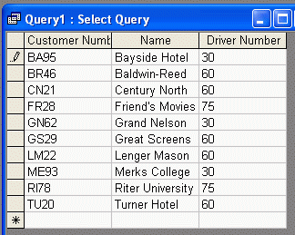
- Follow the instructions on pages A 2.06 – 2.42 in your textbook to create the queries. Note: The book does not tell you to save the queries, but you must save the four queries shown below to get credit.
1
Query A: A Query with no Criteria (Three Fields and Ten Records):
To create this query, follow the instructions from page A 2.06 through A 2.11. Your query should should look like the figure to the right on this page. Close the Query window and save your query as Query A.

B: Criteria for a Field not in the Result:
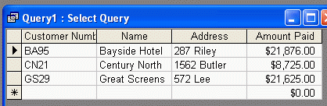
To create this query, follow Steps 1 through 4 on pages A 2.19 and A 2.20. Your query should should look like the figure to the right on this page. Close the Query window and save your query as Query B.
C: Joining Tables:
To create this query, follow Steps 1 through 6 on pages A 2.30 through A 2.32 and steps 1 and 2 on pages A 2.32 and A 2.33. Your query should should look like the figure below on this page. Close the Query window and save your query as Query C.
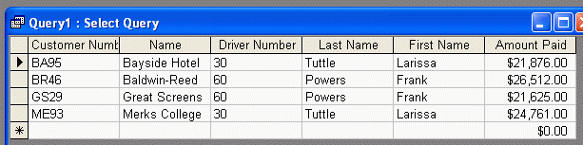

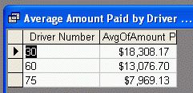
D: Grouping and Saving a Query:
To create this query, follow the Grouping steps on pages A 2.40 and A 2.41, and the Saving a Query steps on page A 2.41. Save the query with the name Average Amount Paid by Driver. Your query should look like the figure to the right on this page.

Revised 11-16-06

