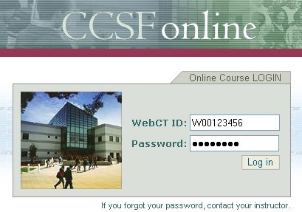
Logging in to CCSF Online

- Start Internet Explorer, Firefox, or any other browser. Type online.ccsf.edu into the Address box. Press the Enter key to open CCSF online as shown to the right on this page.

- Type your student ID into the WebCT ID box. Your Student ID is on your student ID card.

- Type your password into the Password box. If you have not used CCSF online before, your password is:

changeme

If you have used CCSF online previously and changed your password, use the new password you chose. If you forgot your password, ask your instructor to reset it.

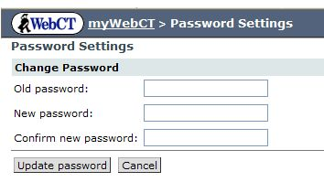
- Click the Log in button. The first time you log in, you will be prompted to change your password.

In the Old password field, type changeme

In the New password field, type a password you make up.

In the Confirm new password field, type this same new password.

Click the Update password button to continue.

- In the next screen, type in your WebCT ID and your new Password. Then click the Log in button.

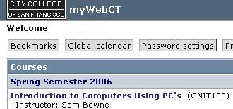
- A page appears with myWebCT and Welcome at the top, as shown to the right on this page. Click on the blue words Introduction to Computers Using PC's.

- Write your WebCT ID and Password below, just to make sure you remember it.

WebCT ID: _________________________________________________

Password: _________________________________________________


- You should see a screen with CNIT 100: Intro to Computers at the top. At the bottom of the screen there are two icons labeled Prep Tests and Online Textbook as shown to the right on this page. Click on Prep Tests.
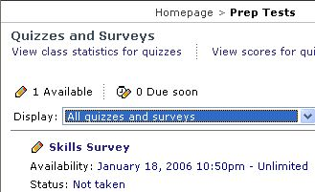
- In the next screen, you should see a Quizzes and Surveys section, with a Skills Survey below it, as shown to the right on this page. If you are just starting the course, click the blue Skills Survey link. When you return here after studying the book to take a Prep Test, click the appropriate Prep Test link.

- In the next screen, click the Begin Survey button.

- A pop-up window will open showing the survey. If you have a pop-up blocker on your browser, it will stop the survey from working. In that case, usually holding down the Ctrl key on the keyboard while clicking the Begin Survey button will solve the problem. Otherwise you need to disable your pop-up blocker, or add the CCSF online site to the allowed sites.

- Answer the questions on the survey. After each answer, click the Save Answer button, and then the Next Question button. After you have answered all the questions, click the Finish button.

Last modified 1-18-06

