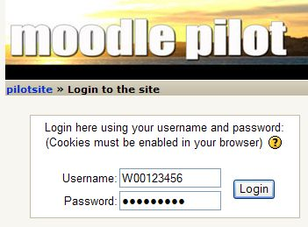
Logging in to iLearn

- Start Internet Explorer, Firefox, or any other browser. Type ilearn.sfsu.edu/pilot into the Address box. Press the Enter key to open moodle pilot as shown to the right on this page.

- Type your student ID into the WebCT ID box. Your Student ID is on your student ID card. If your student ID starts with @, use an X instead.

- Type this password into the Password box:

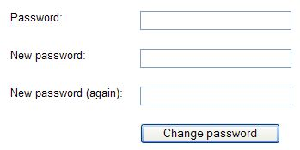
ilearn123

- Click the Log in button. The first time you log in, you will be prompted to change your password.

In the Old password field, type changeme

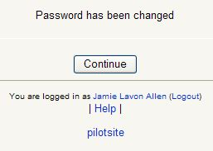
In the New password field, type a password you make up.

In the Confirm new password field, type this same new password.

Click the Change password button to continue.

- When you see the message Password has been changed, as shown to the right on this page, click the blue pilotsite link at the bottom of the screen.

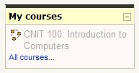

- A page appears with a My courses section at the upper left. Click on the gray CNIT 100: Introduction to Computers link.

- Write your iLearn ID and Password below, just to make sure you remember it.

WebCT ID: _________________________________________________

Password: _________________________________________________

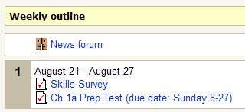
- You should see a screen with Weekly outline at the top. The Skills Survey and the Ch 1a Prep Test should be there as shown to the right on this page.

- Click on Skills Survey.

- On the Skills Survey page, click the Attempt quiz now button.

- In the next screen, answer all the questions. When you are donw, click the Submit all and finish button. A message box pops up saying you will not be able to change your answers. Click OK.

- A Review of Attempt 1 screen opens. For the survey, there are no right or wrong answers, so there’s no need to review them. When you take the prep tests you should use this screen to review the questions you got wrong. For the survey, just click the Continue button.

Last modified 8-218-06

