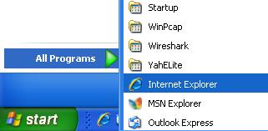
- Click Start, "All Programs", "Internet Explorer" to start Internet Explorer.

- At the top of the Internet Explorer window, click in the Address box. Type in yahoo.com and then press the Enter key to open the Yahoo! main page, as shown below on this page.

- On the right side of the Yahoo! Page, after the words "Free mail", click on the "Sign Up" link.
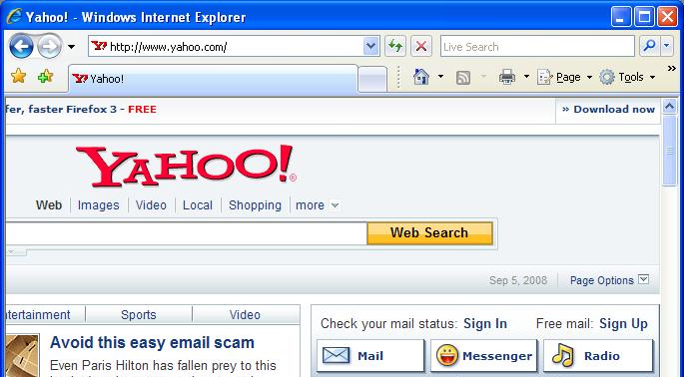
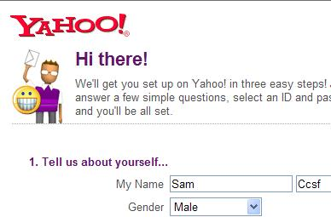

- Fill in this form. Don't give them your real last name. Make up a yahoo name and password. When you have the form filled out, click the "Create my Account" button at the bottom. If you make mistakes in the form, an error message will appear telling you what to correct.

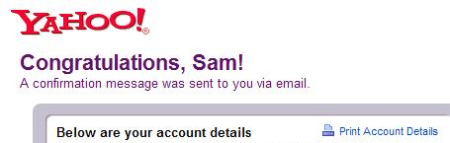
- When you see the Congratulations page, your email account is set up. Write down the account details so you don't forget them. Then click the Continue button.

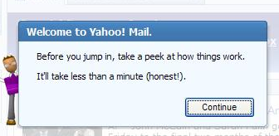
- You will see a "Welcome to Yahoo! Mail." Box. Follow the instructions on your screen to go through the introduction to Yahoo mail.

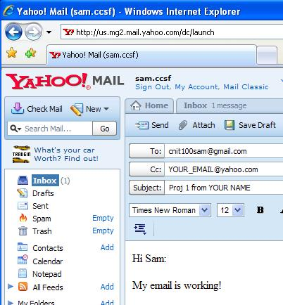
- On the top left of the Yahoo! MAIL window, click the New button. Compose an email to me as shown to the right on this page. Put your own email address in the Cc field, and put your real first and last name in the subject line. At the top left of the window, click the Send button.

- At the top of the window, click the blue "Sign Out" link.

Last modified 9-5-2008

