Finding an Image

- Click Start, "All Programs", "Internet Explorer" to start Internet Explorer.

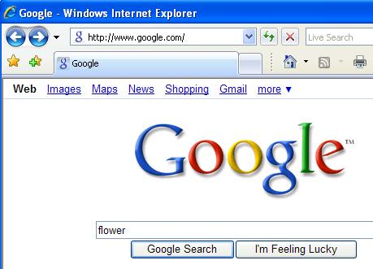
- At the top of the Internet Explorer window, click in the Address box. Type in google.com and then press the Enter key to open the Google page, as shown to the right on this page.

- In the upper left, click Images.

- In the box under the Google logo, type any word describing an image you'd like to find, such as flower. Click the "Google Search" button.

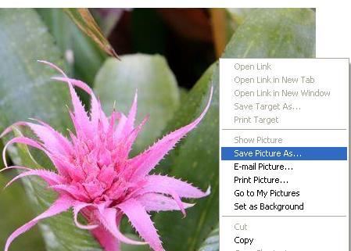
- A page of little images appears. Click one you like to see a full-size version.

Saving an Image

- When you find an image you like, point to it and right-click. A "context menu" pops up. Click "Save Picture As…".
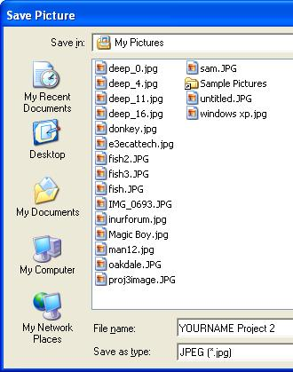
- A "Save Picture" box pops up. At the top of this window. the "Save in" box shows where the picture will be saved—the "My Pictures" folder.

- Near the bottom of this window, click in the "File name" box. Delete the original name, and enter a name of YOURNAME Project 2. Don't use the literal words "YOURNAME"—use your own name. Click the Save button.

Emailing an Image

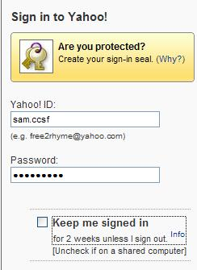
- At the top of the Internet Explorer window, click in the Address box. Type in yahoo.com and then press the Enter key to open the Yahoo! main page.

- On the right side of the Yahoo! Page, click the Mail button.

- A "Sign in to Yahoo!" box appears, as shown to the right on this page. Type in your Yahoo! ID and Password. Click on the "Keep me signed in" box to clear it. Click the "Sign In" button.

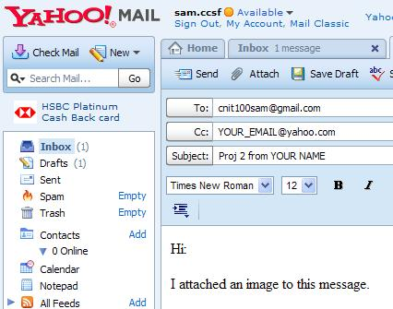
- On the top left of the Yahoo! MAIL window, click the New button. Compose an email to me as shown to the right on this page. Put your own email address in the Cc field, and put your real first and last name in the subject line.

- At the top middle of the window, click the Attach button.

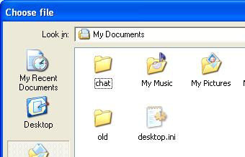

- A "Choose file" box opens, as shown to the right on this page. Point to the "My Pictures" folder and double-click to open it. Find the image with your name on it, and double-click it.

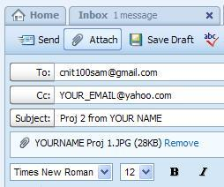

- The email message should now show a paper clip icon below the subject line, with the filename of the attached image, as shown to the right on this page.

- At the top left of the window, click the Send button.

- At the top of the window, click the blue "Sign Out" link.

Last modified 9-5-2008

