Downloading and Installing Avant
- Use your virtual PC.
- Start Internet Explorer and go to avantbrowser.com
- On the left of the window, click Download. On the right side, click Download Avant Browser.
- A c|net page opens. Click Download now.
- In the File Download – Security Warning box, click Run.
- In the Internet Explorer – Security Warning box, click Run.
- Accept the agreement and click through the installer, accepting all the default selections.
- Avant should open. If it does not, double-click the Mozilla Avant icon on the desktop.
- In the Avant Browser box, click No to not make Avant the default browser.
- In the Getting started box, click Next three times, accepting the default selections.
- Close the Most Useful Tips box.
Using Tabbed Browsing
- Avant can open many Web pages at once, using a technique called Tabbed Browsing.
- With Avant open, click File, New, Blank Page. A blank Web page opens. Type in yahoo.com and press the Enter key.
- Click File, New Blank Page, type in google.com and press the Enter key. You now have three Web pages open at once.
- You can control the Tab positions—click the Google tab at the bottom of the screen and drag it to the left so it becomes the first one, as shown below on this page.
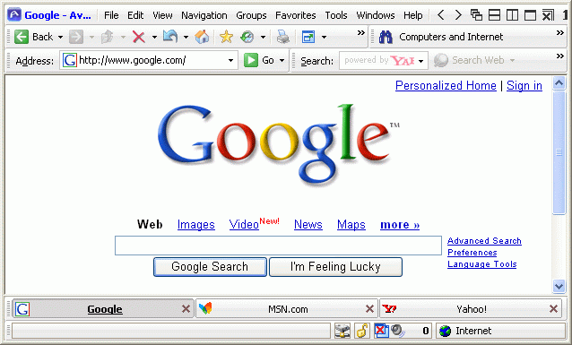

- Click the X button on the Google tab. Google closes, but the other two tabs are still open.
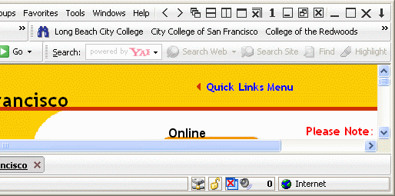
The Similar Websites Bar
- In Avant, go to www.ccsf.edu
- Look at the upper right portion of the window, and find lnks to other colleges such as Long Beach City College, as shown to the right on this page. This is the Similar Links Toolbar, showing pages like the one you are viewing.
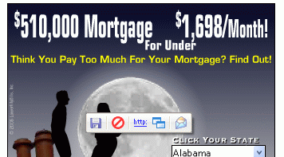
- Try another site, like sfgate.com and see if the similar sites bar is helpful. It might be most useful if you go to a site that specializes in one thing, like a site about music, or sports, or cars.
Blocking Ads
- In Avant, go to cnn.com
- Point to an ad and hold the mouse still for a few seconds. A toolbar pops up with a red circle-and-slash symbol, as shown to the right on this page. Click that symbol to block the ad.
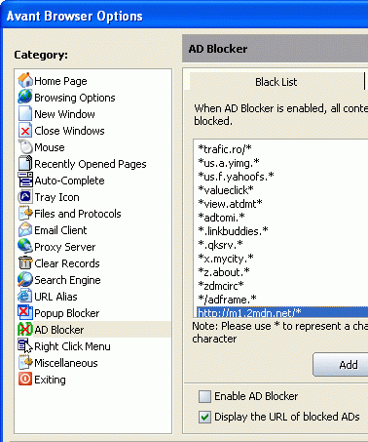
- In the Avant Browser box, click Yes.
- Look at the Avant Browser Options box, as shown to the right on this page. Avant already has a lot of known ad-servers blocked.
- Click OK to close the Avant Browser Options box.

Last modified 9-4-06

