Downloading and Installing Firefox
- Use your virtual PC.
- Start Internet Explorer and go to getfirefox.com
- Click the green Download Firefox button.
- In the File Download – Security Warning box, click Run.
- In the Internet Explorer – Security Warning box, click Run.
- A Firefox Setup box opens. Close Internet Explorer.
- In the box with the large heading Welcome to Mozilla Firefox appears, click Next.
- Accept the agreement and click through the installer, accepting all the default selections.
- Firefox should open. If it does not, double-click the Mozilla Firefox icon on the desktop.
- In the Import Wizard box, click Next.
- In the Home Page Selection box, click Next.
- In the Import Complete box, click Finish.
- Firefox opens. In the Default Browser box, click Yes to make Firefox the default browser. It is best to avoid using Internet Explorer as much as you can, because it is constantly attacked by spyware and other dangerous programs. Firefox is far safer to use on the Web.
Using Tabbed Browsing
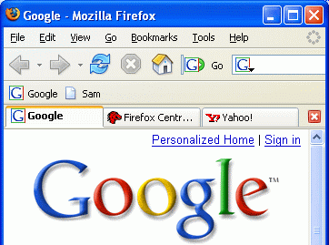
- Firefox can open many Web pages at once, using a technique called Tabbed Browsing.
- With Firefox open, click File, New Tab. A blank Web page opens. Type in yahoo.com and press the Enter key.
- Click File, New Tab, type in google.com and press the Enter key. You now have three Web pages open at once.
- You can control the Tab positions—click the Google tab and drag it to the left so it becomes the first one.
- Click the lower red X button to close the current tab. Google closes, but the other two tabs are still open.

Finding Extensions
- In Firefox, go to https://addons.mozilla.org
- In the Security Warning box, click OK.
- Click the green We Recommend… link, as shown to the right on this page.
Adding the Answers and StumbleUpon Extensions
- Find Answers in the next page and click the green Install Extension link. A Software Installation box opens. Wait three seconds, and click the Install Now button.
- An Extensions box appears showing that Answers will be installed when Firefox is restarted.
- Click in the Web page showing recommended extensions to make it the active window. Scroll down and find StumbleUpon. Click the green Install Extension link. A Software Installation box opens. Wait four seconds, and click the Install Now button.
- An Extensions box appears showing that Answers will be installed when Firefox is restarted.
- Close all open windows, including Firefox. Start Firefox by double-clicking its icon on the desktop.
Using StumbleUpon
- In the upper left of the screen, click the Start Stumbling tool.
- In the Welcome to StumbleUpon box, click Create Account.
- A StumbleUpon web page appears. Fill in the boxes. To add a picture, use any picture you like. If you don’t care, just click the Browse button and open the My Documents folder, open the My Pictures folder, and open the Sample Pictures folder. Double-click a picture in there.
- Look through the boxes at the bottom and select several that interest you. Don’t just pick random ones – choose ones that really interest you if possible. Then scroll to the bottom and click the yellow Create My Account button.
- In the Security Warning box, click Continue.
- There is now a Stumble! Button at the upper left of your browser window. Click it to see a random Website recommended by other browsers. Try several of them and see how it works. StumbleUpon is a good way to find Web sites you would never have noticed otherwise.
Using Answers
- Open a Web page with some text in it. Right-click a word on the page and select Look up on Answers.com. A page opens telling you about the word. This might be useful to explain unfamiliar terms.
- To test it, go to slashdot.org and find an unfamiliar term – there should be plenty of them! Use Answers and see if it can explain the term easily.
Adding Qute and infoRSS
- In Firefox, go to https://addons.mozilla.org
- If a Security Warning box opens, click OK.
- Type Qute in the Search box and click Go. Scroll down and find Qute 3.1. Click the blue Qute 3.1 link.
- Click the green Install now link. In the Confirm box, click OK.
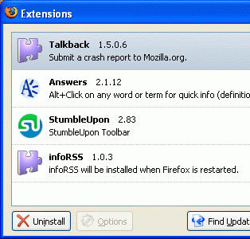
- In the Themes box, click Qute. Click the Use Theme button. Close the Themes box.
- Type RSS in the Search box and click Go. Scroll down to find infoRSS 1.0.3 and click it.
- Scroll down and click the green Install now link.
- In the Software Installation box, click Install Now. Wait until the progress bar moves all the way and you see the message infoRSS will be installed with Firefox is restarted as shown to the right on this page.
- Close all open windows, including Firefox. Start Firefox by double-clicking its icon on the desktop.
- A Welcome to InfoRSS box appears. Click OK.
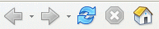
Observing the Qute Theme
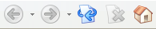
- Look at the toolbar buttons. The original appearance is shown on the top at the right on this page, and the Qute buttons are shown below.

Observing the RSS feed scrollbar
- Look at the lower right portion of the screen. News items should start scrolling by, as shown below on this page. Pick one and point to it – the scroll stops. Click on it to open the news item. This is a handy way to stay informed.

Last modified 9-4-06

