Search Expressions in Google

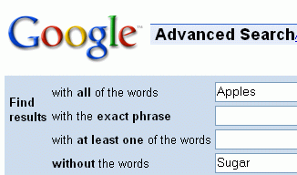
- Open a browser and go to google.com
- On the right side of the page, click the Advanced Search link. The Google Advanced Search page opens, as shown to the right on this page.
- In the with all of the words box, enter Apples
- In the without the words box, enter Sugar


- Click the Google Search button.
- The main Google page appears, as shown to the right on this page. The query box shows the query you need to do that search:

Apples –sugar

- Google uses the minus sign as a Search Operator to remove a word from the search. The Advanced Search page is just a convenient way to use the search operators. Once you learn the operators, you can just type them into the Google main search box to control your searches.
- Use the Advanced Search page to find these three things, and make a note of the search expression with search operators that are required.

- A review comparing various models of cell phones written within the last 3 months

- A list of final exam dates for this semester (Fall 2006) in the ccsf.edu domain

- Pages about City College of San Francisco with those five words in exactly that order.

- Give the Presenter a list of the search expressions required to do these tasks.
Search Expressions in Altavista

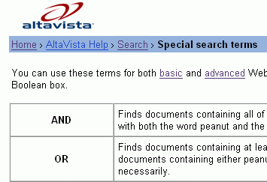
- Open a browser and go to altavista.com
- Click on the tiny blue word Help in the lower right.
- In the next screen, click on Search.
- In the next page, in the AltaVista Features section, click on Special Search Terms. You should see the Special Search Terms page shown to the right on this page.
- Read this information and plan queries to find each of these things:

- A review comparing various models of cell phones written within the last 3 months

- A list of final exam dates for this semester (Fall 2006) in the ccsf.edu domain

- Pages about City College of San Francisco with those five words in exactly that order.

- Use this information to plan your queries, and return to altavista.com to test them. Make sure they find what you are looking for.

- Give the Presenter a list of the search expressions or techniques required to do these tasks.
Search Expressions in Ask
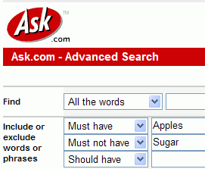
- Open a browser and go to ask.com
- In the upper right, find the Search Tools box. In the lower right of the Search Tools box, click Next.
- Click Advanced Search.
- The Ask Advanced Search page opens, as shown to the right on this page.
- In the Must have box, enter Apples
- In the Must not have box, enter Sugar
- Click the Search button.

- The main Ask page appears, as shown to the right on this page. The query box shows the query you need to do that search:

+Apples –Sugar

- Ask uses the minus sign as a Search Operator to remove a word from the search. The Advanced Search page is just a convenient way to use the search operators. Once you learn the operators, you can just type them into the Ask main search box to control your searches.
- Use the Advanced Search page to find these three things, and make a note of the search expression with search operators that are required.

- A review comparing various models of cell phones written within the last 3 months

- A list of final exam dates for this semester (Fall 2006) in the ccsf.edu domain

- Pages about City College of San Francisco with those five words in exactly that order.

- Give the Presenter a list of the search expressions or techniques required to do these tasks.

