Email and Cookies: Internet Explorer
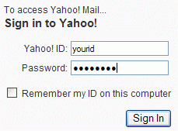
Reading your Yahoo Mail
- Open Internet Explorer and go to yahoo.com
- In the upper left of the Yahoo! page, click My Mail.
- Type in your Yahoo ID and Password, as shown to the right on this page, and click the Sign In button.
- In the Yahoo! Mail page, click Inbox. A list of your Email messages appears.
Navigating Away from Yahoo
- At the top of the Internet Explorer window, type in the address www.ccsf.edu and press Enter.
- The CCSF home page opens. You are not using Yahoo any more. You might easily think it’s OK to just walk away from the machine now and let someone else use it, but it’s NOT OK – try this!
- At the top of the Internet Explorer window, type in the address yahoo.com and press Enter.
- In the upper left of the Yahoo! page, click My Mail.
- In the Yahoo! Mail page, click Inbox. A list of your Email messages appears. This is a very common way that strangers get into your Yahoo account!
- Navigating Away from Yahoo Does Not Make Yahoo Forget Who You Are! This is an important fact, and many people don’t understand it.
Logging Out of Yahoo
- At the top left of the Yahoo! Mail page, click Sign Out.
- At the top of the Internet Explorer window, type in the address yahoo.com and press Enter.
- In the upper left of the Yahoo! page, click My Mail.
- You don’t see your mail anymore. Instead, you are asked for your Yahoo! ID and Password. This is the way to keep your email private.
- Always Sign Out from Yahoo to Keep Your Email Private!
Closing Internet Explorer
- Sign in with your Yahoo ID and Password.
- In the Yahoo! Mail page, click Inbox. A list of your Email messages appears.
- Close Internet Explorer by clicking on the red X in the upper right of the window.
- Open Internet Explorer and go to yahoo.com
- In the upper left of the Yahoo! page, click My Mail.
- You don’t see your email – instead you are asked for a name and password. So closing your browser logged you out. protecting your privacy.
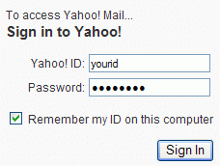
“Remember my ID on this computer”
- Type in your Yahoo ID and Password. Check the box labeled Remember my ID on this computer, as shown to the right on this page. Click Sign In.
- In the Yahoo! Mail page, click Inbox. A list of your Email messages appears.
- Close Internet Explorer by clicking on the red X in the upper right of the window.
- Open Internet Explorer and go to yahoo.com
- In the upper left of the Yahoo! page, click My Mail.
- In the Yahoo! Mail page, click Inbox. A list of your Email messages appears.
- Closing the browser no longer logs you out of Yahoo!
Turning Your Computer Off
- Click Start, Turn Off. In the What do you want the computer to do box, select Shut Down. Click the OK button. Wait until the computer’s front panel lights go out.
- Press the power button and start your computer up again. Log in as usual with the user ID ccsf and no password.
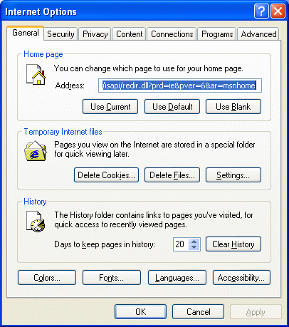
- Open Internet Explorer and go to yahoo.com
- In the upper left of the Yahoo! page, click My Mail.
- In the Yahoo! Mail page, click Inbox. A list of your Email messages appears.
- Even turning the computer off no longer logs you out of Yahoo! Think how easy it would be for another student to get into your account this way!
Deleting Cookies
- From the Internet Explorer menu at the top of the window, click Tools, Internet Options.
- An Internet Options box opens, as shown to the right on this page. In the center of this box, click the Delete Cookies… button.
- In the Delete Cookies box, click OK.
- In Internet Options box, click OK.

- At the top of the Internet Explorer window, type in the address yahoo.com and press Enter.
- In the upper left of the Yahoo! page, click My Mail.
- You are asked to Sign In again.
- Deleting Cookies Protected Your Privacy.

Last updated 9-6-06

