Using Gmail
Starting GMail

If you have a GMail account already, you can use it. If you don’t, use the account described below.

Open a browser and go to gmail.com. Log in with a Username of cnit.100demo and a Password of ccsfpassword

The GMail inbox screen opens as shown below:
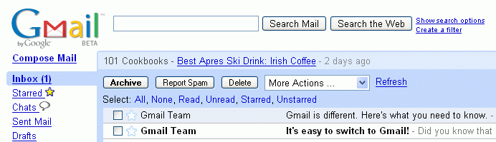

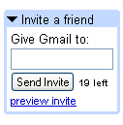
Inviting a New Person to Use GMail

Look in the lower left of the Gmail window for the Invite a friend box, as shown to the right on this page. Type in the New Gmail User’s Yahoo email address and click the Send Invite button.

The Gmail Tour
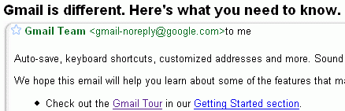
Click on the message that begins “Gmail is different. Here’s what you need to know”
The message opens as shown to the right on this page. Click the Gmail Tour link.

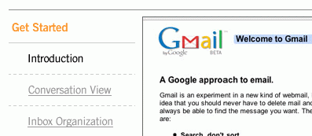

On the left side, click Get Started and then click Introduction. Watch the Introduction and Conversation View portions of the tutorial. Then close the Gmail Tour window.
Creating a Conversation

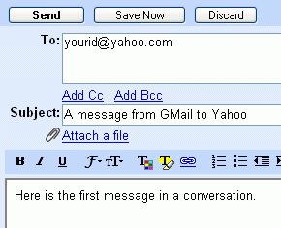
In the Gmail window, click the Compose Message link and send a message to the Yahoo Mail User. The message can have any subject and body, but don’t leave them blank.

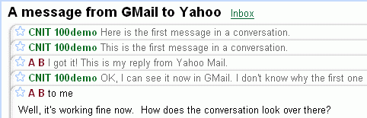
When the Yahoo User replies to your message, reply back. Get a series of 3 or 4 messages back and forth in your conversation, so you can see it as shown to the right. This is called Conversation View.

Your Presenter will need to demonstrate Conversation View to the class.

Last updated 9-6-06

