New Gmail User
Wait for Your Invitation

Give the GMail User your Yahoo email account. You can use any email service you like, such as aol or hoitmail, too. Wait until the GMail User has sent you an invitation to GMail.

Read your Yahoo email. Look for a message saying CNIT 100 has invited you to open a Google mail account. If you don’t see it, check the Bulk Mail and Trash folders. You may need to adjust your spam filter settings and ask the GMail User to send another invitation. If you can’t get the message, try using Yahoo mail and looking in the Bulk Mail folder—that usually works.

Follow the instructions in that message to get your own GMail account.

The GMail inbox screen opens as shown below:
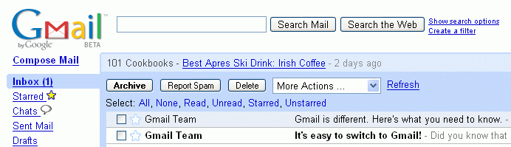

The Gmail Tour
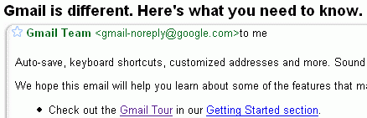
Click on the message that begins “Gmail is different. Here’s what you need to know”
The message opens as shown to the right on this page. Click the Gmail Tour link.

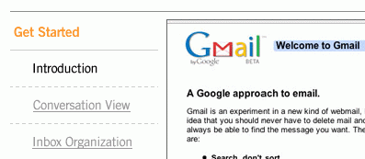

On the left side, click Get Started and then click Introduction. Watch the Introduction and Conversation View portions of the tutorial. Then close the Gmail Tour window.
Creating a Conversation

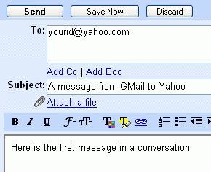
In the Gmail window, click the Compose Message link and send a message to the Yahoo Mail User. The message can have any subject and body, but don’t leave them blank.

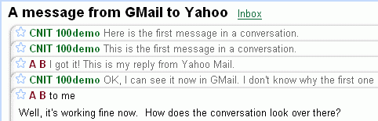
When the Yahoo User replies to your message, reply back. Get a series of 3 or 4 messages back and forth in your conversation, so you can see it as shown to the right. This is called Conversation View.

Your Presenter will need to demonstrate Conversation View to the class.

Last updated 9-6-06

