Two group members should do this process, so you have two hushmail accounts to use!

Creating a Hushmail Account


Open a browser and go to hushmail.com

On the left, click Sign up for free email

On the page titled New Secure Email Account, answer all the questions. Click the Create button at the bottom of the page.

When you see the message Congratulations, your secure email account has been created!¸click the click here link.

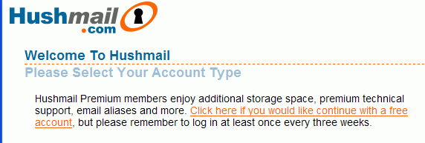
You should see a page titled Welcome to Hushmail as shown below on this page. Click the orange words Click here if you would like continue with a free account.

Enter your passphrase and click the Authenticate button.

Your Hushmail e-mail window opens as shown below on this page. Click the Welcome to Hushmail! subject and read the message.
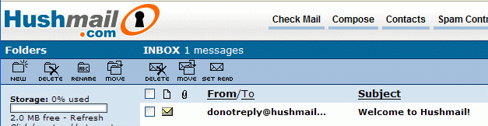

Sending From Hushmail to Yahoo

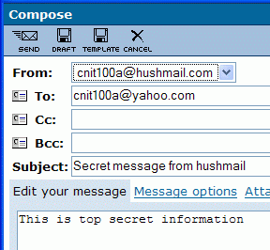
In the Hushmail window, at the top center, click Compose. Compose a message to your own Yahoo account, as shown to the right on this page. Don’t send it to cnit100a@yahoo.com, but send it to your own Yahoo account. Use a subject of Secret message from hushmail.

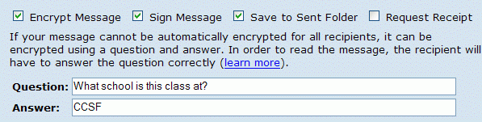
In the upper left of the Compose window, click the SEND button. Hushmail asks you to enter a Question and Answer to secure your message. Enter any question and answer you can remember, as shown below on this page. Then click the SEND button again.

Open another browser window and go to yahoo.com. Read your email. You should see the message with a subject of Secret message from hushmail. Open that message.

To read the message, click on the hushmail link that appears.

Type in the wrong answer and click Continue. It doesn’t work, and you only have 4 tries remaining.

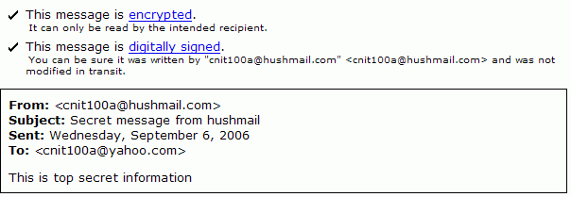
Type in the correct answer and click Continue. The message appears, as shown below. Notice that the message is encrypted and digitally signed. Read the explanation of those terms.

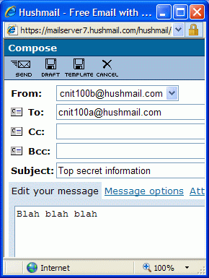
Sending From Hushmail to Hushmail

In the Hushmail window, at the top center, click Compose. Compose a message to the other member of your group who has also made a Hushmail account, as shown to the right on this page. Don’t send it to cnit100a@yahoo.com, but send it to another member of your group. Use a subject of Top Secret Information.

In the upper left of the Compose window, click the SEND button. Hushmail sends the message without asking you for a question.

Get the recipient of the message to click Check Mail ti see the newly arrived Hushmail. Read the message.

Last modified 9-6-06

