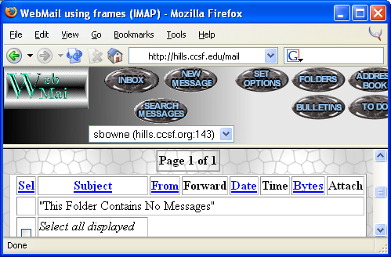
Start a browser and go to hills.ccsf.edu/mail

Enter your HP-UNIX ID and password. Your HP-UNIX ID is the same ID you use in the Batmale 301 computer lab, something like

ssmith01

The password is your birthday in this format:

jan1578

The first time you log in, you will see a configuration page – just accept the defaults and go on to the WebMail page shown to the right on this page.

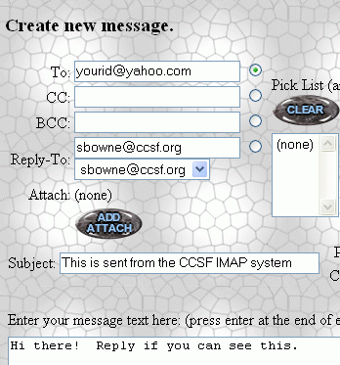

Click the New Message button and compose a message to the Yahoo User as shown to the right on this page. Click the Send Message button to send it.

When the Yahoo User replies to your message, reply to the reply.

Show the Report Writer the exact steps you use to reply to a message.

Last modified 9-6-06

