Google Spreadsheet User
- You should have a GMail account. If you don’t, ask your instructor to invite you to join GMail and follow the instructions in your invitation email to get one.
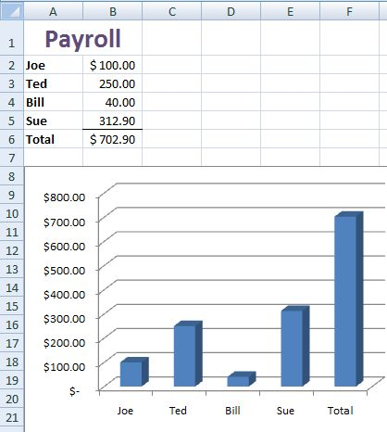
- Open a browser and go to google.com
- Click the more >> link
- Click the even more >> link
- In the Explore and innovate section, click Labs
- Click Google Spreadsheets
- Attempt to make a simple spreadsheet with a chart, as shown to the right on this page. Note: I made that spreadsheet with Excel 2007, so you won’t be able to exactly duplicate it.
- If you have any problems, try to use whatever help menus you can find to help you. You may not be able to make the chart at all.
- Click the Save button. Where is your spreadsheet saved?
- Click the Show sharing options link. Share your spreadsheet with the other Google Spreadsheet User.
- Describe your experiences to the Report Writer.
Google Spreadsheet User
- You should have a GMail account. If you don’t, ask your instructor to invite you to join GMail and follow the instructions in your invitation email to get one.
- Open a browser and go to google.com
- Click the more >> link
- Click the even more >> link
- In the Explore and innovate section, click Labs
- Click Google Spreadsheets
- Attempt to make a simple spreadsheet with a chart, as shown to the right on this page. Note: I made that spreadsheet with Excel 2007, so you won’t be able to exactly duplicate it.
- If you have any problems, try to use whatever help menus you can find to help you. You may not be able to make the chart at all.
- Click the Save button. Where is your spreadsheet saved?
- Click the Show sharing options link. Share your spreadsheet with the other Google Spreadsheet User.
- Describe your experiences to the Report Writer.

Excel User

Use Excel and make a simple spreadsheet with a chart, as shown to the right on this page. Note: I made that spreadsheet with Excel 2007, so you won’t be able to exactly duplicate it.

If you have any problems, try to use whatever help menus you can find to help you.

Describe your experiences to the Report Writer.

