Getting an Image to Work With
- Open Internet Explorer. Go to google.com. Click the images tab. Enter a topic and press the Enter key to find images. Pick an image you might want to modify, either by adding something to it or erasing something. When you see an image you like, right-click on it and select Save Picture As…. Save the image on your desktop or some other folder you can find.
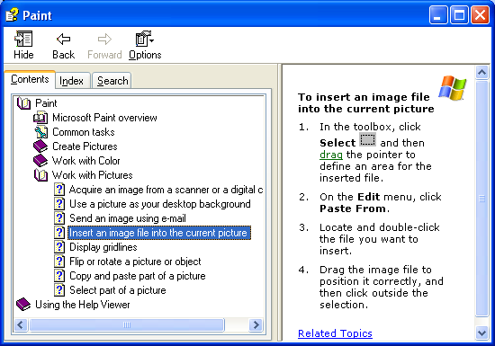
Using Paint
- Click Start, All Programs, Accessories, Paint.
- When Paint opens, click Help, Help Topics. Expand Paint in the left pane, and then expand Work with Pictures and click on Insert an image file into the current picture, as shown to the right on this page.
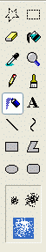
- Follow the instructions to insert the picture into the Paint window.
Pencil
Airbrush
Brush
Brush
Sizes
- Try to paint something on the image that looks good – it’s harder than it looks! Here are some useful Paint tips.
- Choose a color by clicking on the palette at the bottom of the window.
- Draw thin lines with the Pencil
- Use the Airbrush to speckle color on. After clicking on the Airbrush tool, choose a Brush Size in the lower area.
- Use the Brush tool for painting solid shapes. After clicking on the Brush tool, choose a brush size and shape in the lower area.
- When you get a picture that looks as good as you can get it, save it on a floppy disk so the Presenter can demonstrate it.
Getting an Image to Work With
- Open Internet Explorer. Go to google.com. Click the images tab. Enter a topic and press the Enter key to find images. Pick an image you might want to modify, either by adding something to it or erasing something. When you see an image you like, right-click on it and select Save Picture As…. Save the image on your desktop or some other folder you can find.
Downloading and Installing IRFANVIEW
- Open Internet Explorer. Go to irfanview.com. Click the download link.
- In the next screen, click the Tucows Worldwide Network - Download IrfanView link.
- A new window opens with a tucows banner. Click the DOWNLOAD NOW link.
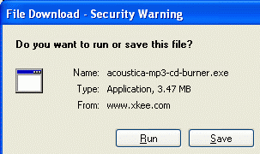
- The next page asks you to choose a download location. Scroll down to find USA and click on it. Click on any location in the list that appears – use one in California if possible. When downloading files, it’s faster, more reliable, and cheaper for the server operators if you use a nearby location.
- A File Download – Security Warning box opens, as shown to the right on this page. Click Run.
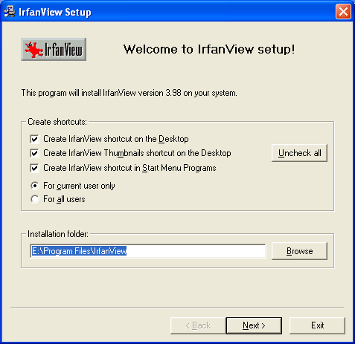
- In the Internet Explorer – Security Warning box, click Run.
- .An Irfanview Setup box opens, as shown to the right on this page. Click Next.
- Click Next through the next two windows.
- When you see a window titled Free! Google Desktop Search, click the Don’t install Google Desktop Search radio button and click Next.
- In the Ready to Install box, click Next.
- In the Installation Successful box, click Done.

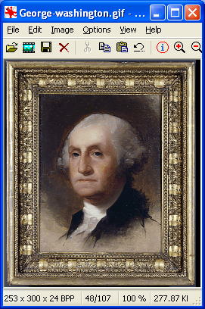
Using Irfanview to Open an Image
- Irfanview should have opened automatically. In the Irfanview window, click File, Open. Find the image you saved earlier and double-click it. Your image should open in Irfanview, as shown to the right on this page.
Using Irfanview to Adjust Colors
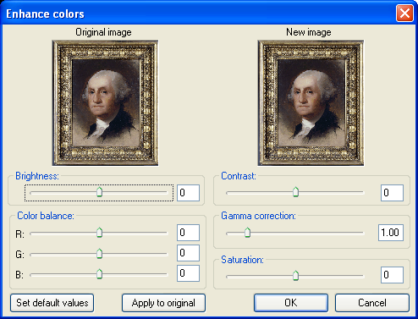
- In the Irfanview window, click Image, Convert to Grayscale. The image should change to black-and-white. To return to normal, click Edit, Undo.
- In the Irfanview window, click Image, Enhance Colors. An Enhance colors box opens, as shown below on this page. Play with these controls to see what they do to the image. When you have an image you like, click Apply to original and save the image with a different file name, so you have both the original and the modified image.
Using Irfanview Effects
- In the Irfanview window, click Image, and then point to Effects. Several effects are available, including Edge Detection and Explosion. Try using several effects and find one you like. Save the modified image with a different file name
Saving the Images on a Floppy Disk
- Put the original image and the modified images on a floppy disk. Explain to the Report Writer what you did to create these images.

