Setting Up the Microphone
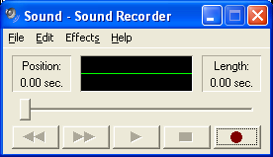
- Plug in the headphones provided by your instructor. There are two plugs – one for the speakers, and one for the microphone. They should plug into corresponding ports on the back of your computer.
Record
Stop
Play
- Click Start, All Programs, Accessories, Entertainment, Sound Recorder.
- Sound Recorder opens as shown to the right on this page. Click the Record button and talk into the microphone. You should see the green line get wavy as the sound is detected. If you don’t see any change in the line, something is wrong. Here are some things to try:
  - Make sure the microphone plug is in the correct port – if you can’t find clear labels, just try all three ports to see if any of them work
  - In Sound Recorder, click Edit, Audio Properties. In the Recording section, try adjusting the options. Click the Volume button, and on the Volume box, click Edit, Advanced Controls. Then click the Advanced button to reach controls that you can try adjusting.
  - If you can’t get the microphone to work, ask your instructor, and/or try a different machine.
- After you get the microphone working, click the Stop button to stop recording. Click the Play button to hear the recording. You may have to adjust the plugs or audio properties to make the sound audible.
Recording a WAV File with Sound Recorder
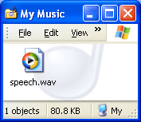
- Once the microphone and speakers are working, click File, New. In the Sound Recorder box, click No.
- Click the Record button and record some speech. Click the Stop button to stop recording.
- Click File, Save As… and save your recording in the My Music folder. Give it any name you like.
- Click Start, My Music. Your file should be there, as shown to the right on this page. Double-click the file. Windows Media Player should open and play your recording.
Converting a WAV File to an MP3 File with Sound Recorder
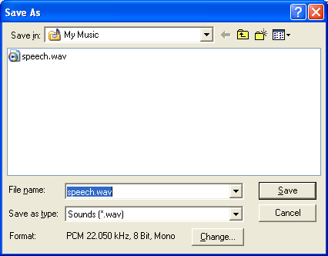
- In Sound Recorder, click File, Save As…. In the Save As box, click the Change button at the bottom, as shown to the right on this page.
Change

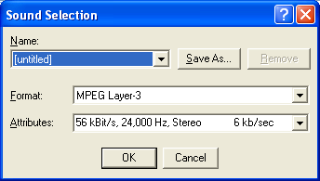
- In the Sound Selection box, select a Format of MPEG Layer 3 and Attributes of 56 kBit/s, 24,000 Hz, Stereo as shown to the right on this page. Click OK.
- In the Save As box, change the filename extension from .wav to .mp3 and click the Save button.

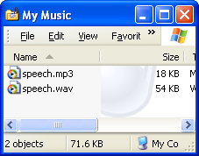
- The My Music folder should now contain two files, as shown to the right on this page. Click them both and make sure they both play. Click View, Details to see the file sizes – the MP3 file should be much smaller. Does it sound worse? Can you hear any difference?
- Save the files on a floppy disk and explain what they are to the Report Writer.

