Only the Teamspace Group Creator should do this part.

Creating a Team

- Open Internet Explorer and go to teamspace.com. Click the Free Trial! button.

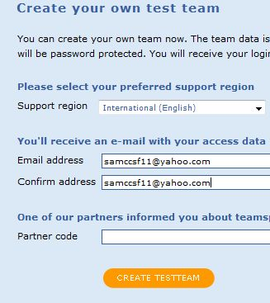
- In the next screen, in the Free Evaluation Team section, click the Create Test Team button.
- In the next screen, select a Support Region of International (English) and enter your email address in both boxes, as shown to the right on this page. Click the CREATE TESTTEAM button.
- Check your email. You should have a message with the subject Welcome to your teamspace team. Open it and click the login link in it.
- A browser should open with a Your personal settings page. Click the Continue button.
- The next page gives you a chance to change your password. Leave the New password and Repeat new password fields blank. Type your name into the Displayed name box and click the Submit button.
- In the Setup your team screen, click the Continue button.

- In the next screen, enter a Team name and click the Continue button.
- In the Modules screen, click the Continue button.
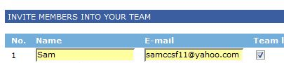
- In the next screen, enter your own name and email address and check your name as the Team Leader. Click the Continue button.
- In the next screen, check the box to accept the Terms and Conditions and click the Continue button.
- In the next screen, check the Admin box in the upper right of the screen.
- In the Team Administration screen, in the center section, click the Add a new member link, as shown below.
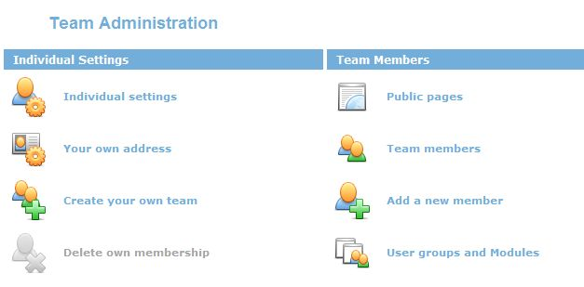

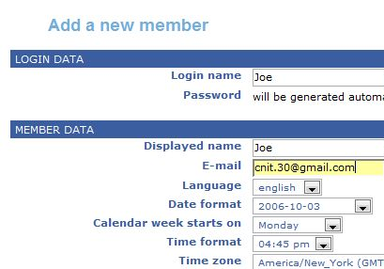
- In the Add a new member box, enter a name for one of your group members and that person’s email address, and click the Add member button.
- Continue adding group members in this manner until All the Teamspace Users are in your Team.

Every Group Member should do this part
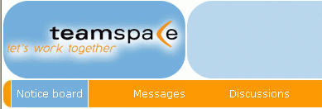
- Check your email. You should have a message with the subject Welcome to team. Open it and click the login link in it.
- Teamspace has several sections, as shown on the yellow bar near the top, labeled Notice board, Messages, Discussions, Creativity, Tasks, etc.
Using the Notice Board
- Click Notice Board section and try to add a New Notice. When some other members of your team have posted Notices, read them here and see how they work.
Sending Messages
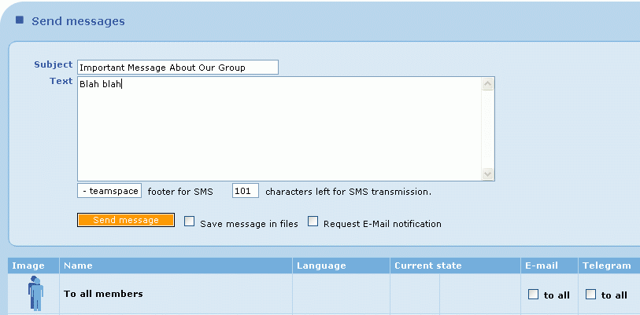
- Click Messages in the top yellow bar. Find another member of your group, and put a check mark in the Telegram section of their line. Then type a message into the box at the top and click Send message. Go look at their screen to see what a Telegram looks like.

Other Tasks
- If time permits, try using the Discussion feature to post a new thread of connected messages, and the Files section to upload a file.
- Explain to the Report Writer what you have done, and what you think of this software. Do you think people could use this to work together on a project?
Last modified 10-2-06

Every Group Member should do this part
- Check your email. You should have a message with the subject Welcome to team. Open it and click the login link in it.
- Teamspace has several sections, as shown on the yellow bar near the top, labeled Notice board, Messages, Discussions, Creativity, Tasks, etc.
Using the Notice Board
- Click Notice Board section and try to add a New Notice. When some other members of your team have posted Notices, read them here and see how they work.
Sending Messages
- Click Messages in the top yellow bar. Find another member of your group, and put a check mark in the Telegram section of their line. Then type a message into the box at the top and click Send message. Go look at their screen to see what a Telegram looks like.

Other Tasks
- If time permits, try using the Discussion feature to post a new thread of connected messages, and the Files section to upload a file.
- Explain to the Report Writer what you have done, and what you think of this software. Do you think people could use this to work together on a project?

Every Group Member should do this part
- Check your email. You should have a message with the subject Welcome to team. Open it and click the login link in it.
- Teamspace has several sections, as shown on the yellow bar near the top, labeled Notice board, Messages, Discussions, Creativity, Tasks, etc.
Using the Notice Board
- Click Notice Board section and try to add a New Notice. When some other members of your team have posted Notices, read them here and see how they work.
Sending Messages
- Click Messages in the top yellow bar. Find another member of your group, and put a check mark in the Telegram section of their line. Then type a message into the box at the top and click Send message. Go look at their screen to see what a Telegram looks like.

Other Tasks
- If time permits, try using the Discussion feature to post a new thread of connected messages, and the Files section to upload a file.
- Explain to the Report Writer what you have done, and what you think of this software. Do you think people could use this to work together on a project?

Every Group Member should do this part
- Check your email. You should have a message with the subject Welcome to team. Open it and click the login link in it.
- Teamspace has several sections, as shown on the yellow bar near the top, labeled Notice board, Messages, Discussions, Creativity, Tasks, etc.
Using the Notice Board
- Click Notice Board section and try to add a New Notice. When some other members of your team have posted Notices, read them here and see how they work.
Sending Messages
- Click Messages in the top yellow bar. Find another member of your group, and put a check mark in the Telegram section of their line. Then type a message into the box at the top and click Send message. Go look at their screen to see what a Telegram looks like.

Other Tasks
- If time permits, try using the Discussion feature to post a new thread of connected messages, and the Files section to upload a file.
- Explain to the Report Writer what you have done, and what you think of this software. Do you think people could use this to work together on a project?

