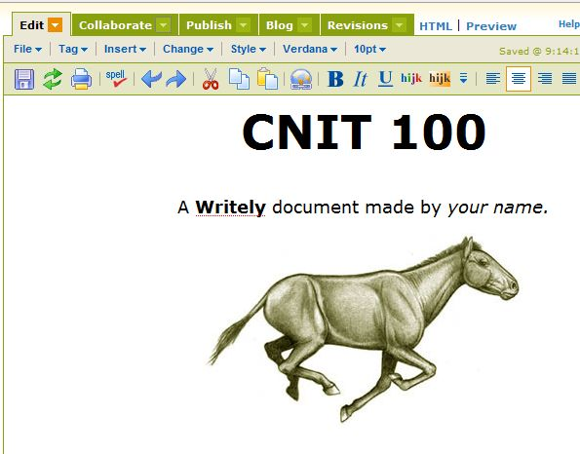
Creating a Document
- You should have a GMail account. If you don’t, ask your instructor to invite you to join GMail and follow the instructions in your invitation email to get one.
- Open a browser and go to writely.com
- Sign in with your GMail account name and password.
- Click the New link in the upper left of the screen.
- In the New Document box, click OK.
- Attempt to make a simple document with an image, as shown to the right on this page. Use a different image, one that you like. You will first have to find an image on the Web and save it on your computer.
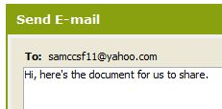
- Click the Save button (it looks like a floppy disk).
Sharing a Document
- Click the drop-down arrow next to the word Collaborate, and click Invide others to edit this document. Enter the Gmail addresses of the other Writely Users. Click OK. A box opens saying E-mail the new collaborators? Click OK.
- In the Send E-mail box, type in a short message as shown to the right on this page, and click OK.
- Check your Email. When the other Writely users get to this point, you will be invited to share their documents. Edit the shared document so they have your name inthemit as well as the names of the other group members.
- Describe your experiences to the Report Writer.

