Starting VMWare Workstation
- Double-click the VMWare Workstation icon on the desktop. In the VMWare Workstation window, click Start this virtual machine.
Ensuring that File Extensions are not Hidden
- Open My Computer. Click Tools, Folder Options. In the Folder Options box, click the View tab. Scroll down to find the Hide extensions for known file types box and make sure it is not checked. Click OK to close the Folder Options box. Close My Computer.
Downloading BigFile.txt
- Open Internet Explorer and go to my Web page samsclass.info. Click the CNIT 100: Intro to Computers link. Click the Handouts link.
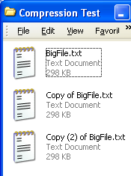
- Under the Ch 3d line, right-click Download BigFile.txt and select Save Target As…. Save the file on your desktop. Close Internet Explorer.
- Right-click the desktop and select New, Folder. Name the new folder Compression Test. Double-click the Comp Compression Test folder to open it, and resize it so you can see the BigFile.txt file on your desktop.
- Drag the BigFile.txt file into the Compression Test folder.
- The BigTile.txt file should be highlighted. If it is not, click it once to highlight it.
- Press Ctrl+C on the keyboard to copy the file, and Ctrl+V to paste it. Press Ctrl+V to paste it again. You should now see three files in the Compression Test folder as shown to the right on this page.
- Right-click the BigFile.txt icon and select Properties from the context menu. There are two values shown: Size: is the actual number of bytes of data in the file, and Size on disk: is the amount of disk space required to store the file. The size on disk is usually larger than the Size because of cluster overhang – wasted space on the disk. Write down both sizes in the box to the right on this page.

BigFile.txt

Size: ______________________________

Size on disk: ______________________________
- Close the BigFile.txt Properties box.
Using NTFS Compression
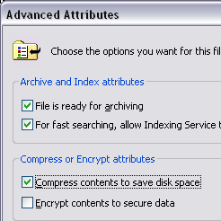
- Right-click the Copy of BigFile.txt icon and select Rename. Rename the file Compressed BigFile.txt
- Right-click the Compressed BigFile.txt file and select Properties.
- In the Compressed BigFile.txt Properties box, on the General tab, click the Advanced button.
- In the Advanced Attributes box, click the Compress contents to save disk space box, as shown to the right on this page. Click OK.
- Click OK to close the Compressed BigFile.txt Properties box.
- Notice that the filename has turned blue. That’s how Windows XP indicates that a file is compressed with NTFS compression.

- Right-click the Compressed BigFile.txt icon and select Properties. Record the Size: and the Size on disk: values in the box to the right on this page.

Compressed BigFile.txt

Size: ______________________________

Size on disk: ______________________________
- Click OK to close the Compressed BigFile.txt Properties window.
- Double-click the BigFile.txt icon. The file opens in Notepad. Close Notepad.
- Double-click the Compressed BigFile.txt icon. The file opens. Your machine has to uncompress it to make it readable by Notepad, but the time that takes is not noticeable. Close Notepad.
Using Zip Compression
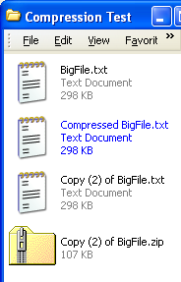
- In the Compression Test window, right-click the Copy (2) of BigFile.txt file and select Send to, Compressed (zipped) Folder. A zipped folder appears, as shown to the left on this page.
- Right-click the Copy (2) of BigFile.zip folder and select Properties. Record the Size: and the Size on disk: values in the box to the right on this page.

Zipped Folder

Size: ______________________________

Size on disk: ______________________________

- Close the Copy (2) of BigFile.zip Properties box.
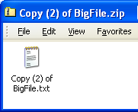
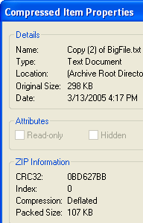
- Double-click the Copy (2) of BigFile.zip folder. The file does not open in Notepad– it opens like a folder. Inside the folder is Copy (2) of BigFile.txt file, as shown to the right on this page. Note the tiny folder icon with a zipper in the upper-left corner of the window – this is your only indication that you are looking inside a zipped file, not in a normal folder.
- In the Copy (2) of BigFile.zip window, right-click the Copy (2) of BigFile.txt icon and select Properties. A Compressed Item Properties window opens, as shown to the left on this page. Find the Original Size and the Packed size and write them in the box below.
- Click OK to close the Compressed Item Properties window.

Compressed Item

Original Size: ______________________________

Packed size: ______________________________

Password-Protected Zip Compression
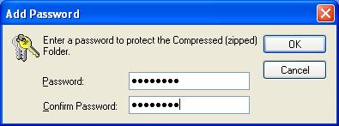
- In the Copy (2) of BigFile.zip folder, click the Copy (2) of BigFile.txt icon to select it. From the menu bar, select File, Add a Password.
- In the Add Password box, enter Password in both boxes, as shown in the figure to the right on this page. Click OK.
- Close the Copy (2) of BigFile.zip window.
- Double-click the Compression Test folder to open it.
- Double-click the Copy (2) of BigFile.zip compressed folder to open it. Note that you can open it and see then name of the compressed file without using the password – this is a potential security hazard. Be careful not to give confidential documents file names that reveal secrets, because the file names are not protected.
- Double-click the Copy (2) of BigFile.txt icon. It does not open in Notepad, but it asks for a Password first. In the Password needed box, enter an incorrect password like 123 and click the OK button.
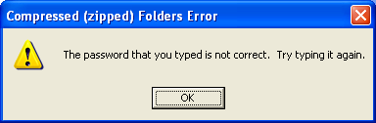
- A Compressed (zipped) Folders Error window opens as shown to the right on this page, showing that you entered an incorrect Password.
- Click OK to close the Compressed (zipped) Folders Error window. Then give it the correct Password. Observe that the file opens correctly.
Last modified 10-4-06

