Starting VMWare Workstation
- Double-click the VMWare Workstation icon on the desktop. In the VMWare Workstation window, click Start this virtual machine.
Downloading and Installing IRFANVIEW
- Open Internet Explorer. Go to irfanview.com. Click the download link.
- In the next screen, click the Tucows Worldwide Network - Download IrfanView link.
- A new window opens with a tucows banner. Click the DOWNLOAD NOW link.
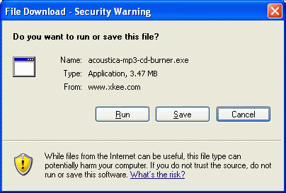
- The next page asks you to choose a download location. Scroll down to find USA and click on it. Click on any location in the list that appears – use one in California if possible. When downloading files, it’s faster, more reliable, and cheaper for the server operators if you use a nearby location.
- A File Download – Security Warning box opens, as shown to the right on this page. Click Run.
- In the Internet Explorer – Security Warning box, click Run.

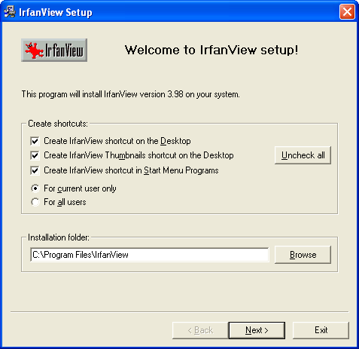
- .An Irfanview Setup box opens, as shown to the right on this page. Notice the Destination folder:

C:\Program Files\IrfanView

- Click Next.
- Click Next through the next two windows.
- When you see a window titled Free! Google Desktop Search, click the Don’t install Google Desktop Search radio button and click Next.
- In the Ready to Install box, click Next.
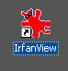
- In the Installation Successful box, click Done.
- Your virtual PC desktop should now have an IrfanView shortcut, as shown to the right on this page.
Examining the Installed Software
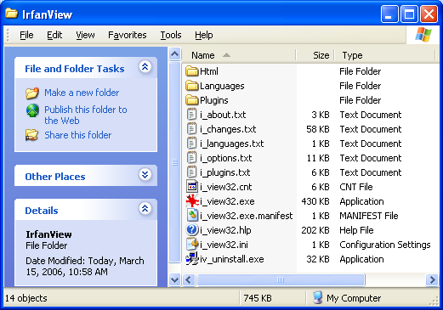
- Click Start, My Computer. Double-click drive C:. Click Show the contents of this folder.
- Double-click Program Files. Click Show the contents of this folder.
- Double-click Irfanview. In the Irfanview window, click View, Details. Several files and folders are visible, as shown below on this page.
- Find all the filename extensions in this window, and in the three folders. Make a list of how many files of each type you find.
- Take your list to the other members of your group, and make sure they have a complete list of file types.
Observing the Uninstall Option
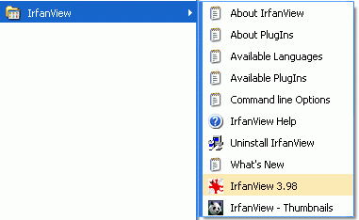
- Click Start, All Programs, IrfanView. Observe that there are several choices here, including an Uninstall Irfanview item. That was a nice thing the programmer provided for us. But not all programs are this kind – what would we do if there were no Uninstall option?
Using Add or Remove Programs
- Click Start, Control Panel. Click Add or Remove Programs.
- Add or Remove Programs opens. Wait until the list of programs appears. Then find IrfanView as shown below on this page.

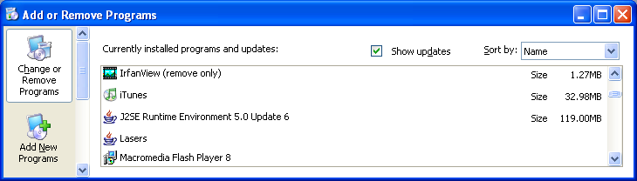

- Click on IrfanView (remove only). A blue bar appears, including a Change/Remove button. Click the Change/Remove button.
- An IrfanView Uninstall box opens, with the message Do you really want to uninstall IrfanView? Click Yes.
- An IrfanView Uninstall box opens, with the message IrfanView uninstalled. Click OK.
- Click Start, My Computer. Double-click drive C:. Double-click Program Files. Look for the IrfanView folder – it should be gone.
- Look for the IrfanView icon on the desktop – it should also be gone.
- Click Start, All Programs, and look for IrfanView – it should be gone. When an uninstallation proceeds correctly, it should remove all traces of the software from your machine.

Last modified 10-4-06

