Starting VMWare Workstation
- Double-click the VMWare Workstation icon on the desktop. In the VMWare Workstation window, click Start this virtual machine.

Setting a Restore Point in the Virtual Machine
- Before doing anything risky with your computer, it is a good idea to create a Restore Point so you can undo changes to your system if you need to. In the Virtual PC, click Start, Help and Support. In Help and Support Center window, in the Pick a Task section, click Undo changes to your computer with System Restore. In the next screen, select Create a Restore Point and click Next. In the next screen enter a Restore Point Description of Your Name Restore Point Before Regedit and click Create.
- When you see the Restore Point Created message, click Close.

Creating a Legal Notice Logon Dialog Box
- Click Start, Run. Enter REGEDIT and press the Enter key.
- In the left pane of the Registry Editor window, click the + sign to expand the HKEY_LOCAL_MACHINE key. Then expand these keys:
SOFTWARE\Microsoft\Windows NT\CurrentVersion\Winlogon
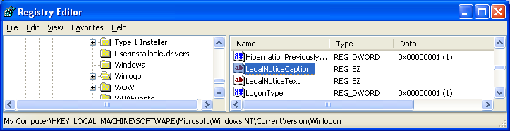
- Your Registry Editor window should look like the example shown below on this page. Find the LegalNoticeCaption value and double-click it.

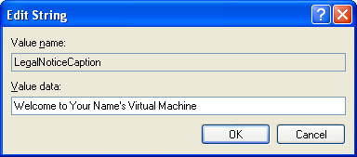
- An Edit String box opens. Enter the Value data: Welcome to Your Name's Virtual Machine as shown to the right on this page. Click OK.
- Find the LegalNoticeText value and double-click it. Enter the value Don't Tread on Me or any other message that suits you and click OK.

Removing System Properties From the My Computer Context Menu
- If Regedit is not already running, click Start, Run. Enter REGEDIT and press the Enter key.
- In the left pane of the Registry Editor window, click the + sign to expand the HKEY_CURRENT_USER key. Then expand these keys:
Software\Microsoft\Windows\CurrentVersion\Policies\Explorer
- Your Registry Editor window should resemble the example below. We need to add a new value to this key.

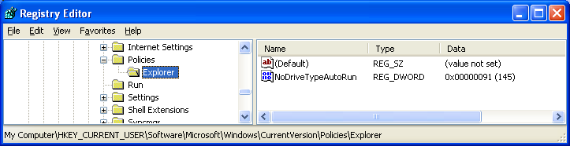
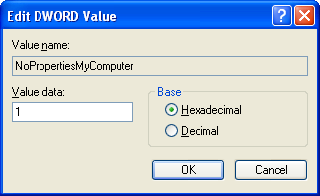
- In the Registry Editor window, click Edit, New, DWORD Value. Enter a value name of NoPropertiesMyComputer and press the Enter key.
- Double-click the NoPropertiesMyComputer value. In the Edit DWORD Value box, enter a Value data of 1, as shown to the right on this page. Click OK.
- Click Start, right-click My Computer, and observe the context menu. Properties is still there! But that does not mean you did anything wrong – the change will not happen until you restart the machine (or at least log off and log back on). We'll do that later.

Restarting the Virtual Machine
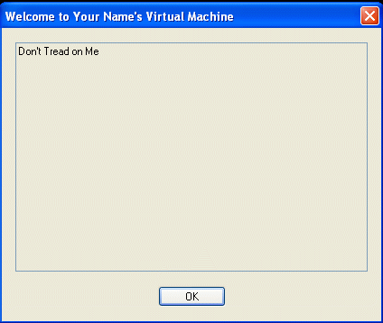
- Click Start, Turn Off Computer. Click Restart.

Observing the Legal Notice Logon Dialog Box
- When the Virtual PC restarts, it should show the Legal Notice, as shown to the right on this page.
- In the Welcome to Your Name's Virtual Machine box, click OK.

Observing the My Computer Context Menu
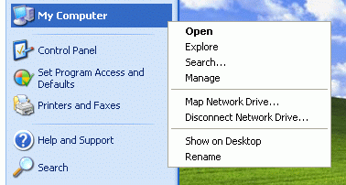
- When the desktop appears, click Start and right-click My Computer. You should see that Properties is absent from the context menu, as shown to the right on this page.

Using System Restore
- In the Virtual PC, click Start, Help and Support. In Help and Support Center window, in the Pick a Task section, click Undo changes to your computer with System Restore. In the next screen, select Restore my computer to an earlier time and click Next.
- When the Select a Restore Point screen appears, select the restore point labeled Your Name Restore Point for Project 31.
- Click Next. If a window opens warning you that changes made after this point will not be monitored, click OK. Click Next again to perform the System Restore.
- Your Virtual PC should be back to its normal condition:
  - No Legal Notice should appear
  - Administrator should not be on the Windows Welcome screen
  - Properties should be on the My Computer context menu

Revised 10-4-06
I got these hacks from theeldergeek.com.

Starting VMWare Workstation
- Double-click the VMWare Workstation icon on the desktop. In the VMWare Workstation window, click Start this virtual machine.

Setting a Restore Point in the Virtual Machine
- Before doing anything risky with your computer, it is a good idea to create a Restore Point so you can undo changes to your system if you need to. In the Virtual PC, click Start, Help and Support. In Help and Support Center window, in the Pick a Task section, click Undo changes to your computer with System Restore. In the next screen, select Create a Restore Point and click Next. In the next screen enter a Restore Point Description of Your Name Restore Point Before Regedit and click Create.
- When you see the Restore Point Created message, click Close.

Adding the Administrator Account to the Windows Welcome Screen
- Click Start, Run. Enter REGEDIT and press the Enter key.
- In the left pane of the Registry Editor window, click the + sign to expand the HKEY_LOCAL_MACHINE key. Then expand these keys:
SOFTWARE\Microsoft\WindowsNT\CurrentVersion\Winlogon\
SpecialAccounts\UserList

- Your Registry Editor window should resemble the example below. We need to add a new value to this key.
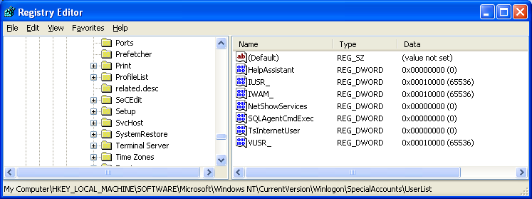

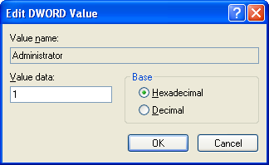
- In the Registry Editor window, click Edit, New, DWORD Value. Enter a value name of Administrator and press the Enter key.
- Double-click the Administrator value. In the Edit DWORD Value box, enter a Value data of 1, as shown to the right on this page. Click OK.
- Close Registry Editor.

Restarting the Virtual Machine
- Click Start, Turn Off Computer. Click Restart.

Observing the Windows Welcome Screen
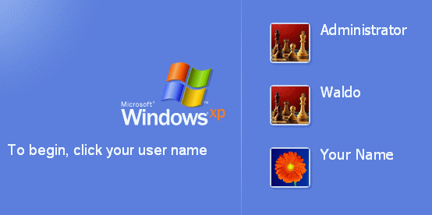
- When the Virtual PC shows the Windows screen, you should see the Administrator account on the list, as shown to the right on this page. I think the other name is Student on your machines, not Waldo.
- Click Student.

Changing the Internet Explorer Title Bar Text
- If Regedit is not already running, click Start, Run. Enter REGEDIT and press the Enter key.
- In the left pane of the Registry Editor window, click the + sign to expand the HKEY_CURRENT_USER key. Then expand these keys:
SOFTWARE\Microsoft\Internet Explorer\Main
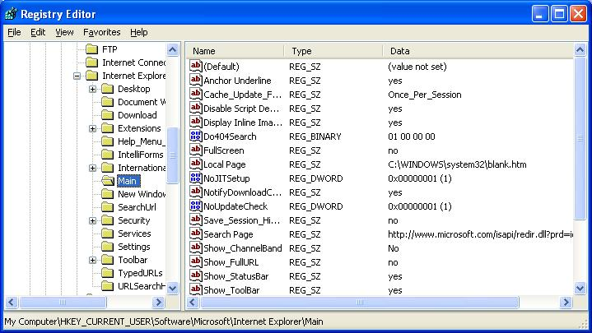
- Your Registry Editor window should resemble the example below. We need to add a new value to this key.

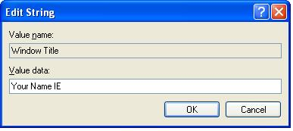
- In the Registry Editor window, click Edit, New, String Value. Enter a value name of Window Title and press the Enter key.
- Press the Enter key again to open an Edit String box as shown to the right on this page. In the Edit String Value box, enter a Value data of Your Name IE, as shown to the right on this page. Click OK.
- Close Registry Editor.

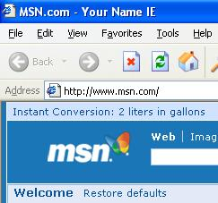

Observing the Internet Explorer Title Bar
- Click Start, All Programs, Internet Explorer. Your name should now appear in the title bar, as shown to the right on this page.

Using System Restore
- In the Virtual PC, click Start, Help and Support. In Help and Support Center window, in the Pick a Task section, click Undo changes to your computer with System Restore. In the next screen, select Restore my computer to an earlier time and click Next.
- When the Select a Restore Point screen appears, select the restore point labeled Your Name Restore Point for Project 31.
- Click Next. If a window opens warning you that changes made after this point will not be monitored, click OK. Click Next again to perform the System Restore.
- Your Virtual PC should be back to its normal condition:
  - No Legal Notice should appear
  - Administrator should not be on the Windows Welcome screen
  - Properties should be on the My Computer context menu

Revised 10-4-06
I got these hacks from theeldergeek.com.

