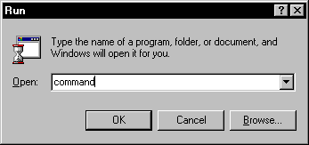
- Insert a floppy disk in your A: drive. Erase all the files on it.
- Use Start, Run to open a Run dialog box.
- Type command in the Open: box and click the OK button to open a DOS window.
- Enter the A: Enter command to make the floppy disk the current device. You should get a prompt of
A:\>
indicating that the current directory is now the root directory of the floppy disk.
- Use the editor to create a new file named DEMO.TXT, with the command
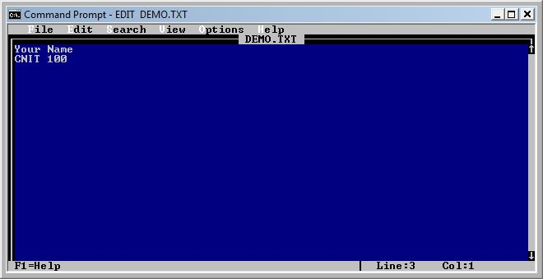
EDIT DEMO.TXT Enter
- This is EDIT, a precursor to Notepad. You can write text files in this simple program.
- On the first line of the file, type your name. Type in another line or two of text, as shown to the right on this page.
- Use the mouse to click File, then Save to save your work. It automatically goes onto the floppy with the filename DEMO.TXT
- Click File, then Exit to exit the Editor.
- Use the following command copy the file DEMO.TXT to a new file named DEMO2.TXT.
COPY DEMO.TXT DEMO2.TXT Enter
- Use the COPY command again to copy the file DEMO.TXT to a new file named DEMO3.TXT. You will have to use a modified form of the command you used in step 10.
- Use the MKDIR command to make a directory in the root directory of your floppy disk named BACKUPS, as shown below:
MKDIR BACKUPS Enter
- Use the MKDIR command again to make a directory on your floppy disk named with your name. If your name is longer than eight characters, abbreviate your name to eight letters or less. You cannot have spaces in a DOS directory name.
- Use the following command copy the file DEMO.TXT to the BACKUPS directory.
COPY DEMO.TXT BACKUPS Enter
- Use the COPY command again to copy the DEMO.TXT to the directory you made in step 13. You will have to use a modified form of the command you used in step 14.
- Enter the following command to see a list of the files in the root directory of the floppy disk:
- DIR Enter
- You should see three files and two directories, as shown below on this page.

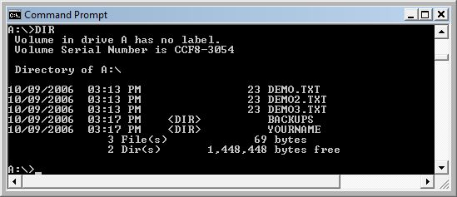

- Use the following command to put the list you saw in step 16 into a new file named DIR1.TXT
DIR > DIR1.TXT Enter
- This is called Output Redirection – the > symbol sends data to a file instead of to the screen.
- Enter the following command to see a list of the files in the BACKUPS directory of the floppy disk:
DIR BACKUPS Enter
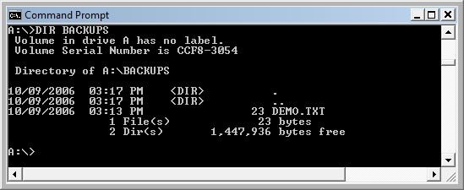
- You should see three objects, as shown below on this page. The first two, . and .. are just reference marks DOS places in each directory. The only object you placed in the directory is DEMO.TXT.

- Use the following command to put the list you saw in step 22 into a new file named DIR2.TXT
DIR BACKUPS > DIR2.TXT Enter
- Enter the following command to see a list of all the files starting with the letter D in all folders in your disk:
DIR D*.* /S Enter
- You should see seven files, as shown below on this page.
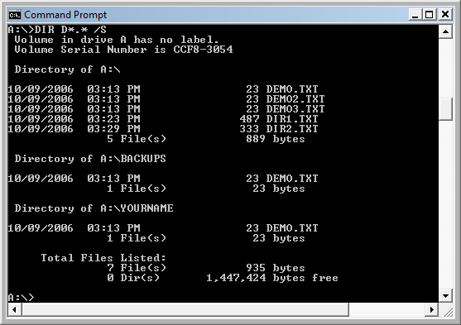
- Use a the following command to put the list you saw in step 25 into a new file named DIR3.TXT
DIR D*.* /S > DIR3.TXT Enter
- Enter the EXIT command to close the DOS window.
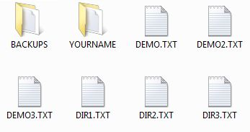
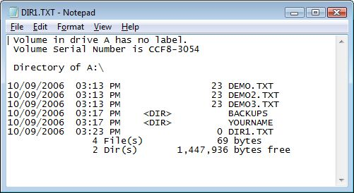
- Click Start, My Computer. Double-click the 3 ½ Floppy (A:) icon to open the A:\ window. Your floppy disk should have 6 files and two folders on it as shown in the figure to the right on this page.
- Double-click the Dir1.txt icon to open the Dir1.txt file in NotePad. Your Dir1.txt file should look like the example to the right on this page.

Revised 10-9-06

