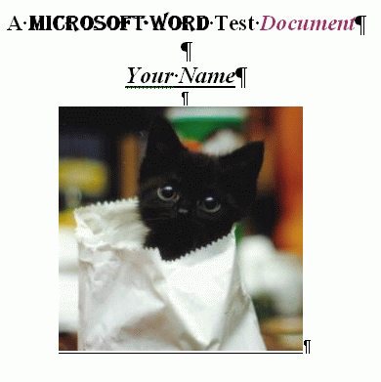
Saving a Word Document in Various Formats
- Open Microsoft Word. Type in a document with some text formatting and an image, like the example shown to the right on this page. (By the way, the image is from kittenwar.com, a Web site popular with cat lovers.)
- Save the file in the My Documents folder, as Your Name. Use your own name, not the literal words “Your Name”. Microsoft Word will add a file extension of .doc.

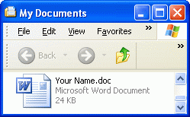
- Click Start, My Documents. You should see your file, as shown to the right on this page. If the file extension is not visible, do these steps to reveal it:
  - Click Tools, Folder Options
  - Click the View tab
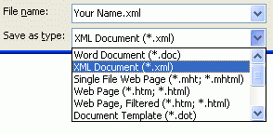
  - Uncheck the Hide extensions for known file types check box
  - Click OK
- In the Microsoft Word window, click File, Save As…. In the Save as type: drop-down list box, select XML Document, as shown to the right on this page. Click the Save button.
- In the Microsoft Word window, click File, Save As…. In the Save as type: drop-down list box, select Plain Text. Click the Save button.
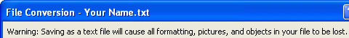
- A File Conversion box opens warning you that all formatting, pictures, and objects in your fill will be lost, as shown above on this page. Click OK.
- Close Microsoft Word.
Examining the Saved Files: a DOC File
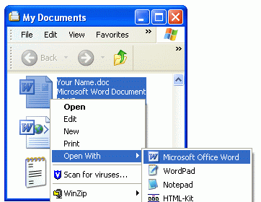
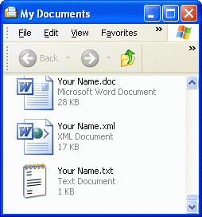
- The My Documents folder should now show the three files, as shown to the right on this page. Notice that the icons are all different, and that the file sizes are also different.
- One simple way to see how these files store information is to open them in both Word and Notepad.
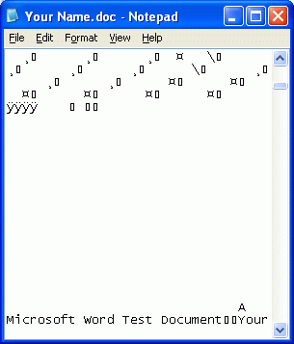
- Right-click the Your Name.doc file, point to Open With…., and click Microsoft Office Word, as shown to the right on this page.
- The file opens with all the formatting and the image intact. That is because Word is “smart” and can understand formatting information and graphics and construct the page.
- Right-click the Your Name.doc file, point to Open With…., and click Choose program…. In the Open With box, scroll down to Notepad and click it. Click the OK button.
- The file is a mess! The upper portion is all unreadable gibberish, which is what non-ASCII information looks like in Notepad. If you scroll down a bit, you will see the text you typed in, but with none of the formatting information. This happens because Notepad is “dumb” and will just convert each byte to a single character using ASCII. Notepad has no ability to format text or display graphics – everything just looks like text to Notepad.
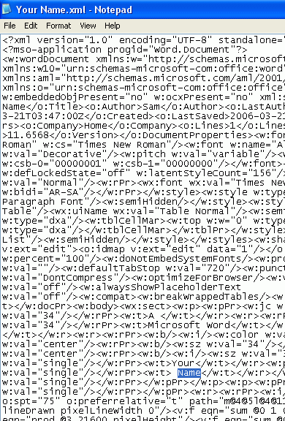
Examining the Saved Files: an XML File
- In the My Documents window, right-click the Your Name.xml file, point to Open With…., and click Microsoft Office Word.
- The file opens with all the formatting and the image intact. That is because Word is “smart” and can understand formatting information and graphics and construct the page.
- Right-click the Your Name.xml file, point to Open With…., and click Choose program…. In the Open With box, scroll down to Notepad and click it. Click the OK button.
- This file is still pretty confusing, but it is actually an ASCII file. The letters you typed are in there, but they are hard to find. Notice the word “Your” highlighted in the figure to the right on this page. The formatting information here is in XML Tags which look like HTML Tags. If you scroll down further you can see a grid of characters that are the XML encoding of the image.
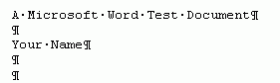
Examining the Saved Files: a TXT File
- Close all Microsoft Word windows.
- In the My Documents window, right-click the Your Name.txt file, point to Open With…., and click Microsoft Office Word.
- The file opens with only the text -- all the formatting and the image are gone, as shown above on this page. The TXT file format has no way to store anything but plain ASCII text, so formatting and images were lost, just as Word warned you.
- Right-click the Your Name.txt file, point to Open With…., and click Notepad. The file looks the same way it did in Word – just the text.

