1. HP-UNIX User ID and Passwords
User ID  (name like ssmith01) | ______________________________
First Password  (birthday like jan1276) | ______________________________
New Password  (anything you want, at least 6 characters, must include letters and numbers) | ______________________________

Fill in the three items in the box to the right. There is a chard of User IDs on the bulletin board in the lab.

If you have already used your HP-UNIX account, don’t use your birthday – use the password you chose previously.

2. Start the SSH Secure Shell Client

Click Start, All Programs, SSH Secure Shell, Secure Shell Client. The SSH Secure Shell window opens as shown in the figure to the right on this page.

3. Connect to Remote Host

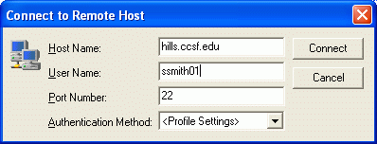
Click the Quick Connect button in the SSH Secure Shell window. A Connect to Remote Host window appears as shown in the figure to the right on this page. Enter a Host Name of hills.ccsf.edu and put your User ID in the User Name box (don’t use ssmith01—use your own ID instead). Then click the Connect button.

4. Host Identification

If a Host Identification window opens as shown to the right, press Enter to close it.

5. Enter Your Password

An Enter Password box opens. Type in your birthday (like this jan1475) and press Enter.

6. You are Now Connected

You should see a hills.ccsf.edu window as shown to the right on this page.

At the
TERM = (vt100)
line, press Enter.

A $ should appear, showing that you are connected to the HP-UNIX system, and it is ready for you to enter a UNIX command. You may see some letters before the $, like

bash-2.04$

That’s OK.

Using the date command
- Enter the following command to show the current date and time:
date
After typing in the command, press the Enter key. The date and time appears on the screen.

Using output redirection >
- Enter the following command to create a file named foo with the current date and time in it.
date > foo
After typing in the command, press the Enter key. Nothing appears on the screen, because the output redirection operator > has told UNIX to send the data to the file named foo instead of to the screen. From now on, the instructions won’t keep telling you to press the Enter key, but you need to press Enter after each UNIX command.

Using the echo command
- Enter the following command to add CNIT 100 to the file named foo
echo “CNIT 100” >> foo
The >> symbol is called the append operator, and it tells UNIX to add the new data to the end of the file named foo.
- Enter the following command to add Your Name to the file named foo
echo “Your Name” >> foo
Don’t use the literal words “Your Name” – put in your own name instead.

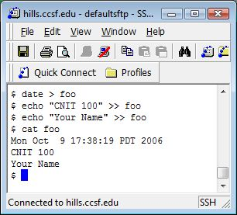
Using the cat command to view a file’s contents
- Enter the following command to see the contents of the file named foo
cat foo
The cat command is short for “concatenate” – when used with only one file, it shows the file’s contents on the screen. Your screen should look like the example shown to the right on this page. There should be three lines shown after the cat foo command, containing the date, CNIT 100, and your name. If the file is not correct, go back to step 8 and try again.

Using the pwd command to see your working directory
- You are working in a special directory created just for you on the UNIX system, called your home directory. To see the name of your working directory, enter this command
pwd
You should see the name of your home directory, which will be something like /students/ssmith01

Using the ls command to see the objects in your working directory
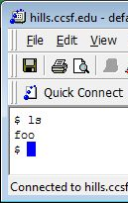
- Enter the following command to see a list of the files and subdirectories in your working directory
ls
The output should show the file named foo as shown to the right on this page. You may have other objects in your home directory also.

Using the cp command to copy files
- Enter the following command to copy the foo file to a new file named foo2
cp foo foo2
- Enter the ls command and verify that there are now two files: foo and foo2
- Use the cp command again to copy the foo file to a new file named foo3
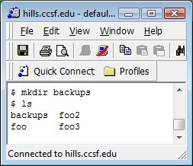
- Enter the ls command and verify that the new file has been created.

Using the mkdir command to make a directory
- Enter the following command to create a new directory named backups
mkdir backups
- Enter the ls command. You should see four objects, backups, foo, foo2, and foo3, as shown to the right on this page.
- Use the mkdir command again to make a directory with your name on it. Your name can be as long as you wish, but it cannot include spaces or other special characters such as <>{}[]()”’*?|/\^!#$&~-. You can use periods or underscores to separate words, such as arthur.mailer or Arthur_Mailer. Remember that UPPERCASE and lowercase letters are treated as different letters in UNIX.
- Enter the ls command and verify that the new directory has been created.

Using the ls command to append a directory to the file named foo
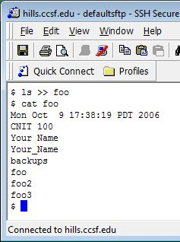
- Enter the following command to append a directory to the file foo (be careful to use an append operator >> and not a redirection operator >)
ls >> foo
- Enter the following command to display the contents of the foo file on the monitor.
cat foo
Your file should look like the example to the right on this page.

