Starting Your Computer
- Start your computer with the appropriate L removable hard drive in it.

Starting VMWare Workstation
- Double-click the VMWare Workstation icon on the desktop.
- When the VMWare Workstation window opens, click Start this virtual machine.

Creating a New Partition
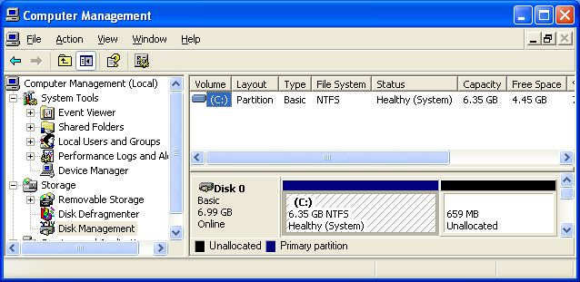
- Click Start and point to My Computer. Right-click My Computer and click Manage. Computer Management opens, as shown below. In the left pane, click Disk Management. You should see some Unallocated space on the lower right of this window. If there is no Unallocated space, call your instructor to fix it.
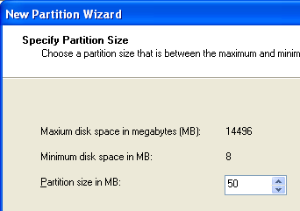
- In the lower right portion of Disk Management, right-click the Unallocated section and select New Partition.
- The New Partition Wizard opens. Click Next.
- In the Select Partition Type screen, accept the default selection of Primary Partition and click Next.
- In the Select Partition Size screen, enter a value of 50 MB, as shown to the right on this page. Click Next.
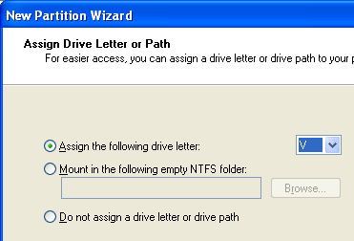
- In the Assign Drive Letter or Path screen, select a drive letter of V, as shown to the right on this page. Click Next.
- In the Format Partition screen, accept the default selections and click Next.
- In the Completing the New Partition Wizard screen, click Finish.
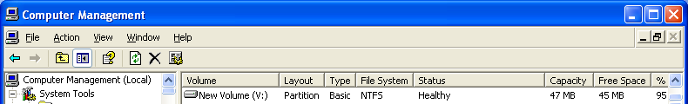
- You should see the formatting process in the Computer Management window. Some of the unallocated space will vanish and a new V: partition will appear. When the formatting is complete, the partition should show a status of Healthy in the upper right pane, as shown below on this page.

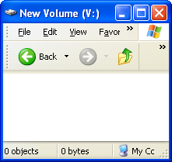
- Close Computer Management.

Examining the V: Partition
- Click Start, My Computer. Double-click New Volume (V:). A New Volume (V:) window opens, as shown to the right on this page. This volume is empty because we have not saved any files here yet.

Downloading testfile and BigTestfile
- Open Internet Explorer and go to my Web page samsclass.info. Click the CNIT 100: Intro to Computers link. Click the Handouts link.
- Under the Ch 4b line, right-click Download testfile.txt and select Save Target As…. Save the file on your desktop.
- Under the Ch 4b line, right-click Download BigTestfile.txt and select Save Target As…. Save the file on your desktop.
- Close Internet Explorer.

Copying testfile.txt onto V:
- Drag testfile.txt from the desktop to V: and drop it there.
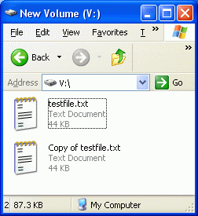

Filling the V: Partition with Files
- Click once in an empty portion of the New Volume (V:) window. On the keyboard, hold down the Ctrl key and tap A once to select the test file.
- Then hold down the Ctrl key and tap C to copy the file to the clipboard.
- Then hold down the Ctrl key and tap V. That will make a copy of the file, as shown to the right on this page.
- Repeat those three keystrokes again: Ctrl+A, Ctrl+C, Ctrl+V. Now the folder has four files in it.
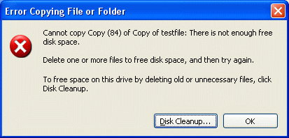
- Repeat those three keystrokes again: Ctrl+A, Ctrl+C, Ctrl+V. Now the folder has eight files in it.
- Repeat the three keystrokes again: Ctrl+A, Ctrl+C, Ctrl+V, a total of six or seven more times. You will have to wait for the copies to finish after the first few sets of copies. Each time you do this, you double the number of files in the folder.
- Eventually the folder will be full, and you will see an error message as shown to the right on this page. Click OK.

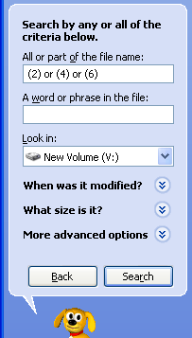
Deleting Some of the Files
- In the New Volume (V:) window, click the Search button. Rover, the search dog, appears in the left pane. Click All files and folders.
- In the All or part of the file name: box, enter (2) or (4) or (6) as shown to the right on this page. Click the Search button.
- The Search Results window shows 24 files. Press Ctrl+A to select them all.
- Hold down the Shift key and press the Delete key to delete them without putting them into the Recycle bin. In the Confirm Multiple File Delete box, click Yes. This will leave 24 scattered open spaces on the hard disk. Close the Search Results window.

Saving a Big File
- Click Start, My Computer. Double-click New Volume (V:).
- Drag BigTestfile from the desktop to V: and drop it there. If the file cannot be copied, try emptying the Recycle bin.
- Now there is a fragmented file on V:, stored in those scattered open spaces.
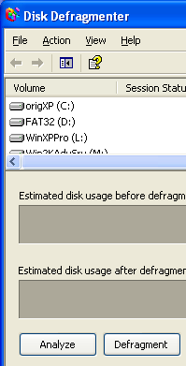

Running a Fragmentation Analysis
- Click Start, My Computer. Right-click New Volume (V:) and click Properties. In the New Volume (V:) Properties window, click the Tools tab. Click the Defragment Now… button.
- A Disk Defragmenter box opens, as shown to the right on this page. Click Analyze.
- A Disk Defragmenter box opens saying “You do not need to defragment this volume.” Click View Report.
- Scroll down in the Analysis Report to the File fragmentation section, as shown below on this page. You should see that one or more files were fragmented – when I did it, I found 7 fragmented files, as shown below on this page.
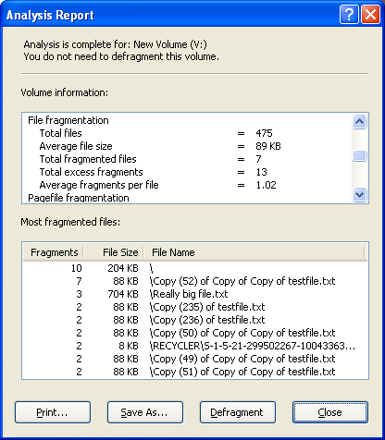

Defragmenting the Volume
- Click the Defragment button. If you get an error message complaining that there is not 15% free space, click Yes.
- When the defragmentation is complete, click View Report. Now there should be fewer Fragmented files—only one when I did it.

Last modified 10-11-06

