Starting VMWare Workstation
- Double-click the VMWare Workstation icon on the desktop.
- When the VMWare Workstation window opens, click Start this virtual machine.

Creating a New Partition
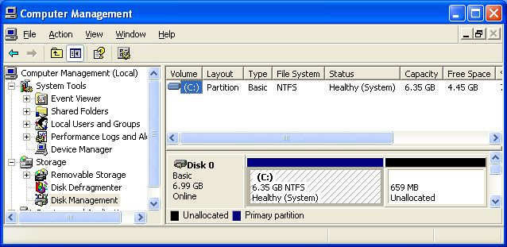
- Click Start and point to My Computer. Right-click My Computer and click Manage. Computer Management opens, as shown below. In the left pane, click Disk Management. You should see some Unallocated space on the lower right of this window. If there is no Unallocated space, call your instructor to fix it.

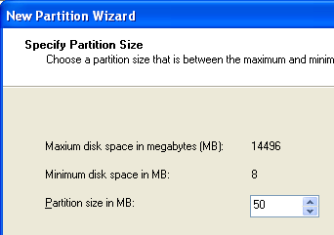
- In the lower right portion of Disk Management, right-click the Unallocated section and select New Partition.
- The New Partition Wizard opens. Click Next.
- In the Select Partition Type screen, accept the default selection of Primary Partition and click Next.
- In the Select Partition Size screen, enter a value of 50 MB, as shown to the right on this page. Click Next.

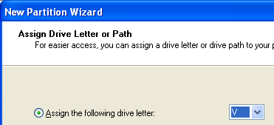
- In the Assign Drive Letter or Path screen, select a drive letter of V, as shown to the right on this page. Click Next.

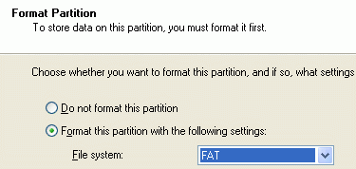
- In the Format Partition screen, select a File system of FAT, as shown to the right on this page. Click Next.
- In the Completing the New Partition Wizard screen, click Finish.
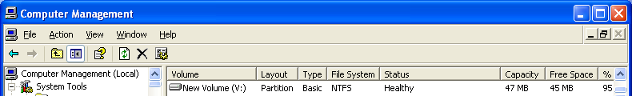
- You should see the formatting process in the Computer Management window. Some of the unallocated space will vanish and a new V: partition will appear. When the formatting is complete, the partition should show a status of Healthy in the upper right pane, as shown below on this page.
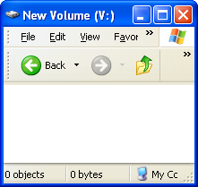
- Close Computer Management.

Examining the V: Partition
- Click Start, My Computer. Double-click New Volume (V:). A New Volume (V:) window opens, as shown to the right on this page. This volume is empty because we have not saved any files here yet.

Creating the Test file
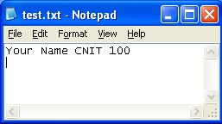
- Click Start, All Programs, Accessories, Notepad.
- In the Notepad window, type in your name and CNIT 100 as shown to the right on this page. Save the file on your desktop with the name Test.

Copying the Test file onto V:
- Drag the Test file from the desktop to V: and drop it there.

Installing Acronis Disk Director Suite (Trial Version)
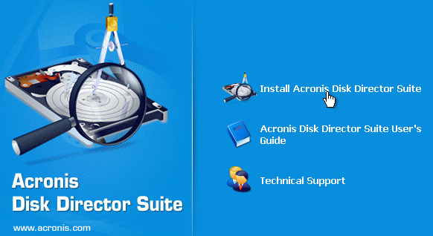
- Get the CD from your instructor labeled Acronis Disk Director Suite. Insert it into your computer.
- In your virtual machine, click Start, My Computer. Double-click the CD-ROM drive. Drag the DiskDirectorSuite10.0_d_en file to the desktop of your virtual PC.
- Double-click the DiskDirectorSuite10.0_d_en file.
- In the Open File – Security Warning box, click Run.
- When you see the Acronis Disk Director Suite screen shown to the right on this page, click Install Acronis Disk Director Suite.
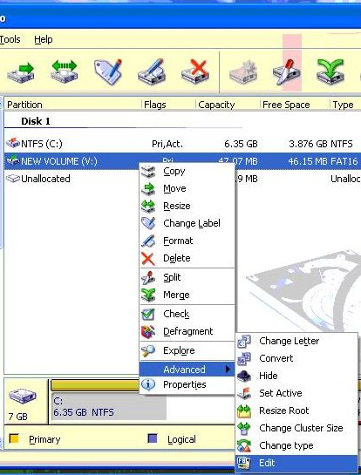
- In the Welcome to the Acronis Disk Director Suite Setup screen, click Next.
- Accept the agreement and click Next.
- In the Setup Type screen, click Typical.
- In the Select Administrator Options screen, click Next.
- In the Registration screen, enter your name and email address, and click Next.
- In the next screen, click Proceed.
- In the Installation Complete screen, click Close.
- In the Confirmation screen, click Yes. Wait while your virtual machine restarts.

Using Acronis Disk Director Suite to Examine the V: Volume
- Double-click the Acronis Disk Director Suite icon on the desktop.
- From the menu bar, click View, Manual Mode.
- In the right pane, right-click NEW VOLUME (V:), and in the context menu, click Advanced, Edit, as shown to the right on this page.

- From the menu bar, click View, As Hex. You should see a screen full of numbers, as shown below. What you are seeing here is the exact bytes on the hard disk in their raw form. This portion of the disk is the Boot Sector, and it’s not very easy to read. Look at the ASCII text on the right side – some of it is readable, such as FAT 16 and, further down, Remove disks or other media.
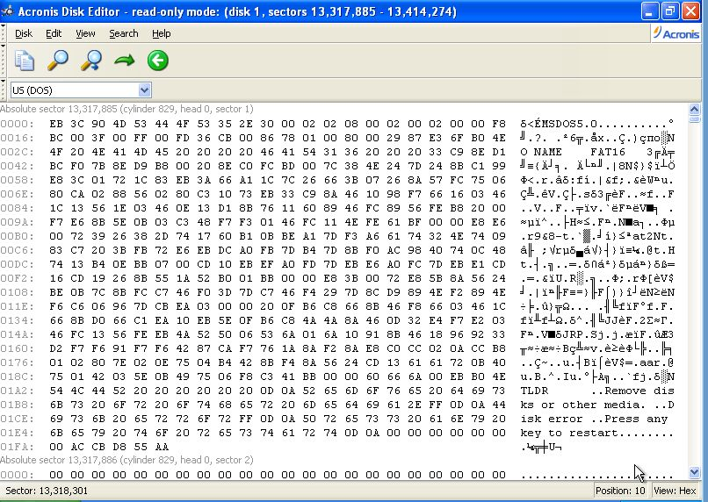
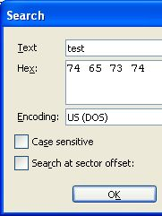
- Let's find the Root Directory on this volume. From the menu bar, click Search, Search. In the Search box, type in test, as shown to the right on this page, and click OK.

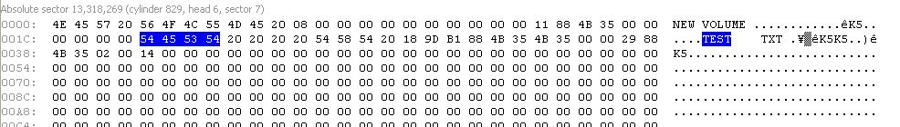
- You should now see a sector that starts with the words "NEW VOLUME", as shown below. This is the directory of the volume.

- To see it another way, from the menu bar, click View, As FAT Folder. Now you can see the directory in a more readable way, as shown below. The volume is named NEW VOLUME and it contains one file named TEST with a filename extension of TXT.
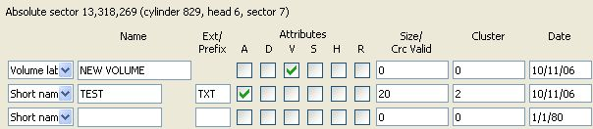

- From the menu bar, click View, As Hex. From the menu bar, click Search, Search. In the Search box, type in CNIT, and click OK.

- You should see a sector as shown below, showing the text you typed into your file. The bytes are on the left, and on the right side you can read the text "Your Name CNIT 100".

