Starting VMWare Workstation
- Double-click the VMWare Workstation icon on the desktop.
- When the VMWare Workstation window opens, click Start this virtual machine.
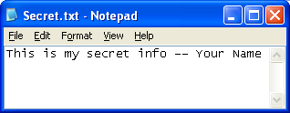
Making a Deleted File
- Click Start, All Programs, Accessories, Notepad. In the Notepad window, type in a short message including your name, as shown to the right on t his page. Save the file on a floppy disk with the name Secret.txt.
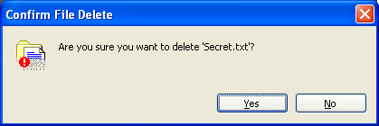
- Click Start, My Computer, 3 ½ Floppy (A:). Click the Secret.txt file once to select it. Press and hold the Shift key. Press the Delete key. Read the Confirm File Delete box that appears—it should say Are you sure you want to delete ‘Secret.txt’?, like the box shown to the right on this page. Click Yes. This deletes the file completely, so that it is not in the Recycle bin, and Windows does not provide any way to ever get the file back. By the way, just pressing Delete has the same effect – files deleted from floppy disks never go into the recycle bin anyway.

Downloading and Installing Recover My Files
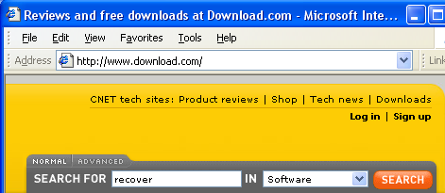
- Open Internet Explorer and go to downloads.com
- In the SEARCH FOR box, enter recover and click the Go button.

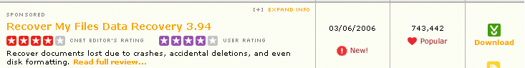
- Find Recover My Files Data Recovery as shown below, and click the green Download button on the right side.

- In the File Download – Security Warning box, click Run.
- In the Internet Explorer – Security Warning box, click Run.
- When you see the Welcome to the Recover My Files Setup Wizard, close all other programs and click Next.
- Accept the agreement and click Next.
- Click Next through the remaining screens, accepting the default selections.
- At the Product Activation screen, click Later.
- When you see the Completing the Recover My Files Setup Wizard, click Finish.
- In the Recover My Files box, check I accept the terms of this agreement and click OK.
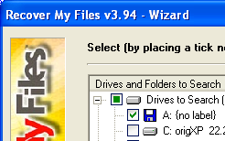
Recovering Deleted Files
- In the Tip of the Day box, click Close.
- In the Recover My Files v3.94 – Wizard, click Fast File Search. Click Next.
- In the next screen, put a check mark by drive A: as shown to the right on this page. Click Next.
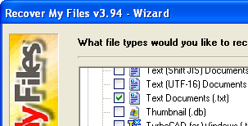
- The next screen is where you choose which file types to recover. Scroll down to the Documents section and check Text Documents (*.txt) as shown to the right on this page. Click Start.
- When the search finishes, you should be able to find Secret.txt and click it, as shown below on this page. You will see the file contents in the preview pane at the bottom.
- Close the Recover My Files window.
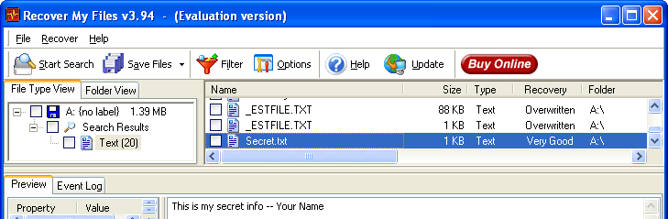

Downloading and Installing AbsoluteShield File Shredder
- Deleting files is not enough to stop people from getting them back. For that you need to shred them.
- Open Internet Explorer and go to downloads.com
- In the SEARCH FOR box, enter shredder and click the Go button.
- Find AbsoluteShield File Shredder, and click the green Download button on the right side.
- In the File Download – Security Warning box, click Run.
- In the Internet Explorer – Security Warning box, click Run.
- When you see the Welcome to the AbsoluteShield File Shredder Setup Wizard, close all other programs and click Next.
- Accept the agreement and click Next.
- Click Next through the remaining screens, and click Install to install the software.
- At the Click Finish to exit Setup screen, click Finish.
- If a Microsoft AntiSpyware box pops up, allow the change.
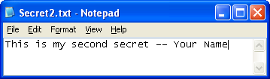
Making a Shredded File
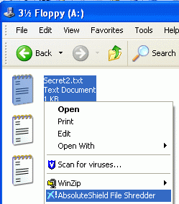
- Click Start, All Programs, Accessories, Notepad. In the Notepad window, type in a short message including your name, as shown to the right on this page. Save the file on a floppy disk with the name Secret2.txt. Close Notepad.

- Click Start, My Computer. Double-click 3 ½ Floppy (A:). Right-click the Secret2.txt file and click AbsoluteShield File Shredder as shown to the right on this page.

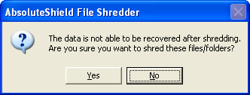
- In the AbsoluteShield File Shredder box shown to the right on this page, click Yes. When you see the message 1 file is shredded, the file is gone.

Recovering Deleted Files
- To prove that the shredded file is really gone, run the Recovery program again.
- In the Recover My Files v3.94 – Wizard, click Fast File Search. Click Next.
- In the next screen, put a check mark by drive A:.
- The next screen is where you choose which file types to recover. Scroll down to the Documents section and check Text Documents (*.txt). Click Start.
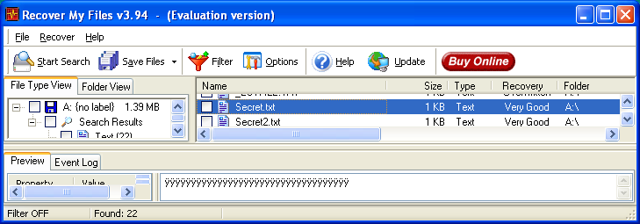
- When the search finishes, hunt through all the files. Secret2.txt is on the list, but if you click it you will see that the contents have been destroyed, as shown below—the lower pane has nothing readable in it. The contents of the file are completely gone.

Last modified 10-11-06

