Use your Virtual Machine
- You can’t do this project on the host machine.

Starting SSH Secure File Transfer
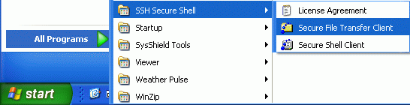
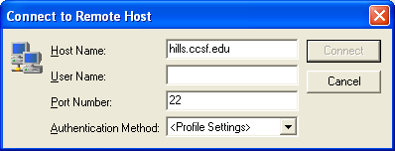
- Click Start, All Programs, SSH Secure Shell, Secure File Transfer Client as shown to the right on this page. If SSH Secure Shell is not there, download and install it first.
- When the – defaultftp – SSH Secure File Transfer window opens, press the Enter key. In the Connect to Remote Host box, enter a Host Name: of hills.ccsf.edu as shown to the right on this page. Get your User Name: from the list on the bulletin board in the classroom. Enter your User Name and press the Enter key.
- If a Host identification box appears, press the Enter key.
- When a Message from the server box appears, press the Enter key.
- Enter your password into the Enter password box. Your password is your birthday, with three letters, two numbers, and two numbers, like this: oct0178
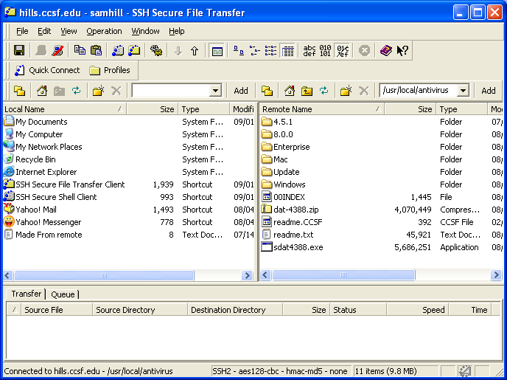
- A SSH Secure File Transfer window opens as shown below.

Downloading the McAfee Installer
- On the upper right part of the SSH Secure File Transfer window there is a white box showing the working directory on the HP-UNIX system. Click in that box, enter /usr/local/antivirus, and then press the Enter key.
- Double-click the 8.0.0 folder.
- If you are using a Windows system, double-click the Windows folder. You will see a text file, several PDF files with documentation, and a large ZIP file (VSE80iLEN.zip) containing the software.

- Drag the ZIP file to your desktop.

Uninstalling the Current Antivirus Software
- You can’t have two antivirus programs running at once on your computer. They will conflict and freeze or crash your machine. So if you have antivirus software on there already, you have to remove it before adding MacAfee. In S214, you should already have McAfee, so remove it with these steps:
- Click Start, Control Panel. In Control Panel, if Add or Remove Programs is not visible, click Switch to Classic View. Double-click Add or Remove Programs. Click McAfee VirusScan Enterprise to highlight it, as shown below. Click the Remove button.
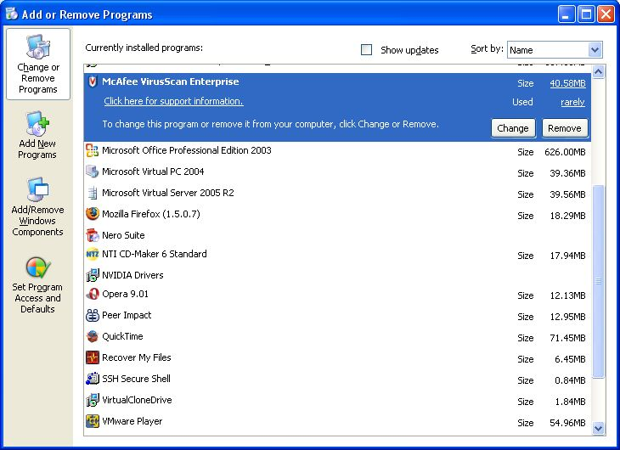
- In the Add or Remove Programs box, click Yes.

Saving the eicar.com test virus in the My Documents folder
- Open Internet Explorer and go to eicar.com
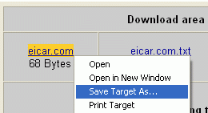
- The eicar page opens, as shown to the right on this page. In the left bar, click The AntiVirus (AntiMalware) testfile eicar.com.
- In the next screen, scroll down to the bottom and find the Download area using the standard protocol http. Right-click eicar.com and select Save Target As… as shown to the right on this page. Save the file in the My Documents folder.
Installing McAfee Antivirus Software
- Double-click the VSE80iLEN.zip file to open the archive. Create a folder on your desktop and drag the files into it. Open that folder and double-click the Setup file. The installer will start, with a window titled FEAD® 2.3 Optimizer©. When that window closes, a McAfee VirusScan Enterprise Setup window will open. Click Next, accept the agreement, click OK, click Next, and click Install. When the installation is done, click Finish.
- Leave the Update Now box checked, but clear the Run On-Demand Scan box.
- Wait for the installation to complete.
Scanning the My Documents Folder
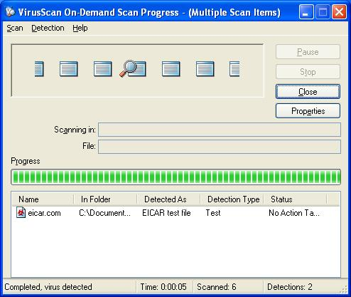
- Click Start. Right-click My Documents. Click Scan for viruses. You should see the eicar.com file found, as shown to the right on this page.

Revised 10-16-06

