Use your Virtual Machine
- You can’t do this project on the host machine.

Uninstalling the Current Antivirus Software
- You can’t have two antivirus programs running at once on your computer. They will conflict and freeze or crash your machine. So if you have antivirus software on there already, you have to remove it before adding MacAfee. In S214, you should already have McAfee, so remove it with these steps:
- Click Start, Control Panel. In Control Panel, if Add or Remove Programs is not visible, click Switch to Classic View. Double-click Add or Remove Programs. Click McAfee VirusScan Enterprise to highlight it, as shown below. Click the Remove button.
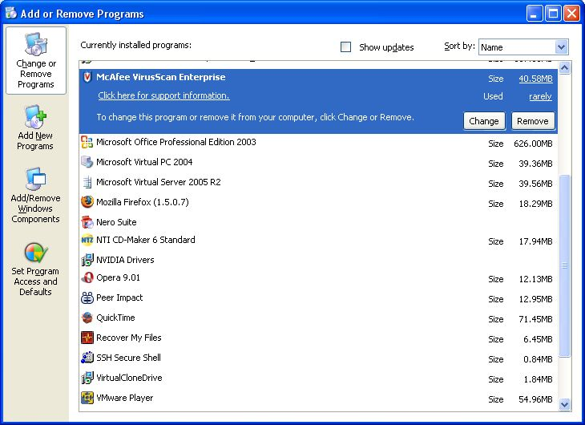
- In the Add or Remove Programs box, click Yes.

Saving the eicar.com test virus in the My Documents folder
- Open Internet Explorer and go to eicar.com
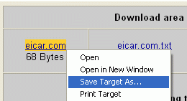
- The eicar page opens, as shown to the right on this page. In the left bar, click The AntiVirus (AntiMalware) testfile eicar.com.
- In the next screen, scroll down to the bottom and find the Download area using the standard protocol http. Right-click eicar.com and select Save Target As… as shown to the right on this page. Save the file in the My Documents folder.
Installing Windows OneCare 90-Day Trial
- Open Internet Explorer (NOT Firefox) and go to windowsolnwcare.com
- Click the Download the 90-day free trial button.
- If you see a message saying You are about to view pages over a secure connection, click OK.
- In the screen titled Windows Live OneCare, click Start Now.
- In the screen titled 1. Checking your system and settings, click Continue.
- In the Information Bar box, click OK.
- Click the yellow Information Bar at the top of your browser. Click Install ActiveX Control.
- In the Internet Explorer – Security Warning box, click Install.
- In the Windows Live OneCare box, click Run.
- The screen titled 1. Checking your system and settings should now have a message saying …your computer meets the installation requirements…. Click Continue.
- Accept the Terms of Service and click Confirm.
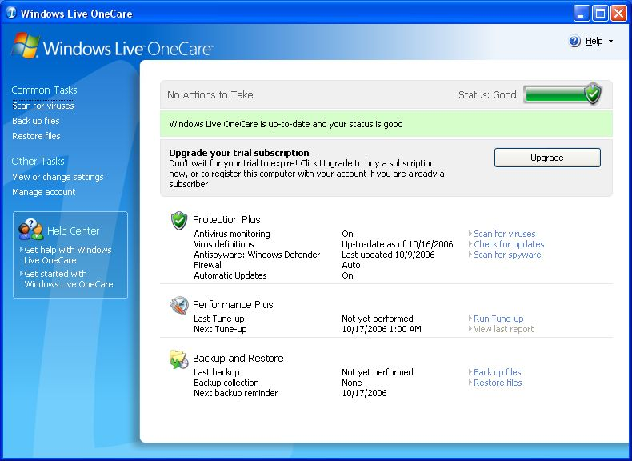
- In the screen titled 3. Install Windows Live OneCare, click Install.
- Wait until the process finishes. It should take about 5 minutes, and then show you a Congratulations message.
- Leave the Restart Now box checked and click Continue.
- In the Windows Live OneCare screen, click Yes.
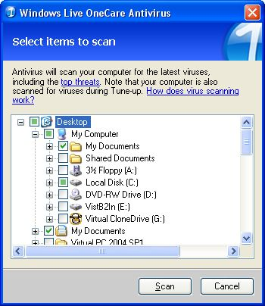
- When the virtual machine restarts, you should see the Windows Live OneCare screen, as shown to the right on this page.
Running a Virus Scan
- In the Windows Live OneCare box, in the left pane, click Scan for viruses.
- In the box that appears, clear all the check boxes and check My Documents. Some other boxes show green squares, but only My Documents should be checked, as shown to the right on this page. Click the Scan button.

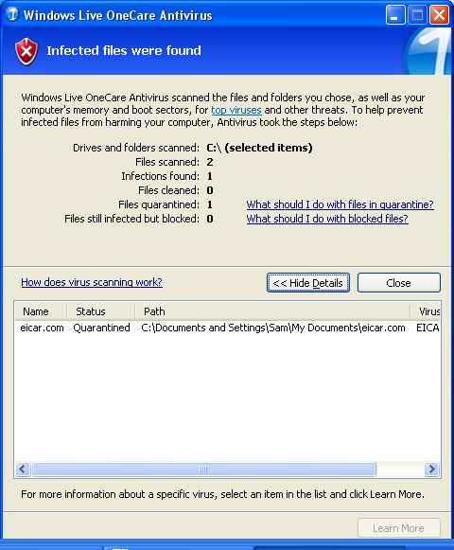
- You should see a message saying Infected files were found as shown to the right on this page. Click the Details button to see the lower pane. The file found was eicar.com.

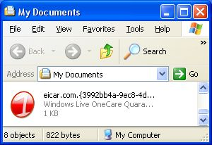
- Click Start, My Documents. The eicar file is still there, but OneCare has changed it to a Quarantine file with a big red 1 icon, as shown to the right on this page.

Revised 10-16-06

