Use your Virtual Machine
- You can’t do this project on the host machine.

Testing Your Computer for Viruses with PC Pitstop

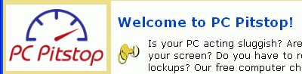
Open Internet Explorer, click in the Address bar near the top of the window, and type in

www.pcpitstop.com

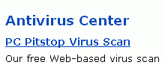
Then press the Enter key open the PC Pitstop page, as shown to the right on this page

Click on AntiVirus in the upper left part of the window. The Antivirus Center page opens, as shown to the right on this page. Click PC Pitstop Virus Scan.
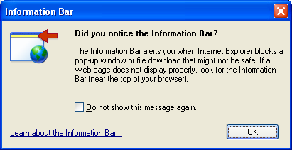

If an Information Bar box opens, as shown to the right on this page, click OK.

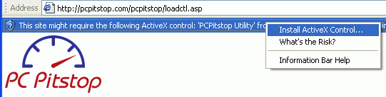
Click the yellow bar at the top of the browser window, and click Install ActiveX Control… as shown to the right on this page.
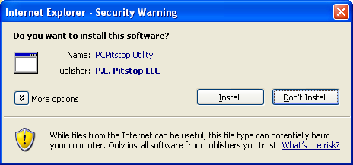

When the Internet Explorer – Security Warning box opens, as shown to the right on this page, click Install.

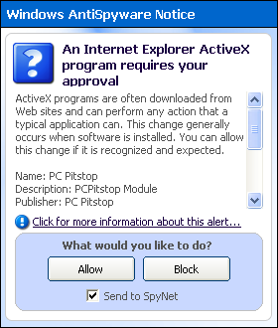
If a Windows AntiSpyware Notice box opens, as shown to the right on this page, click Allow.

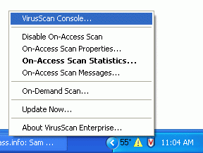
Stopping McAfee Antivirus
- During the PC Pitstop virus scan, we must disable the McAfee resident virus scanner. Look on the lower right corner of the desktop near the clock for a little blue shield with a red V on it. Right-click that shield and select VirusScan Console as shown to the right on this page.

- A VirusScan Console window opens. Click Buffer Overflow Protection as shown to the right on this page, and click the red square button to stop it.
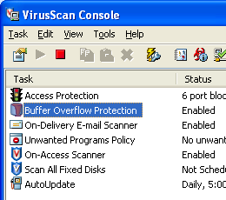

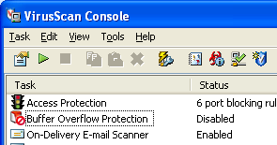
- The Buffer Overflow Protection icon will show a red circle-and-slash icon over it, and its Status will change to Disabled, as shown to the right on this page. This is a dangerous thing to do – don’t open new Web pages or insert floppies or CDs while the virus scanner is off. We’ll just leave it off while the other virus scanner is running, and turn it back on when it’s done.

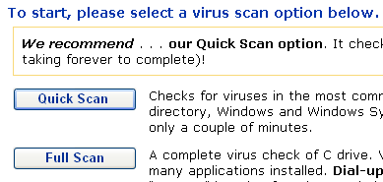

In the PC Pitstop window, click the Quick Scan button, as shown to the right on this page.

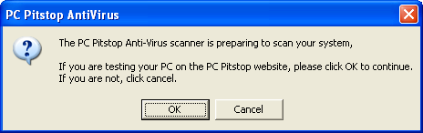

When a PC Pitstop Utility box opens, as shown below, click OK.
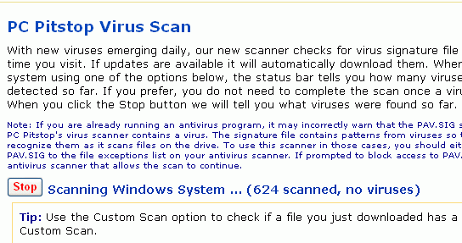

Wait while the PC Pitstop virus scan runs. It will show you the number of files scanned, as shown to the right on this page.



When the scan is complete, it will show your results, as shown to the right on this page.

Enabling McAfee Antivirus
- In the VirusScan Console window, click Buffer Overflow Protection as shown to the right on this page, and click the green triangle button to start it. The status should change to Enabled as shown below on this page.
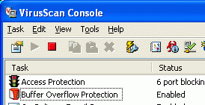

Last Updated: 3-27-06

