Getting a GMail Account
- If you already have a GMail account, you can use it for this project. If you don’t have one, or you prefer to make a new one, check your email. Your instructor has invited you to make a new GMail account. If you can’t find the invitation, ask your instructor to send you another one. Follow the instructions in your invitation email to get your GMail account.
Use your Virtual Machine
- You can’t do this project on the host machine.

Downloading and Installing Google Desktop
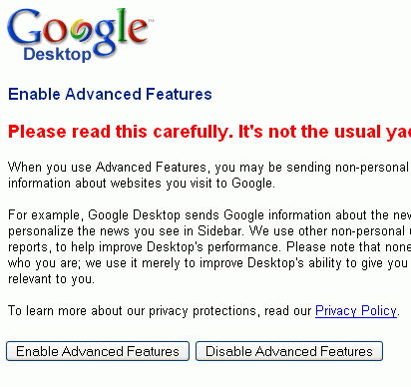
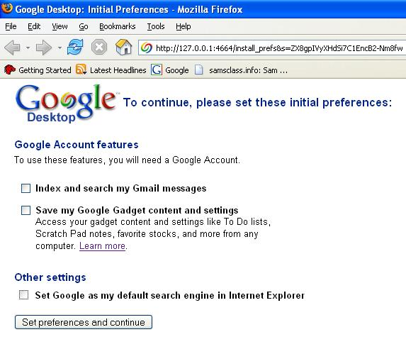
- Start a Web browser such as Internet Explorer. Go to desktop.google.com
- Click the Agree and Download button.
- A File Download – Security Warning box opens. Click Run.
- An Internet Explorer – Security Warning box, click Run. The Google Desktop Installer appears.
- If a box pops up saying Google Desktop needs to close some programs, allow that.
- In the initial preferences screen, uncheck all three boxes, as shown to the right on this page, and click Save preferences and continue.
- In the next screen, click No, don’t personalize my homepage.
- In the Google Desktop window shown immediately to the right on this page, click Enable Advanced Features.
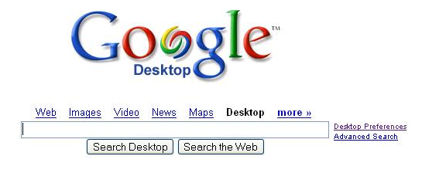
- The next screen is the Google Desktop home page, as shown to the right on this page. On the right side, click Desktop Preferences.

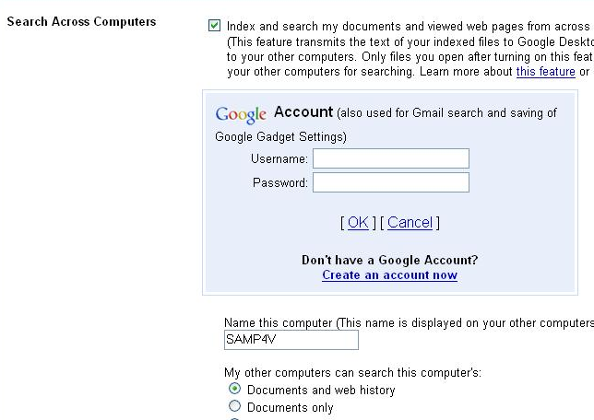
- In the Google Desktop Preferences page, click the Google Account Features tab. Check the Index and search my documents box, as shown to the right on this page. Enter your Google username and password and click the blue OK.
- Verify that the Documents and web history radio button is selected, as shown to the right on this page, and clck Save Preferences.

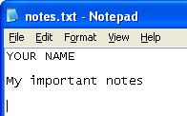
Creating a Text Document
- Click Start, All Programs, Accessories, Notepad. Type in some text as shown to the right on this page, and save the file in the My Documents folder with any name you like.

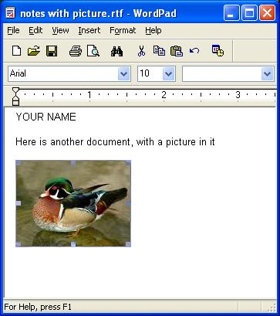
Creating a Document With an Image
- Click Start, All Programs, Accessories, WordPad. Type in some text as shown to the right on this page. Add an image to the document this way:
  - Open a Web browser and go to google.com
  - Click the Images link
  - Type in a topic and press the Enter key
  - Right-click on the desired image and select Copy image
  - Right-click in the Wordpad document and select Paste
- Save the file in the My Documents folder with any name you like.

Searching your Desktop from Another Virtual Machine
- Go to another virtual machine. If it doesn’t already have Google Desktop on it, download and install it the same way you did above.
- Double-click the Google Desktop icon on the desktop.
- The Google Desktop home page appears, as shown to the right on this page. On the right side, click Desktop Preferences.

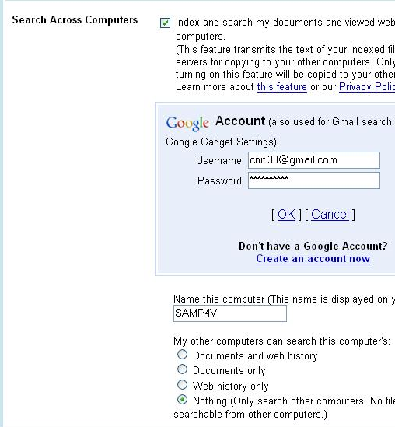
- In the Google Desktop Preferences page, click the Google Account Features tab. In the Search Across Computers section, make sure the Index and search my documents box is checked, as shown to the right on this page. Click the blue Change account link, and enter your own Gmail Username and Password. Click OK.
- Verify that the Nothing radio button is selected, as shown to the right on this page, and clck Save Preferences.
- Click the Google Desktop logo to return to the main Google Desktop page.
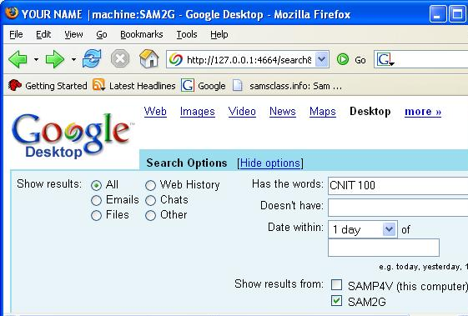
- Click Advanced Search. If Google Desktop is working correctly, you should see an option to search the other machine’s desktop. If you don’t, try waiting a couple minutes. If you still don’t see the option, return to Google Desktop Preferences and change the account name to cnit.100demo with a password of ccsfpassword
- With that user name and password, you should see an option to search for files on the machine I set up previously, as shown to the right on this page. The machine I set up when writing this project is named SAM2G. Try searching for CNIT 100 on it. You should find a Test Word Document I saved on that machine with a picture in it. Try to open the file and see what’s inside.
- Consider what you learned – can you use Google Desktop as an easy way to back up your files? Why or why not?

