Broadband Costs
Search the Internet to find specific companies selling the various types of Internet access in the chart below. Find speeds and price data.

When you are done, type the results into a Word document and save it on a floppy for the Results Presenter.
Type Company Speed Cost

Dial-up

Cable

T3

OC3

Internet Backbone
- Open a browser and go to caida.org
- At the top of the page, click Tools.
- In the Visualization section, click Mapnet.
- In the center-right portion of the page, click run mapnet.
- A map of the world opens. This is showing the Internet backbone – the main data links that carry the world’s Internet traffic.
- In the top row, select View USA. On the right in the second row, select Commercial Backbones.

- In the list on the lower left, click a commercial service provider to see that provider’s backbone. Then use the mouse to point to a specific line, and the speed and location of that line appears in the lower right. For example, in the figure below I have highlighted an AT&T WorldNet link from San Francisco to Los Angeles. This link has two “pipes” (probably fiber optic cables) – one running at 45 Mbps and the other at 155 Mbps.
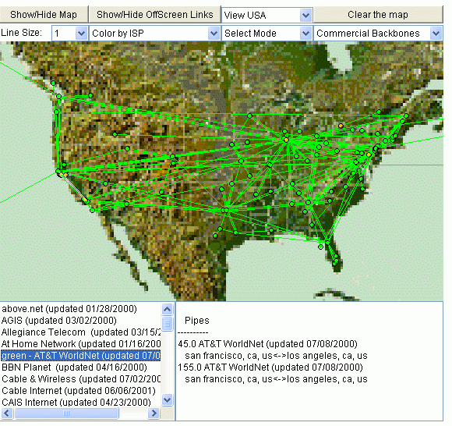

- Find examples of links with the speeds below. Hint –switch to Color by Bandwidth, and try other companies.
Speed Company From city To city
1.5 Mbps

45 Mbps

2488 Mbps

