BEFORE YOU START:

Decide what domain name you want to register. It can be anything you want, such as cnit100xy. Each person must use a different domain name, so I recommend replacing the xy with your initials. Write it below:

Domain name: __________________________________

Also choose a Web Site to connect to that domain name. If you were setting up a real business, this Web Site would be at your own Web server. For this project, you can use any Web page, either your own page or someone else’s. However, some Web sites are already forwarded and cannot be forwarded again, so you should think of two alternate sites to try.

Web Site: __________________________________

Alt. Web Site: __________________________________

Alt. Web Site: __________________________________

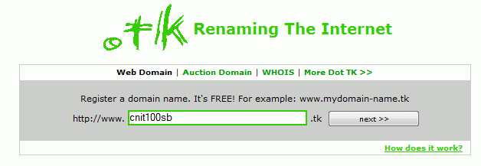
Free Domain Names at TK.com
- Open Internet Explorer and go to www.dot.tk
- In the REGISTER A DOMAIN NAME box, enter your desired domain name and click the next button. If that domain is already registered, or you see a page in some foreign language, click the Back button and try a different domain name.

- If the domain is available, you will a message saying This domain is still available. Accept the default selection of Free domain as shown to the right no this page, and click next.
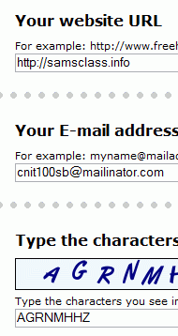
- In the Your website URL box, enter your Web Site. Enter an email address and fill in the characters you see, as shown to the right on this page. Click next. If you want to avoid spam in your mailbox, use a mailinator address--just make up anything you can remember and add @mailinator.com to the end of it.
- In the next page, labeled Registration Step 2 of 2, scroll down and fill in the form. Use a password you can remember. Click Continue.
- You should see a Your registration has succeeded! Message.
- Now you need to read your email. Open another browser window and look for a message from vmailerd@dot.tk. If you used a mailinator address, read it at mailinator.com.
- Find the CONFIRMATION CODE in that email message, and copy it to the clipboard. Click the link in step 1 in that email message. Paste in your CONFIRMATION NUMBER and click Confirm.
- A page appears saying Login to My Dot TK. Enter your email address and the password you chose in step 5, and click Login.
- Open Internet Explorer and type in your domain name. it has to start with www and end with .tk, like www.cnit100sb.tk
- It took a long time (ten minutes or more) for them to activate my domain, so if yours is not working yet, take a look at the one I made to see how they work:
http://www.cnit100sb.tk/

