Do not use the virtual computers for this project.
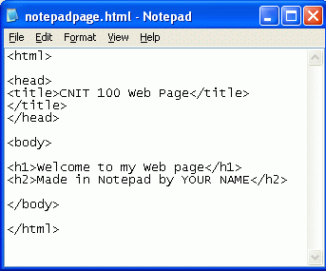
Making a Web Page with Notepad
- Click Start, All Programs, Accessories, Notepad.
- Type in the text you see to the right on this page. Save the file with the name notepadpage.html in the My Documents folder. Make sure you use the .html extension! It your file has a .txt extension it will not work!
- Don’t close Notepad, but resize it so that it uses no more than half the screen.

Viewing your Web Page Locally
- Click Start, My Documents. Find the notepadpage.html icon and double-click it. It will open in a Web browser, as shown below on this page. Resize this window so it’s visible on the screen beside the Notepad file.
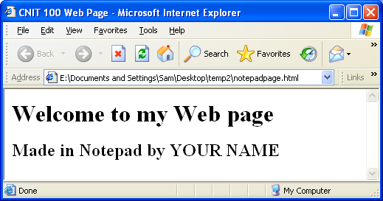

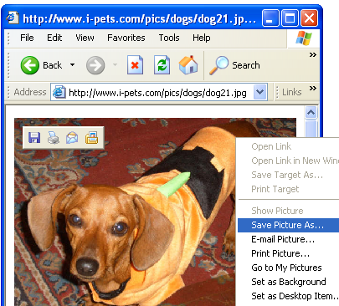
Saving an Image File
- Open a new browser window and go to Google.com. Do a search for anything you like, such as dogs, and find a picture you like.
- You need to save this picture on your hard disk, and you need to make sure you know its exact file name, including the file extension.
- Right-click on the picture you like best and select Save Picture As…, as shown to the right on this page.

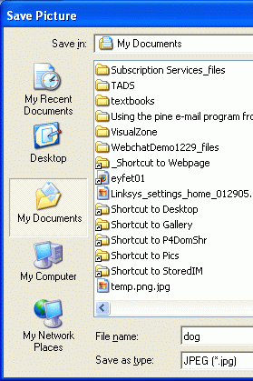
- The Save Picture dialog box opens, as shown to the right on this page. In the left section of the Save Picture dialog box, click the My Documents folder.
- In the File name: box, type in a short, simple name you can remember, like dog. Notice the file extension in the Save as type: box—it should be either gif or jpg. Write down the complete file name below. In my example, the file name is dog.jpg but your name may be different.

Image File Name: __________________________
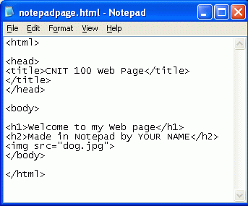
Adding the Image to the Web Page
- Add this line to the Notepad file, after the line including YOUR NAME, as shown to the right on this page:
<img src=”dog.jpg”>
- Click File, Save to save the file. In the browser window, click View, Refresh. The image should appear, as shown to the right on this page.

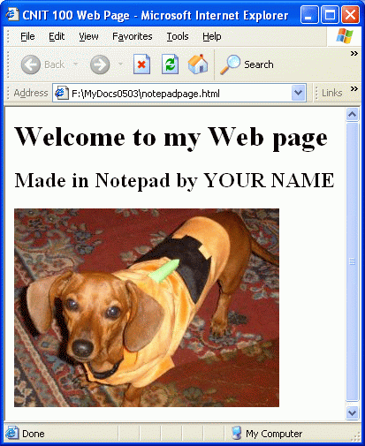

- In the browser, click View, Refresh. The image should appear, as shown to the right on this page.
Publishing the Web Page on the CCSF Server
- This Web page consists of two files in your my Documents folder: notepadpage.html and dog.jpg. But no one can see the files on your computer – to make them available to other people, you have to move the files up to a Web server.
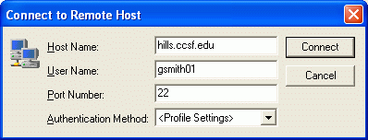
- Click Start, All Programs, SSH Secure Shell, Secure File Transfer Client. When the Secure File Transfer window opens, press the Enter key.
- In the Connect to Remote Host window, enter a Host Name of hills.ccsf.edu and a User Name of your HP-UNIX ID. Your HP-UNIX ID is the same ID you use to get your CCST email, or to log in to the computers in the ACRC in Batmale room 301. Press the Enter key.
- One or two more boxes appear. Press Enter to close them. When you see the Enter Password box, enter your birthday in the format jul0369
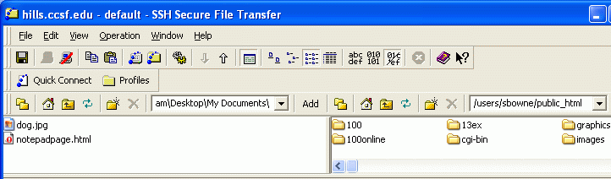
- Double-click the public_html folder in the right pane to open it, and navigate to My Documents folder in the left pane. You should see the two files notepafpage.html and dog.jpg in the left pane, as shown below on this page.

- Drag the two files from the left pane to the right pane and drop them. This copies your files to the server.
- Open a browser and type in this URL to see your page:
hills.ccsf.edu/~gsmith01/notepadpage.html
Replace gsmith01 with your HP-UNIX ID.

Last modified 4-26-06 3 pm

