Installing IIS
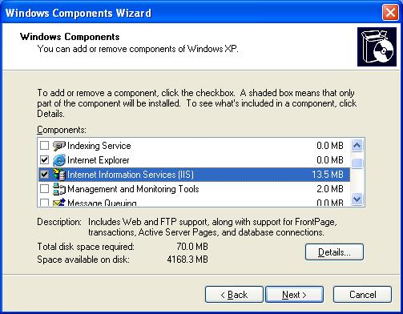
- Use your virtual machine.
- Click Start, Control Panel. Double-click Add or Remove Programs. In the Add or Remove Programs box, click Add/Remove Windows Components.
- In the Windows Components Wizard, check Internet Infornation Services (IIS) as shown to the right on this page. Click Next. If it asks you to insert a Windows XP installation CD, get one from your instructor.
- In the Completing the Windows Components Wizard screen, click Finish.
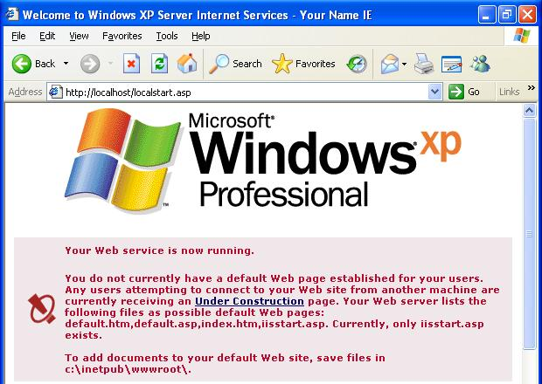
- Internet Information Services is Microsoft’s Web server. Your Windows XP machine will now deliver Web pages to other machines when they send HTTP requests to it.
- Close all windows. Restart the virtual machine.
- Click Start, All Programs, Internet Explorer. Enter a Web address of http://localhost and press the Enter key. A page opens, as shown to the right on this page, saying Your Web service is now running.
Making a Website Folder
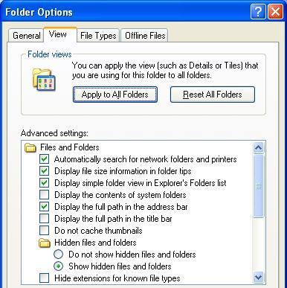
- Click Start, My Computer. Double-click the Shared Documents folder. Right-click an empty portion of the Shared Documents window and click New, Folder. Type in the name Website and press the Enter key.
- In the Shared Documents window, from the menu bar, click Tools, Folder Options. Click the View tab. Find the line labeled Hide extensions for known file types and make sure there is not a check mark next to it. Click OK.
Making a Web Page
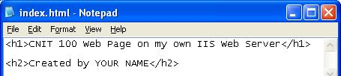
- Double-click the Website folder to open it. Right-click an empty portion of the Website window and click New, Text Document. Type in the name index.html and press the Enter key. In the Rename box, click Yes.
- Right-click the index.html icon and click Open With…, Notepad.
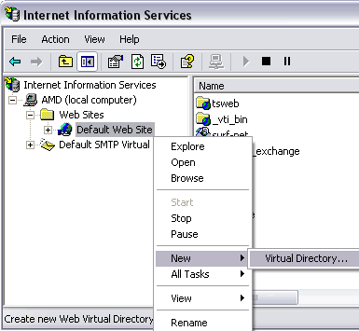
- In Notepad, enter the two lines of HTML as shown to the right on this page. Click File, Save to save your page.
Creating a Virtual Directory
- All you have to do now is to tell IIS where your Web site is. To do that, click Start, Control Panel. If you see a Pick a category header, click Switch to Classic View in the upper left. Double-click Administrative Tools.
- Double-click on the Internet Information Services icon.
- In the Internet Information Services console, in the left pane, click the + sign to expand your computer’s branch, as shown to the right on this page. Expand the Web Sites branch. Right-click Default Web Site, and click New, Virtual Directory….

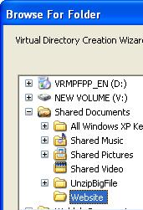
- In the Welcome to the Virtual Directory Creation Wizard screen, click Next.
- In the Virtual Directory Alias screen, enter home and click Next.
- In the Web Site Content Directory screen, click the Browse button. Expand the Shared Documents folder and click the Website folder, as shown to the right on this page. Click OK. In the Web Site Content Directory screen, click Next.

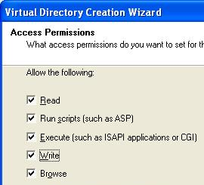

- In the Access Permissions screen, check all the boxes, as shown to the right on this page. Click Next.
- In the Internet Services Manager box, click Yes.
- In the You have successfully completed the Virtual Directory Creation Wizard screen, click Finish.
Viewing Your Page Locally
- Open Internet Explorer and enter this Web address: http://localhost/home/index.html
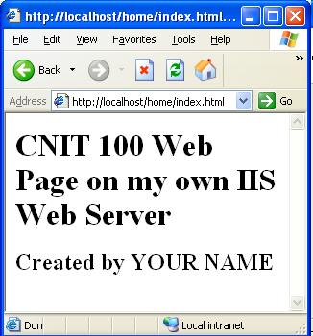
- Press the Enter key to open the page. You should see the Web page you made with your name on it, as shown to the right on this page.
Finding Your Computer’s Name
- Click Start. Right-click My Computer and click Properties. Click the Computer Name tab. Find the Full computer name and write it down. It should be something like S214-07v
Viewing Your Page on Another Machine
- Go to another computer in the room. Open Internet Explorer and enter this Web address:
http://S214-07v/home/index.html
(Replace S214-07v with your computer’s name.)
- Press the Enter key to open the page. You should see the Web page you made with your name on it.
Based on this Web page: http://www.webwizguide.com/asp/tutorials/installing_iis_winXP_pro.asp

