Note: The instructions below assume you are using Internet Explorer version 6. If you are using IE 7, watch for the italic notes – a few things are different. To find your version, click Help, About Internet Explorer from the Internet Explorer menu bar.
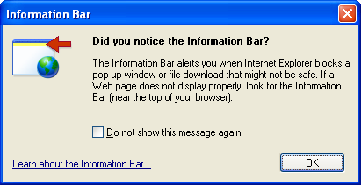
Running PC Pitstop ActiveX Tests
- Open Internet Explorer and go to pcpitstop.com. In the left column, click Check ActiveX. An Information Bar box opens, as shown to the right on this page. Click OK or Close (the button has a different name in IE 7).
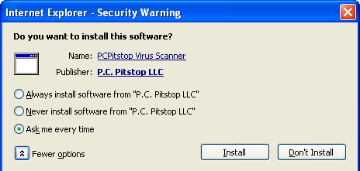
- Click the yellow Information bar near the top of the Internet Explorer window, and click Install ActiveX Control.
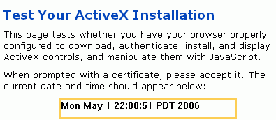
- In the Internet Explorer – Security Warning box, click the More Options button, to make your window show all the options as shown to the right on this page. Internet Explorer just read the digital certificate that was attached to the ActiveX control, and found out the name of the company that signed it – PCPitstop. Now it is asking you whether you trust PCPitstop or not.
- In the Internet Explorer – Security Warning box, click the Always install software from "P.C. Pitstop LLC" radio button, and click the Install button.
- The date and time appears in the yellow box, as shown to the right on this page. This indicates that ActiveX is operating.
- Close Internet Explorer.
Removing PC Pitstop from the Trusted Publishers List
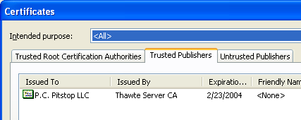
- Open Internet Explorer. Click Tools, Internet Options. Click the Content tab. Click the Publishers button. Click the Trusted Publishers tab. You should see P.C. Pitstop LLC, as shown to the right on this page.

- In the Certificates window, click on the P.C. Pitstop line to select this publisher. Click the Remove button.
- In the Certificates window, click Yes.
- In the Certificates window, click Close.
- In the Internet Options window, click OK.
- Close Internet Explorer.
Running PC Pitstop ActiveX Tests Again
- Open Internet Explorer and go to pcpitstop.com. In the left column, click Check ActiveX. The date and time appears in the yellow box, showing that ActiveX is working. No warning messages appeared. That's because the ActiveX controls for this page were already loaded.
- ActiveX controls remain on your computer until you remove them. They are installed programs.
Managing Installed ActiveX Controls
- In the Internet Explorer window, click Tools, Internet Options.
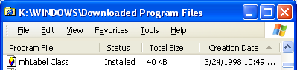
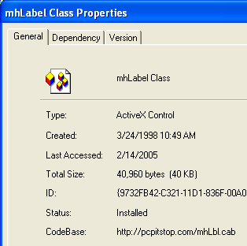
- In the Internet Options window, on the General tab, in the Temporary Internet Files section, click the Settings button. (In IE 7, the section is named Browsing history.) In the Settings box, click the View objects button. You should see a Downloaded Program Files window as shown to the right on this page. Find the mhLabel Class object in the list, right-click it, and click Properties.
- A mhLabelClass Properties box opens, as shown to the right on this page. Notice at the bottom the CodeBase: item shows that this is the object installed by pcpitstop.
Removing the Installed ActiveX Control
- Close all windows. This is necessary because you cannot delete the ActiveX control while it is in use.
- Open Internet Explorer.
- If you are using Internet Explorer version 6:
  - Click Tools, Internet Options.
  - In the Internet Options window, on the General tab, in the Temporary Internet Files section, click the Settings button.
  - In the Downloaded Program Files window, right-click the mhLabelClass item and click Remove. In the Remove Program File box, click Yes. The file vanishes.

- If you are using Internet Explorer version 7:
  - Click Tools, Manage Add-ons, Enable or Disable Add-ons.
  - In the Manage Add-ons box, click the Show: drop-down list and select Add-ons that have been used by Internet Explorer, as shown below on this page. Click the mhLabelClass item and click the Delete button in the lower right portion of the window. The file vanishes.
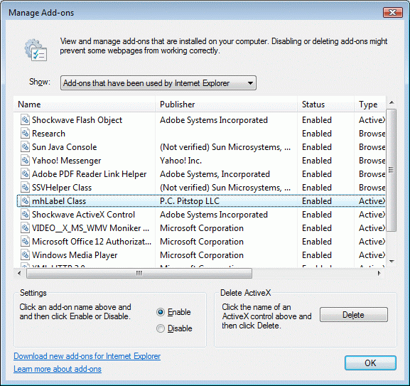
- Close all windows.
Running PC Pitstop ActiveX Tests
- Open Internet Explorer and go to pcpitstop.com. In the left column, click Check ActiveX. An Information Bar box opens. This shows that the ActiveX control is no longer installed, and that PC Pitstop is no longer a trusted publisher.
Last modified 11-12-06

