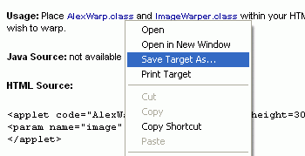
Getting a Java Applet
- Open a browser and go to javaboutique.internet.com/AlexWarp
- Scroll down to the Usage section. Right-click the AlexWarp.class link and select Save Target As…, as shown to the right on this page. Save the file in the My Documents folder.
- Right-click the ImageWarper.class link and select Save Target As…,. Save the file in the My Documents folder. These two .class files are precompiled Java applets – compiled into bytecode.
Getting an Image
- Open a browser and go to google.com or any other search engine you like. Search for any topic you like, such as horses and find an image you like. Right-click on the image and save it in the My Documents folder.
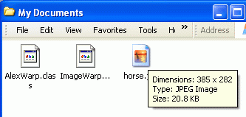
Finding the Size of Your Image
- Click Start, My Documents. You should see the three files you saved: AlexWarp.class, ImageWarper.class, and the image file, as shown to the right on this page.
- Point to the image file and wait a few seconds. A screentip box should appear showing the size of your image, as shown to the right on this page. My image, for example, was 385 pixels wide, and 282 pixels high. Write down the width and height of your image in the box to the right.

Width: _______________

Height: _______________
Making a Web Page
- Click Start, All Programs, Accessories, Notepad.
- Type in the HTML Form shown below. Use the actual width and height of your image instead of the numbers in the example below, and use the name of your image file instead of horse.jpg
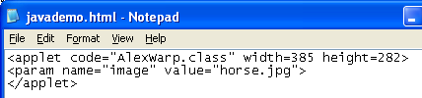

- Save the file in the My Documents folder with the name javademo.html
Publishing the Web Page on the CCSF Server
- Click Start, All Programs, SSH Secure Shell, Secure File Transfer Client. When the Secure File Transfer window opens, press the Enter key.
- In the Connect to Remote Host window, enter a Host Name of hills.ccsf.edu and a User Name of your HP-UNIX ID. Your HP-UNIX ID is the same ID you use to get your CCST email, or to log in to the computers in the ACRC in Batmale room 301. Press the Enter key.
- One or two more boxes appear. Press Enter to close them. When you see the Enter Password box, enter your birthday in the format jul0369
- Double-click the public_html folder in the right pane to open it, and navigate to My Documents folder in the left pane. You should see the four files you made in the left pane, as shown below.
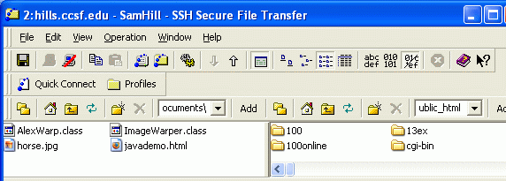

- Drag all four of the files from the left pane to the right pane and drop them. This copies your Web page, image, and the Java applets to the server.
Viewing your Page With the Java Applet
- Open a browser and type in this URL to see your page:
hills.ccsf.edu/~gsmith01/javademo.html
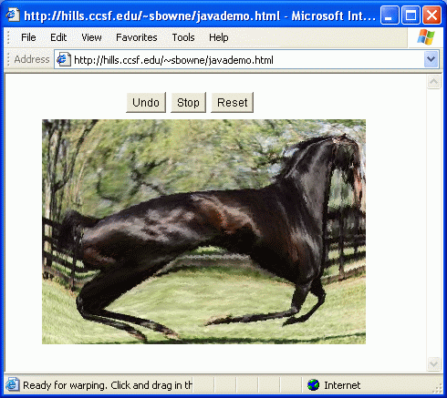
Replace gsmith01 with your HP-UNIX ID.
- Your page should look like the example to the right on this page. Click on the image. Then click and crag across the image to distort it. That’s what the Java Applet does.

Last modified 5-1-06

