Making a Perl Script
- Click Start, All Programs, Accessories, Notepad.
- Type in the Perl script shown below. Be careful to make it exactly correct. This script captures data from a form and writes it into an HTML file.
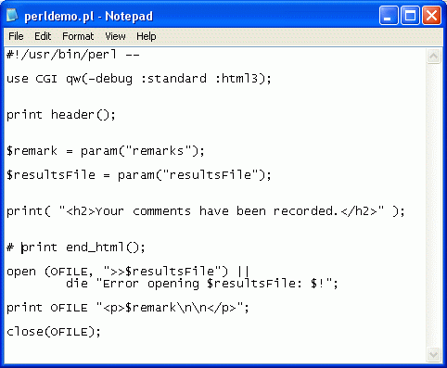

- Save the file in the My Documents folder as perldemo.pl
- Be careful not to save it as perldemo.pl.txt
Making an HTML Form
- Click Start, All Programs, Accessories, Notepad.
- Type in the HTML Form shown below. Be careful to make it exactly correct. NOTE: You will have to replace the sbowne in the second and third lines with your HP-UNIX ID, which will look something like ssmith01. There is a list of HP-UNIX IDs on the bulletin board.
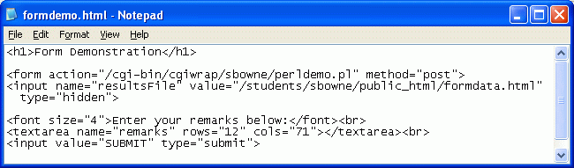
- Save the file in the My Documents folder with the name formdemo.html

Publishing the Form on the CCSF Server
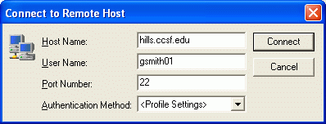
- Click Start, All Programs, SSH Secure Shell, Secure File Transfer Client. When the Secure File Transfer window opens, press the Enter key.
- In the Connect to Remote Host window, enter a Host Name of hills.ccsf.edu and a User Name of your HP-UNIX ID. Your HP-UNIX ID is the same ID you use to get your CCST email, or to log in to the computers in the ACRC in Batmale room 301. Press the Enter key.
- One or two more boxes appear. Press Enter to close them. When you see the Enter Password box, enter your birthday in the format jul0369

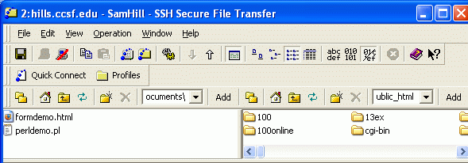
- Double-click the public_html folder in the right pane to open it, and navigate to My Documents folder in the left pane. You should see the file formdemo.html in the left pane, as shown below.
New Folder button

- Drag formdemo.html from the left pane to the right pane and drop it. This copies your HTML Form to the server.
Putting the Perl Script on the CCSF Server
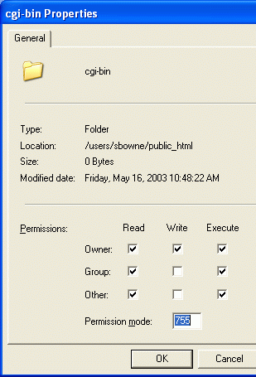
- On the right pane of the hills.ccsf.edu window, click the New Folder button, as shown in the figure above on this page. A new folder icon appears. Type in the name cgi-bin and press the Enter key.
- Right-click the cgi-bin folder and select Properties. In the cgi-bin Properties box, click all three of the Execute boxes to put check marks in them, as shown to the right on this page. Make sure all three of the Read boxes are checked too. Then click OK. This step makes the directory usable by Internet users.
- Double-click the cgi-bin folder to open it.
- Drag the perldemo.pl file from the left pane to the right pane and drop it.
- Right-click the perldemo.pl file and click Properties.
- In the perldemo.pl Properties box, make sure all three of the Execute boxes and all three of the Read boxes are checked. Then click OK
Testing Your Form
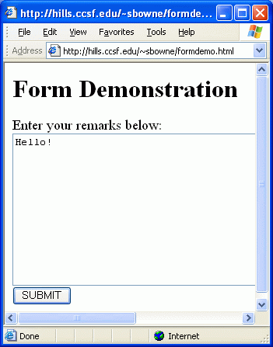
- Open a browser and type in this URL to see your form:
hills.ccsf.edu/~gsmith01/formdemo.html
Replace gsmith01 with your HP-UNIX ID.
- Your form should look like the example to the right on this page. Type in some text, such as Hello! and click the SUBMIT button. If your script is working correctly, you will see a message saying Your comments have been recorded.

- To see your comments, open another browser and type in this URL:
hills.ccsf.edu/~gsmith01/formdata.html
Replace gsmith01 with your HP-UNIX ID. You should see the comment you saved, as shown below.
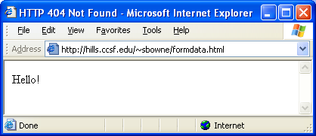

Last modified 5-1-06

