Don’t use the virtual machine for this project.
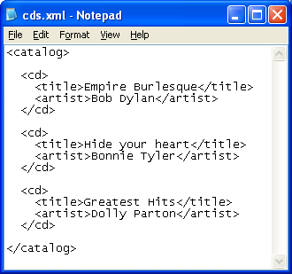
Writing an XML Document
- XML is just used to store information in a text file.
- Click Start, All Programs, Accessories, Notepad. Type in the text shown to the right on this page. Notice how the tags come in pairs: the opening tag of <catalog> at the top matches the closing tag of </catalog> at the bottom. Each CD is enclosed by <cd> and </cd> tags, and so on.
- Save the file in the My Documents folder as cds.xml (make sure it is not named cds.xml.txt).

Opening the XML Document in Internet Explorer
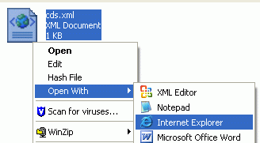
- Click Start, My Documents. Right-click the cds.xml file, point to Open With…, and click Internet Explorer as shown to the right on this page.
- In the Information Bar box, click OK.
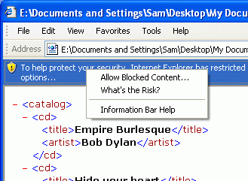

- Click the yellow Information bar at the top of the Internet Explorer window and select Allow Blocked Content… as shown to the right on this page.
- In the Security Warning box, click Yes.
Using Internet Explorer’s XML Parser
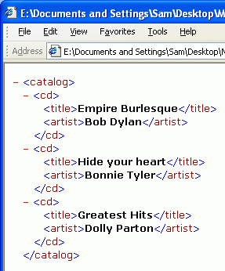
- Internet Explorer now shows the XML file, as shown to the right on this page. This document was created by the XML Parser contained in Internet Explorer.
- Notice that the tags are color-coded, and there are red minus signs to the left of the opening <catalog> and <cd> tags.

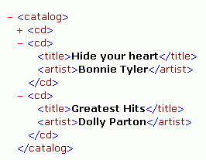
- Click the minus sign to the left of the first <cd> tag. The Empire Burlesque information vanishes, as shown to the right on this page, and the minus sign changes to a plus sign. This is called collapsing the item.
- Click the plus sign to expand the CD item again.
- Click the minus sign to the left of the <catalog> tag. All the text vanishes except for one <catalog> tag with a plus sign next to it. The entire XML file contains one object named catalog and you have collapsed it, like closing a book so you can only see the title on the cover.
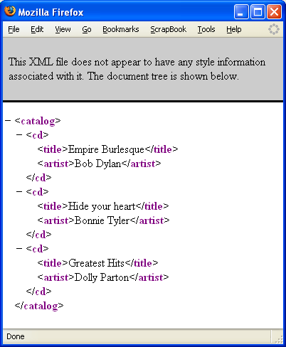
Using Firefox’s XML Parser
- In theMy Documents folder, right-click the cds.xml file, point to Open With…, and click Firefox.
- Firefox now shows the XML file, as shown to the right on this page, because Firefox also contains an XML Parser.
- Click the minus and plus signs in the Firefox window—they work the same way they did in Internet Explorer.
- Notice that the page looks different in Internet Explorer and Firefox. The colors and fonts are different. Why aren’t they the same? The reason is in the gray box at the top of the Firefox window – there is no style information.
Writing an XSL Document
- XSL is used to tell the browser how to display XML information. The style sheet below tells the browser to put the word Title: before each CD title, and to make the artist names italic.
- Click Start, All Programs, Accessories, Notepad. Type in the text shown below on this page.
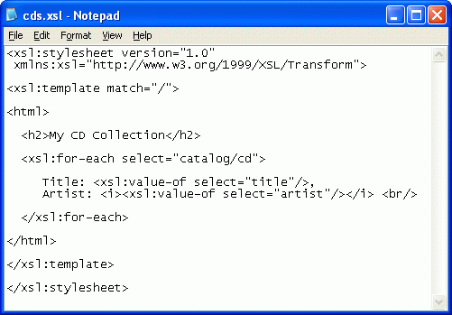
- Save the file in the My Documents folder as cds.xsl.

Connecting the XSL Document to the XML Document
- In the My Documents folder, right-click the cds.xml file, point to Open With…, and click Notepad. If Notepad is not on the list, click Choose Program and select Notepad.
- Add one line to the top of the cds.xml file, as shown below. This line tells the XML parser where to find the XSL file. Save the file.
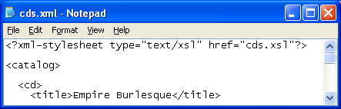
Viewing the XML Document in Internet Explorer
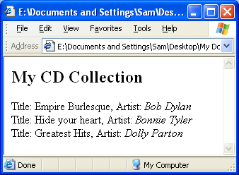
- In the Internet Explorer window, click View, Refresh. Now the page is formatted, as shown to the right, and the plus and minus signs no longer appear.

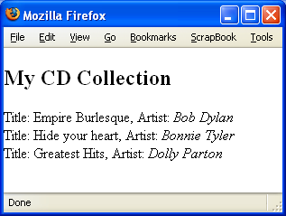
Viewing the XML Document in Firefox
- In the Firefox window, click View, Reload. Now the page is formatted, as shown to the right, and looks very similar to the page as seen in Internet Explorer.

Based on a tutorial from http://www.w3schools.com/xsl/xsl_for_each.asp
Last modified 5-1-06

