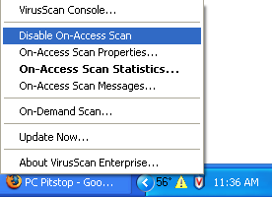
Disabling McAfee Antivirus
- While doing this project, we must disable the McAfee resident virus scanner. Look on the lower right corner of the desktop near the clock for a little blue shield with a red V on it. Right-click that shield and select Disble On-Access Scan as shown to the right on this page.

- The shield icon now shows a red circle-and-slash on it, showing that it is disabled, as shown to the right.
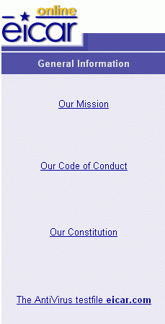

Saving the eicar.com test virus in the My Documents folder

Open Internet Explorer, click in the Address bar near the top of the window, and type in

eicar.com

The eicar page opens, as shown to the right on this page. In the left bar, click The AntiVirus testfile eicar.com.

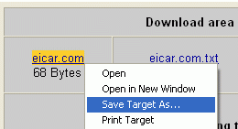
In the next screen, scroll down to the bottom and find the Download area using the standard protocol http. Right-click eicar.com and select Save Target As… as shown below on this page. Save the file in the My Documents folder.


Downloading AVG Free AntiVirus Software
- Open Internet Explorer. Go to free.grisoft.com
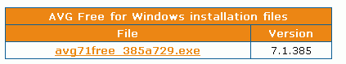
- Scroll to the bottom of the page and click on GET AVG Free for Windows – RIGHT NOW as shown at the top right on this page.
- In the next screen, scroll to the bottom and click avg71free_385a729.exe.

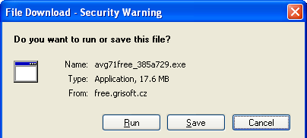
- In the File Download – Security Warning box, click Run.

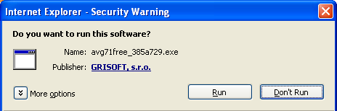
- In the Internet Explorer – Security Warning box, click Run.
- In the AVG Free Edition installer window, click Next, Accept, Accept.
- In the Accept Installation type box, accept the default selection of Standard installation (recommended) and click Next.
- In the Installation summary box, click Finish.
- If some Windows AntiSpyWare Notice boxes appear, click Accept.
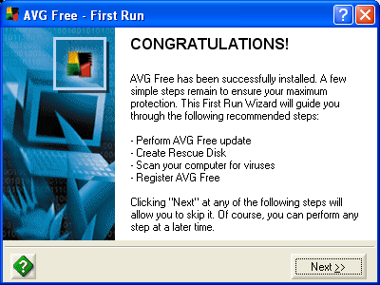
- In the CONGRATULATIONS! box, click Next >>.
- In the AVG Free Update box, click Check for Updates.
- In the Update box, click Internet.
- In the AVG Free Update Selection box, click Update.
- In the Update was successfully finished box, click OK.
- In the AVG Free Update Selection box, click Next >>.
- In the Create Rescue Disk box, click Next >>.
- In the Virus Scan box, click Next >>.
- In the AVG Free Registration box, click Next >>.
- In the YOUR COMPUTER IS PROTECTED! box, click Continue….
- In the AVG Free Registration box, click Next >>.
- In the AVG Free Registration box, click Next >>.

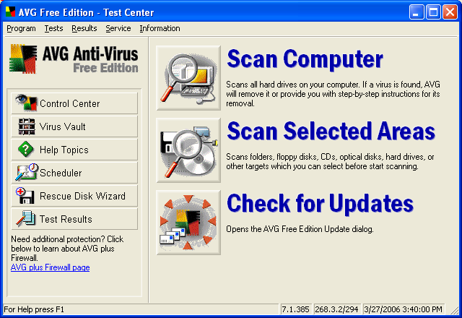
- In the Avg Free Edition – Test Center window, click the button to the left of the words Scan Selected Areas.

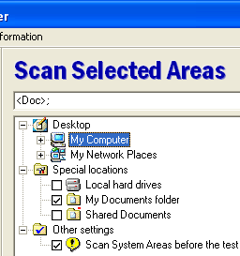
- In the tree structure that appears, check My Documents folder as shown to the right, and click the Scan Selected Areas button.
- You should see the red message Virus identified EICAR_Test as shown below.
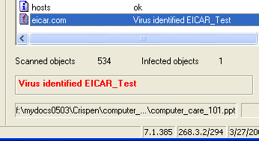

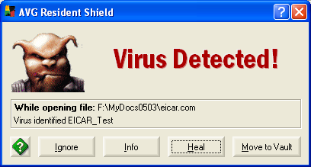
- Click Start, My Documents. Find the eicar.com file and double-click it. A Virus Detected! box opens, as shown to the right on this page. Click the Heal button. In the Object was successfully healed! Box, click OK.
- Look in My Documents – the eicar.com file is gone.

Revised 3-27-06

