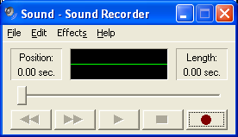
Setting Up the Microphone
Record
Stop
Play
- Do not use the virtual machine.
- Plug in the headphones provided by your instructor. There are two plugs – one for the speakers, and one for the microphone. They should plug into corresponding ports on the front of your computer.
- Click Start, All Programs, Accessories, Entertainment, Sound Recorder.
- Sound Recorder opens as shown to the right on this page. Click the Record button and talk into the microphone. You should see the green line get wavy as the sound is detected. the line does not show any waves, try this:

Click Start, Control Panel.

If you see a Pick a category header, click Switch to Classic View in the left pane.

Double-click Sound and Audio Devices.

In the Sound and Audio Devices Properties box, click the Audio tab.

In the Sound recording section, click the Volume button.

In the Recording Control box, click the Options menu item and make sure Advanced Controls is checked. That should make an Advanced button appear.

Click the Advanced button. In the Advanced Controls for Microphone box, check the Front Panel Microphone box. Close all the sound control windows, and close Control Panel.
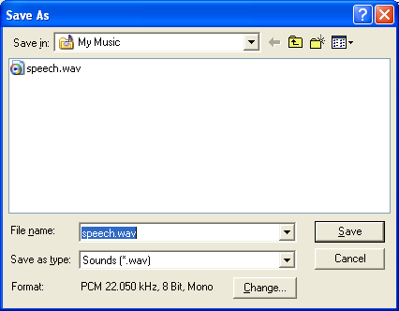
- After you get the microphone working, click the Stop button to stop recording. Click the Play button to hear the recording. You may have to adjust the plugs or audio properties to make the sound audible.
Change
Recording a MP3 File with Sound Recorder
- Once the microphone and speakers are working, click File, New. In the Sound Recorder box, click No.
- Click the Record button and record some speech. Click the Stop button to stop recording.
- In Sound Recorder, click File, Save As…. In the Save As box, click the Change button at the bottom, as shown to the right on this page.
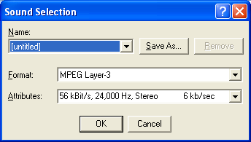
- In the Sound Selection box, select a Format of MPEG Layer 3 and Attributes of 56 kBit/s, 24,000 Hz, Stereo as shown to the right on this page. Click OK.

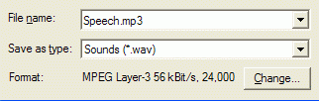
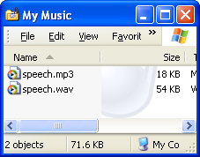
- In the Save As box, enter a file name with a .mp3 file extension, as shown to the right on this page. Make sure the Save in: box at the top of the Save As window shows the My Music folder. Click the Save button.
- Click Start, My Music. Your file should appear, as shown to the right on this page. Double-click it to play it and see how it sounds. If you don’t like it, re-record it.
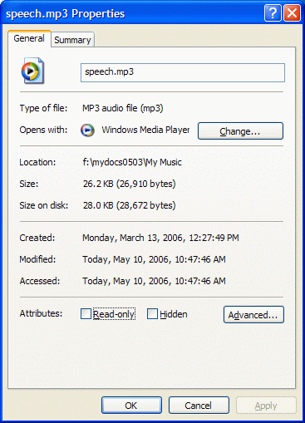
- When you are content with your audio file, right-click it and select Properties. In the Properties sheet, find the Size: as shown to the right on this page. My example file has a size of 26,910 bytes. Find the size of your file and write it down.
Creating Your RSS Feed File
- Open a browser and go to samsclass.info/100/projects/RSS_Template.html
- Highlight all the text, as shown below, right-click, and click Copy.

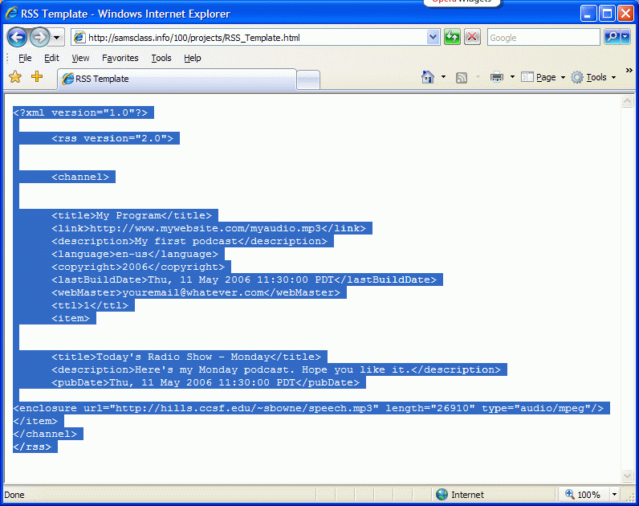
- Click Start, All Programs, Accessories, Notepad. Right-click in the Notepad window and click Paste.
- You can modify the title of the program, website address, dates, and so on in this file to make it yours. But the only part you really have to correct is the line starting <enclosure near the end. There are three changes you need to make here:
- Change sbowne to your own HP-UNIX ID
- Change speech.mp3 to the correct file name
- Change 26910 to the correct file size
- Save the file in the My Music folder with a filename of podcast.rss.
Putting your RSS Feed on the Hills Server
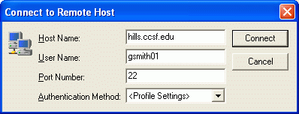
- Click Start, All Programs, SSH Secure Shell, Secure File Transfer Client.
- When the Secure File Transfer window opens, press the Enter key.
- In the Connect to Remote Host window, enter a Host Name of hills.ccsf.edu and a User Name of your HP-UNIX ID. Your HP-UNIX ID is the same ID you use to get your CCST email, or to log in to the computers in the ACRC in Batmale room 301. Press the Enter key.
- One or two more boxes appear. Press Enter to close them. When you see the Enter Password box, enter your birthday in the format jul0369
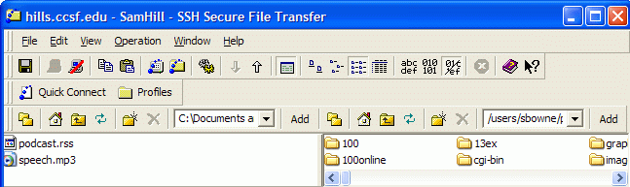
- Double-click the public_html folder in the right pane to open it, and navigate to the My Music folder in the left pane. You should see the two files podcast.rss and speech.mp3 in the left pane, as shown below on this page.

- Drag the two files from the left pane to the right pane and drop them. This copies your files to the server.

Viewing a Podcast in Internet Explorer 7
- Go to the a machine with the newest version of Internet Explorer on it (the demonstration machine in S215 has it) and open your feed by entering this URL:
hills.ccsf.edu/~gsmith01/podcast.rss
Replace gsmith01 with your HP-UNIX ID. Your podcast should open as shown below. When I tried it, clicking on the blue speech.mp3 link did not work, but right-clicking on it, saving it on the desktop, and playing it from there did. Try to play your sound file.
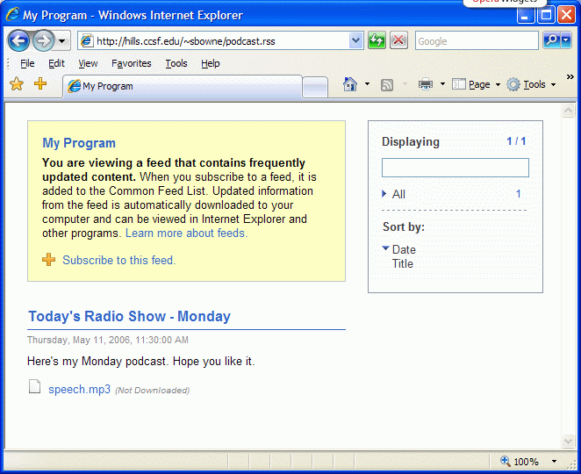
- If your podcast won’t play, try opening mine at hills.ccsf.edu/~sbowne/podcast.rss
- If mine works, but yours doesn’t, check your RSS code with the RSS Validator at: rss.scripting.com
Based on http://radio.about.com/od/podcastin1/a/aa030805a.htm
Last modified 5-11-06

