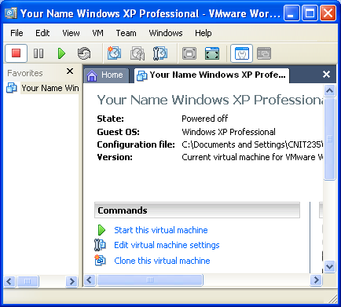
Starting VMWare Workstation
- We will use a program called VMWare Workstation, which simulates a computer on top of the existing Windows XP operating system. That way you can practice installation and other activities without changing (and possibly damaging) the existing operating system.
- Double-click the VMWare Workstation icon on the desktop.
- A VMWare Workstation window opens as shown to the right on this page. Click the blue Start this virtual machine link.
- A couple of VMWare message boxes will open, telling you details about how VMWare works that don’t matter right now. Just click the default selection to get past them.
- When your virtual PC starts, you will see a window with a virtual desktop in it, and a virtual Start button. Whenever you need to install software, do it in the virtual PC. That way you won’t mess up the host PC.
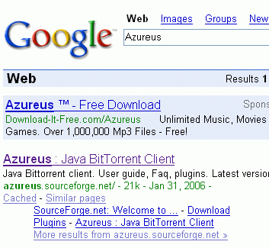
Installing the Azureus BitTorrent Client
- Open a browser and Google Azureus

- Click on the Azureus : Java BitTorrent Client link

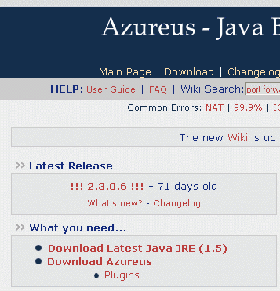
- You need to download two things: Java JRE and Azureus. Click on Download Latest Java JRE

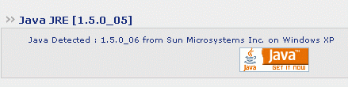

- In the next screen, click on the orange java icon

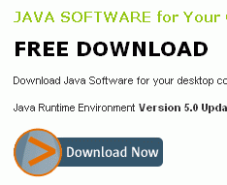
- In the next window, click the Download Now button.

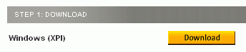
- In the next screen, click the Download button next to Windows XP.

- Install the software, following the prompts on the screen.

- Then close your browser and restart it. Use Google again to find the Azureus download page. Click Download Azureus.

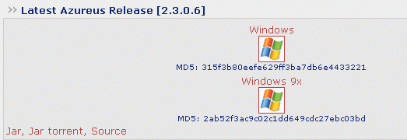
- When you see the latest Azureus Release screen, click the Windows icon.

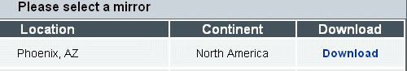
- When you see the screen that asks you to Please select a mirror, click the Download link for any mirror in the USA.
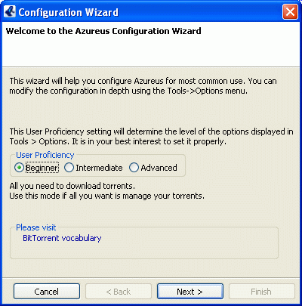
- Download the file, save it on your desktop, and run it. Follow the on-screen prompts to install the software.

- After it is installed, click Start, All Programs, Azureus, Azureus to run it. Update it and restart it as prompted to.
- You will see the Configuration Wizard as shown to the right. Just click Next and accept all the default settings.

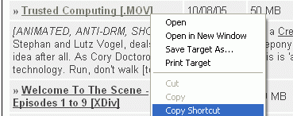
- To find some torrents to download, open a browser and go to legaltorrents.com.

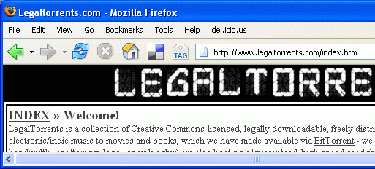
- Find something you want to see, right-click it, and select Copy Shortcut.

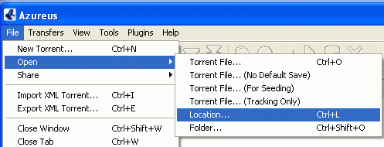
- In the Azareus window, click File, Open, Location.

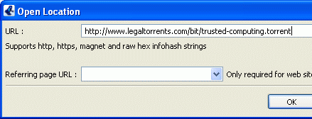
- In the Open Location dialog box, paste the link into the URL box and click OK.

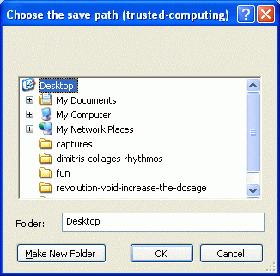

- In the Choose the save path box, select Desktop and click OK.

- That’s all. The file should download to the desktop. For more help, use the Help menu in Azareus.

Remember: Downloading copyrighted songs, movies, etc. is a crime! Make sure you are getting legal torrents.

