Creating an important file
- Click Start, All Programs, Accessories, Notepad. Type in your name and any text. Save the file as Important.txt in your My Documents folder. Close Notepad.
Backing up “My documents and settings”
- Click Start, All Programs, Accessories, System Tools, Backup.
- In the Welcome to the Backup or Restore Wizard screen, click Next.
- In the Backup or Restore screen, accept the default selection of Back up files and settings and click Next.
- In the Want to Back up screen, accept the default selection of My documents and settings and click Next.
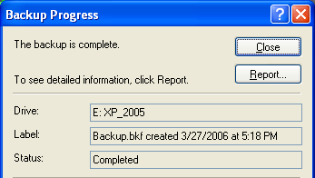
- In the Backup Type, Destination, and Name screen, click the Browse button. In the Save As… box, click the Desktop button. Accept the default name of Backup.bkf, and click Save. In the Backup Type, Destination, and Name screen, click Next.
- In the Completing the Backup or Restore Wizard screen, click Finish.
- When you see the message The backup is complete, as shown to the right on this page, click the Report button to see a report. Read through it and close it. Close the Backup Progress window.
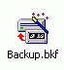
- On the desktop, you should see the Backup.bkf file. All your files are contained in this single file.
Losing an important file
- Open My Documents and click Important.txt once to select it. Press the Delete key to delete it.
- On the desktop, double-click the Recycle Bin. Important.txt is in there. Close the Recycle Bin window.
- Right-click Recycle Bin and select Empty Recycle Bin. In the Confirm Multiple File Delete box, click Yes.
- Double-click the Recycle Bin. There are no files in there – Important.txt is now gone, and there is no utility included in Windows XP that can recover it.
Restoring the Important.txt File
- Click Start, All Programs, Accessories, System Tools, Backup.
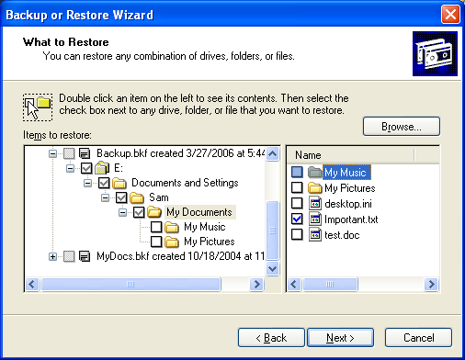
- In the Welcome to the Backup or Restore Wizard screen, click Next.
- In the Backup or Restore screen, click Restore files and settings and click Next.
- In the What to Restore screen, expand items in the left pane to find the My Documents folder, as shown to the right on this page.
- Check the Important.txt box in the right pane and click Next.
- In the Completing the Backup or Restore Wizard screen, click Finish.
- When you see the message The restore is complete, click Close.
- Open My Documents. The Important.txt file is back now.

