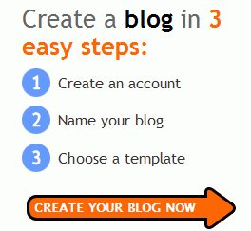
Creating a Blog
- Open a browser go to blogger.com

- Click the CREATE YOUR BLOG NOW arrow

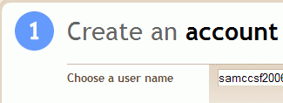

- A page appears with a blue number 1 in the upper left. Fill out the form, making up a user name and password. Click CONTINUE.

- A page appears with a blue number 2 in the upper left. Fill out the form, making up a title and a URL. Click CONTINUE.

- A page appears with a blue number 3 in the upper left. Click any template and click CONTINUE.
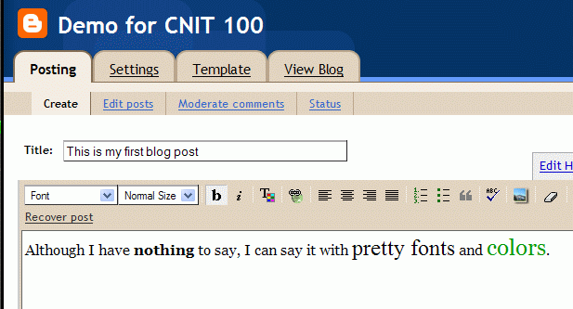
- A page appears with a blue exclamation mark (!) in the upper left. Click START POSTING .

- Enter a title and some text, and click the Publish Post button.

- When you see the Your blog published successfully. Message, click the View Blog link.
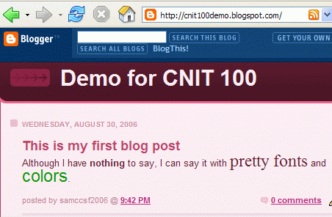
- You should see your blog, with the URL you chose.

Last modified 8-30-06

