Creating a File to Back Up
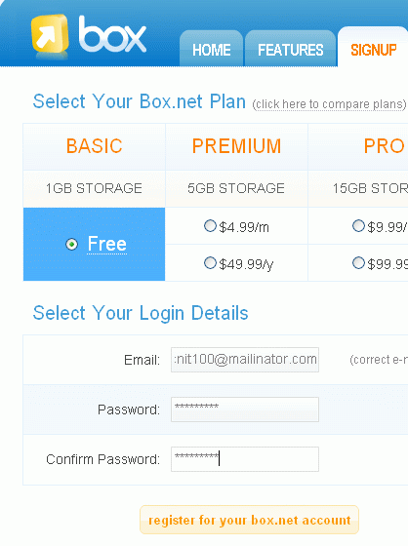
- Open Microsoft Word. Type in your name, or any other text. Save the document in the My Documents folder with the name Important Info.
Signing up at Box.net
- Open a browser and go to box.net
- Click the SIGNUP tab. They want you to enter an email address here, but that might be unwise because a lot of free sites send spam to the email address. So instead, use an address of yourname@mailinator.com as shown to the right on this page, replacing yourname with your own name, or any name you like.
- Enter any password into the two boxes and click the Register for your box.net account button.
- Open another browser and go to mailinator.com
- In the Check your inbox! Box, enter yourname (you must use the same name you gave to box.com). Click go.
- You should see a message with the subject Please activate your Box.net account as shown below and to the right on this page. Click that subject to open the message.
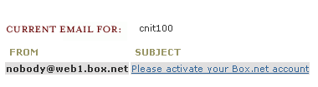
- Click the link in the email message.
- A Box.net page opens. Enter your password and click the login button.
- A orange box appears with the message Welcome to Box.net! Click the Close button.
Uploading a File
- In the box window, click Upload a file into this directory.
- In the Upload files box, click the add files button.
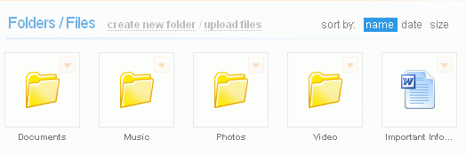
- In the File Upload box, click the My Documents button and double-click Important Info.
- Click the upload button. The Important Info file appears as shown to the right on this page.
Making a Big File
- One problem with some online file storage services is that the upload and download speeds are slow. To test that, let’s make a big file.
- Press the PrtScn button on the upper right of the keyboard. This copies the contents of the video memory to the clipboard – nothing visible happens on the screen.
- Click Start, All Programs, Accessories, Paint. Click Edit, Paste. A copy of the desktop is pasted into the Paint window.
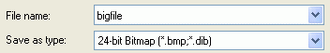
- Click File, Save As…. Save the file in the My Documents folder with the name bigfile. Make sure it is saved with a Save as type: of 24-bit Bitmap as shown to the right on this page.
- Click Start, My Documents. Right-click bigfile and click Properties. Check the size of the file—its exact size depends on the resolution of your monitor, but it should be at least 1 megabyte.
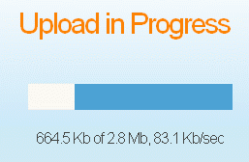
Uploading a Big File
- In the box window, click Upload files.
- In the Upload files box, click the add files button.
- In the File Upload box, click the My Documents button and double-click bigfile.
- Click the upload button. You should see the Upload in Progress box, as shown to the right on this page. Make a note of the upload speed, after the comma under the progress bar. When I tried it, the speed was 83.1 Kb/sec. Note that although they use the units Kb/sec (kilobits per second), it should actually be KB/sec – (kilobytes per second).

